|  |
| --- |
|  |
| System Development Life Cycle for CL Software |
| logoSmall_color2  **BASIC Bank Limited,  ICT Division 36, Dilkusha C/A Dhaka-100**  **[Type the fax number]**  **[Pick the date]** |
|  |

**Version History**

|  |  |
| --- | --- |
|  | **Description** |
| 30-May-2012 | Version 2.0.0 – System Development Life Cycle released. |
| 30-September-2012 | Version 3.1.0 – System Development Life Cycle released. |
| 30-December-2012 | Version 3.2.0 – System Development Life Cycle released. |

**Table of Content:**

**Project Overview**

**Project Definition ……………………………………………………………………….. 3**

**Software Development Life Cycles:**

**What is Waterfall Model? ………………………………………………………………. 16**

**History of the Waterfall Model ………………………………………………………… 16**

## CL Software Development Life Cycle

**Advantages of New CL Software ……………………………………………………….. 19**

**CL Version 2.0.0**

**Requirement Analysis ....................................................................................................... 20**

**System Analysis and Design: ............................................................................................ 29**

**Implementation .................................................................................................................. 32**

**Integration and Testing .................................................................................................... 106**

**Installation ......................................................................................................................... 109**

**Maintenance ...................................................................................................................... 110**

**CL Version 3.1.0**

**Requirement Analysis ....................................................................................................... 112**

**System Analysis and Design: ............................................................................................ 126**

**Implementation.................................................................................................................... 139**

**Integration ........................................................................................................................... 147**

**Testing ................................................................................................................................. 147**

**Installation and Maintenance ........................................................................................... 148**

**CL Version 3.2.0**

**Requirement Analysis ......................................................................................................... 149**

**System Analysis and Design................................................................................................. 152**

**Implementation...................................................................................................................... 156**

**Integration.............................................................................................................................. 162**

**Testing..................................................................................................................................... 196**

**Installation and Maintenance .............................................................................................. 197**

**Future Works and Development**

**Future Works and Development …………………………………………………………. 197**

**1. Project Overview:**

Presently Branches are using distributed stand-alone CL (Loan Classification & Provisioning) software where users manually input data in all fields to prepare various CL reports. The process depends on a single user of a Branch and is time consuming. Besides at Head Office level, the consolidated CL report is prepared manually based on reports received from Branches.

To overcome the problems mentioned above, ICT Division in consultation with Recovery Division developed centralized CL Software. The software has been developed in light of BRPD Circular No.05 of June 05, 2006, BRPD Circular No.32 of October 27, 2010 and BRPD Circular No.01 of January 01, 2012. After development, the software has been tested thoroughly. The software will be interfaced with our core banking software KASTLE Core Banking Solution (KCBS). So data of most of the fields of the new CL Software will be directly imported from the corresponding fields of KCBS.

**1.1 Project Definition:**

This project is initially based on the following circular from Bangladesh Bank. The rules and regulations of the circular are stated below.

**1.1.1 BRPD Circular No.05 of June 05, 2006**

In order to strengthen credit discipline and improve the recovery position of loans and advances by the banks, Bangladesh Bank vide BCD Circular No. 34/1989 introduced a new system covering loan classification, the suspension of interest due, and the making of provisions against potential loan loss. With a view to further strengthening credit discipline and bring classification and provisioning regulation in line with international standard, a phase wise program for loan classification and provisioning was undertaken by Bangladesh Bank through BCD Circular No. 20/1994. Afterwards, a comprehensive circular, BRPD Circular No. 16/1998 was issued with major amendments in BCD Circular No. 34/1989 and 20/1994 with a view to achieving a more specified & simplified system of loan classification and provisioning. As part of the process i.e. regarding the changes, it needs to be mentioned here that Bangladesh Bank has already introduced 'Special Mention Account' vide BRPD Circular No. 02/2005 and 09/2005 for the banks to raise early warning signals for accounts showing first signs of weakness and making appropriate provisioning therein. As a further move towards this end, changes in the formats for

Classification and provisioning (CL-1, 2, 3, 4 & 5) have been made vide BRPD Circular Letter No.08/2005. Moreover, some changes have been made in the provisioning requirement for Consumer Financing & Small Enterprise Financing. Now in order to enable the banks to have all existing instructions on the subject at one place this Master Circular has been prepared by incorporating all instructions issued from time to time. It may also be mentioned that this Circular also includes a few new instructions as well as new formats for loan classification & provisioning.

**1. Categories of Loans**

All loans and advances will be grouped into four(4) categories for the purpose of classification,

Namely

(a) Continuous Loan

(b) Demand Loan

(c) Fixed Term Loan &

(d) Short-term Agricultural & Micro Credit.

**(a) Continuous Loan: -** The loan Accounts in which transactions may be made within certain

Limit and have an expiry date for full adjustment will be treated as Continuous Loans. Examples are: CC, OD etc.

**(b) Demand Loan:** The loans that become repayable on demand by the bank will be treated as

Demand Loan. If any contingent or any other liabilities are turned to forced loans (i.e. without any prior approval as regular loan) those too will be treated as Demand Loans. Such as: Forced LIM, PAD, FBP and IBP etc.

**(c) Fixed Term Loan:** The loans, which are repayable within a specific time period under a

Specific repayment schedule will be treated as Fixed Term Loans.

**(d) Short-term Agricultural & Micro Credit:**

**Short-term Agricultural Credit** will include the short-term credits as listed under the Annual

Credit Program issued by the Agricultural Credit and Special Program Department (ACSPD) of Bangladesh Bank. Credits in the agricultural sector repayable within 12(twelve) months will also be included herein. **Short-term Micro-Credit** will include any micro-credits not exceeding Tk.25,000/= (twenty five thousand) and repayable within 12(twelve) months, be those termed in any names such as Non-agricultural credit, Self-reliant Credit, Weaver's Credit or Bank's individual project credit.

**2. Basis for Loan Classification: -**

**(A) Objective Criteria:**

**(1) Past Due/Over Due**

(i) Any **Continuous Loan** if not repaid/renewed within the fixed expiry date for repayment will be treated as past due/overdue from the following day of the expiry date.

(ii) Any **Demand Loan** if not repaid/rescheduled within the fixed expiry date for repayment will be treated as past due/overdue from the following day of the expiry date.

(iii) In case of any installment(s) or part of installment(s) of a **Fixed Term Loan (not over five**

**Years)** is not repaid within the fixed expiry date, the amount of unpaid installment(s) will be treated as past due/overdue from the following day of the expiry date.

(iv) In case of any installment(s) or part of installment(s) of a **Fixed Term Loan(over five years)** is not repaid within the fixed expiry date, the amount of unpaid installment(s) will be treated aspast due/overdue after six months of the expiry date.

(v) The **Short-term Agricultural and Micro-Credit** if not repaid within the fixed expiry date for repayment will be considered past due/overdue after six months of the expiry date.

**(2)** All unclassified loans other than Special Mention Account (SMA) will be treated as **Standard**.

**(3)** A Continuous credit, Demand loan or a Term Loan which will remain overdue for a period of 90 days or more, will be put into the **"Special Mention Account(SMA)"** and interest accrued on such loan will be credited to Interest Suspense Account, instead of crediting the same to Income Account. This will help banks to look at accounts with potential problems in a focused manner and it will capture early warning signals for accounts showing first sign of weakness. Loans in the "**Special Mention Account (SMA)**" will have to be reported to the Credit Information

Bureau (CIB) of Bangladesh Bank. However, it is reiterated that loans in the "Special Mention

Account" will not be treated as defaulted loan for the purpose of section 27KaKa (3) of the Bank

Company Act, 1991.

**(4)** Any **continuous loan** will be classified as:

**a. ‘Sub-standard'** if it is past due/overdue for 6 months or beyond but less than 9 months

**b.** `**Doubtful'** if it is past due/overdue for 9 months or beyond but less than 12 months

**c.** `**Bad/Loss'** if it is past due/overdue for 12 months or beyond

**(5)** Any **Demand Loan** will be classified as:

**'Sub-standard'** if it remains past due/overdue for 6 months or beyond but not over 9 months from the date of claim by the bank or from the date of creation of forced loan.

**`Doubtful'** if it remains past due/overdue for 9 months or beyond but not over 12 months from the date of claim by the bank or from the date of creation of forced loan.

**`Bad/Loss'** if it remains past due/overdue for 12 months or beyond from the date of claim by the

bank or from the date of creation of forced loan.

**(6)** In case of any installment(s) or part of installment(s) of a **Fixed Term Loan** is not repaid within the due date, the amount of unpaid installment(s) will be termed as `defaulted installment'.

**(6.1)** In case of **Fixed Term Loans**, which are repayable within **maximum five years of time**:

If the amount of **'defaulted installment'** is equal to or more than the amount of installment(s)

Due within 6 (six) months, the entire loan will be classified as **''Sub-standard''**.

If the amount of **'defaulted installment'** is equal to or more than the amount of installment(s) due within 12 (twelve) months, the entire loan will be classified as **''Doubtful"**.

If the amount of **'defaulted installment'** is equal to or more than the amount of installment(s) due within 18 (eighteen) months, the entire loan will be classified as **''Bad/Loss''.**

**(6.2)** In case of **Fixed Term Loans**, which are repayable in **more than five years** of time: -

If the amount of 'defaulted installment' is equal to or more than the amount of installment(s) due within 12 (twelve) months, the entire loan will be classified as **''Sub-standard''**.

If the amount of 'defaulted installment' is equal to or more than the amount of installment(s) due within 18 (eighteen) months, the entire loan will be classified as **''Doubtful"**.

If the amount of 'defaulted installment' is equal to or more than the amount of installment(s) due within 24 (twenty four) months, the entire loan will be classified as **''Bad/Loss''.**

Explanation: If any Fixed Term Loan is repayable on monthly installment basis, the amount of

Installment due within 6 months will be equal to the sum of 6 monthly installments. Similarly, if the loan is repayable on quarterly installment basis, the amount of installment(s) due within 6 months will be equal to the sum of 2 quarterly installments.

**(7)** The **Short-term Agricultural and Micro-Credit** will be considered irregular if not repaid within the due date as stipulated in the loan agreement. If the said irregular status continues, the credit will be classified as 'Substandard ' after a period of 12 months, as 'Doubtful' after a period of 36 months and as 'Bad/Loss' after a period of 60 months from the stipulated due date as per loan agreement.

**(B). Qualitative Judgement:**

If any uncertainty or doubt arises in respect of recovery of any Continuous Loan, Demand Loan or Fixed Term Loan, the same will have to be classified on the basis of qualitative judgement be it classifiable or not on the basis of objective criteria. If any situational changes occur in the stipulations in terms of which the loan was extended or if the capital of the borrower is impaired due to adverse conditions or if the value of the securities decreases or if the recovery of the loan becomes uncertain due to any other unfavorable situation, the loan will have to be classified on the basis of qualitative judgement.

Besides, if any loan is illogically or repeatedly re-scheduled or the norms of re-scheduling are violated or instances of (propensity to) frequently exceeding the loan-limit are noticed or legal action is lodged for recovery of the loan or the loan is extended without the approval of the competent authority, it will have to be classified on the basis of qualitative judgement.

Despite the probability of any loan being affected due to the reasons stated above or for any other reasons, if there exist any hope for change of the existing condition by resorting to proper steps, the loan, on the basis of qualitative judgement, will be classified as 'Sub-standard '. But even if after resorting to proper steps, there exists no certainty of total recovery of the loan, it will be classified as ' Doubtful ' and even after exerting the all-out effort, there exists no chance of recovery, it will be classified as ' Bad/Loss ' on the basis of qualitative judgement.

The concerned bank will classify on the basis of qualitative judgement and can declassify the loans if qualitative improvement does occur. But if any loan is classified by the Inspection Team of Bangladesh Bank, the same can be declassified with the approval of the Board of Directors of the respective bank. However, before placing such case to the Board of Directors, the Managing

Director/Chief Executive Officer and the respective Branch Manager of the bank shall have to certify that the terms and conditions of declassification have been duly fulfilled by the borrowers. The bank will have to inform such declassifications to the Department of Banking Inspection/concerned offices of Bangladesh Bank within 15 days of such decision taken by the Board of Directors. Bangladesh Bank will examine these matters on case-to-case basis and if any irregularities/deviations is detected, necessary legal action will be taken against the concerned officials.

**3. Accounting of the interest of classified loans:**

If any loan or advance is classified as 'Sub-standard' and 'Doubtful', interest accrued on such loan

will be credited to Interest Suspense Account, instead of crediting the same to Income Account. In case of rescheduled loans the unrealized interest, if any, will be credited to Interest Suspense Account, instead of crediting the same to Income Account.

As soon as any loan or advance is classified as 'Bad/Loss', charging of interest in the same account will cease. In case of filing a law-suit for recovery of such loan, interest for the period till filing of the sui can be charged in the loan account in order to file the same for the amount of principal plus interest. But interest thus charged in the loan account has to be preserved in the 'Interest Suspense' account. If any interest is charged on any 'Bad/Loss' account for any other special reason, the same will be preserved in the 'Interest Suspense' account. If classified loan or part of it is recovered i.e., real deposit is effected in the loan account, first the interest charged and not charged is to be recovered from the said deposit and the principal to be adjusted afterwards.

**4. Maintenance of provision:**

**(a)** (i) Banks will be required to maintain **General Provision** in the following way :

(1) @ 1% against all unclassified loans (other than loans under Small Enterprise and Consumer Financing and Special Mention Account.)

(2) @ 2% on the unclassified amount for Small Enterprise Financing.

(3) @ 5% on the unclassified amount for Consumer financing whereas it has to be maintained @ 2% on the unclassified amount for

(i) Housing Finance and

(ii) Loans for Professionals to set up business under Consumer Financing Scheme.

(4) @ 5% on the outstanding amount of loans kept in the 'Special Mention Account' after netting off the amount of Interest Suspense.

**(b)** (i) Banks will maintain provision at the following rates in respect of classified Continuous, Demand and Fixed Term Loans:

(1) Sub-standard 20%

(2) Doubtful 50%

(3) Bad/Loss 100%

(ii) Provision in respect of Short-term Agricultural and Micro-Credits is to be maintained at the following rates:

(1) All credits except 'Bad/Loss' (i.e. 'Doubtful', 'Sub-standard', irregular and regular credit accounts): 5%

(2) 'Bad/Loss’: 100%

**6. Base for Provision:**

Provision will be maintained at the above rate on the balance to be ascertained by deducting the amount of 'Interest Suspense' and value of eligible securities from the outstanding balance of classified accounts.

**7. Eligible Securities:**

In the definition of 'Eligible Securities' as mentioned in the above paragraph the following securities will be included as eligible securities in determining base for provision:

-100% of deposit under lien against the loan

-100% of the value of government bond/savings certificate under lien.

-100% of the value of guarantee given by Government or Bangladesh Bank

-100% of the market value of gold or gold ornaments pledged with the bank.

- 50% of the market value of easily marketable commodities kept under control of the bank

- Maximum 50% of the market value of land and building mortgaged with the bank

- 50% of the average market value for last 06 months or 50% of the face value, whichever is less, of the shares traded in stock exchange.

**Determination of Market Value of Eligible Securities**

In determining market value of easily marketable commodities, land and building, banks are advised to follow the instructions mentioned below:

(a) Easily marketable goods will mean pledged, easily en-cashable/saleable goods that remain under full control of the bank. However, while the concerned bank branch official will conduct periodic inspection to verify as to whether issues such as the suitability of goods for use, expiry period, appropriateness of documentary evidences, up to date insurance cover, same will have to be assessed by the professional assessor from time to time.

(b) For land and building, banks will have to ensure whether title documents are in order and concerned land and building will have to be valued by the professional valuation firm along with completion of proper documentation in favour of the bank. In absence of professional valuation firm, certificate in favour of such valuation will have to be collected from the specialized engineer. Nevertheless, temporary houses including tin-shed structure shall not be shown as building.

(c) In order to facilitate the on-site inspection by our Department of Bank Inspection, banks are also advised to maintain complete statement of eligible securities on a separate sheet in the concerned loan file. Information such as description of eligible securities, their assessment by recognized firm, marketability of the commodity, control of the bank, and reasons for considering eligible securities etc. will have to be included in that sheet.

**8.** In terms of the above policies, the banks will conduct their classification- activities on quarterly basis. In this connection revised forms for loan classification, provisioning and interest suspense that is CL-1 to CL-6 have been enclosed herewith which will replace the existing ones.

(i) CL-1 is the compilation/summary of 5 other forms. This form is for showing summary of classification status for different loan categories mentioned earlier along with staff loan.

(ii) CL-2 is for reporting loan classification of Continuous Loan

(iii) CL-3 is for reporting loan classification of Demand Loan

(iv) CL-4 is for reporting loan classification of term loans which are repayable within maximum 5(five) years.

(v) CL-5 is for reporting loan classification of term loans of over 5(five) years.

Bank branches shall send the completed forms (CL-1 to CL-6) to their Head Office. The Head

Offices of banks should make arrangements for scrutiny of all the forms prepared by the branches. Where necessary, they should carry out corrections and ensure maintenance of the corrected forms in the records of the branch. After scrutiny of all forms (CL-1, CL-2, CL-3, CL-4, CL-5 and CL-6) prepared by branches and being satisfied with the results, they should prepare a consolidated position of classification, provisions and interest suspense using form CL-1 and send the same to Banking Regulation & Policy Department of Bangladesh Bank. Banks are also advised to preserve the CL statements in both their Head Offices and branches for inspection by the Bangladesh Bank Inspection Team.\

**9.** Banks having **Offshore Banking Unit (OBU**) will report to Bangladesh Bank in similar way in a separate CL-1 named **OBU SUMMARY OF LOAN CLASSIFICATION AND PROVISION** (enclosed herewith) . In this regard, concerned banks will prepare and send data on OBU transactions for A, B and C type in separate worksheets along with the consolidated statement through the said separate CL-1 named **OBU SUMMARY OF LOAN CLASSIFICATION AND PROVISION** to the Banking Regulation and Policy Department and CIB of Bangladesh Bank.

**10.** Banks are advised to submit detailed statements through CL-1 in respect of classification,

provision and interest suspense accounts within 30 days from the reference date and ensure correct and timely submission of CL-1 failing to which Penalty may be imposed on the concerned non compliant bank.

**11.** Banks shall submit the consolidated quarterly statement on revised CL-1 format starting from the quarter ended June, 2006.

Report Formats:

Formats of CL 1 to CL6 are given below which should be submitted to Bangladesh Bank at every quarter.

1. CL 1 Report Format:



2. CL 2 Report Format:



3. CL 3 Report Format:



4. CL 4 Reporting Format:



5. CL 5 Report Format



6. CL 6 Report Format



7. CL 1 Report Format



**1.1.2. BRPD Circular No.32 of October 27, 2010**

According to the circular banks are required to maintain 1% general provision on unclassified loans/advances against Continuous, Demand and Term loans; 2% against Housing Finance (HF) andLoans for Professionals to set up business (LP) and 5% against other loans (other than HF & LP). It is tomention in this regard that banks are also required to maintain 1% general provision on unclassifiedamount of the funded loan disbursed to stock dealers enlisted with Stock Exchange, separate subsidiary company established by a bank company for dealing business in share brokerage and merchant bankingand any other company or institution or individual for dealing such business.It is mentionable in this context that bank loan/bank financing to above mentioned dealers/subsidiarycompanies/any other company or institution or individual become vulnerable due to volatility of marketprices of shares/debentures. Considering the investment risks in the capital market it has now been decidedthat banks shall maintain 2% general provision instead of 1% against unclassified amount of any kind offunded loan disbursed to stock dealers enlisted with Stock Exchange, separate subsidiary companyestablished by a bank company for dealing business in share brokerage and merchant banking and anyother company or institution or individual for dealing such business.In this context, the existing Cl-1 format has been amended. Banks are advised to submit data in the revisedCL-1 format. This instruction shall come into force with immediate effect.

CL 1 Report Format:



**1.2 Software Development Life Cycles:**

Water fall model is followed for the development cycle of CL software. In this document all the steps are followed by waterfall model.

**1.2.1 What is Waterfall Model?**

The waterfall model is a sequential design process, used in software development processes, in which progress is seen as flowing steadily downwards (like a waterfall) through the phases of Conception, Initiation, Analysis, Design, Construction, Testing, Production/Implementation, and Maintenance.

The waterfall development model originates in the manufacturing and construction industries; highly structured physical environments in which after-the-fact changes are prohibitively costly, if not impossible. Since no formal software development methodologies existed at the time, this hardware-oriented model was simply adapted for software development.

The first known presentation describing use of similar phases in software engineering was held by Herbert D. Belington at Symposium on advanced programming methods for digital computers on 29 June 1956. This presentation was about the development of software for SAGE. In 1983 the paper was republished with a foreword by Belington pointing out that the process was not in fact performed in a strict top-down fashion, but depended on a prototype.

The first formal description of the waterfall model is often cited as a 1970 article by Winston W. Royce, although Royce did not use the term "waterfall" in this article. Royce presented this model as an example of a flawed, non-working model. This, in fact, is how the term is generally used in writing about software development—to describe a critical view of a commonly used software development practice.

**1.2.2 History of the Waterfall Model**

In 1970 Royce proposed what is now popularly referred to as the waterfall model as an initial concept, a model which he argued was flawed (Royce 1970). His paper then explored how the initial model could be developed into an iterative model, with feedback from each phase influencing previous phases, similar to many methods used widely and highly regarded by many today.

Despite Royce's intentions for the waterfall model to be modified into an iterative model, use of the "waterfall model" as a purely sequential process is still popular, and, for some, the phrase "waterfall model" has since come to refer to any approach to software creation which is seen as inflexible and non-iterative.

**1.2.3 Stages of Water Fall Model:**

In Royce's original waterfall model, the following phases are followed perfectly in sequential order:

* **Requirements specification**
* **Design**
* **Implementation**
* **Integration**
* **Testing**
* **Installation**
* **Maintenance**

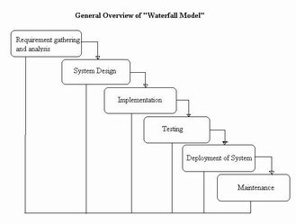

The waterfall model maintains that one should move to a phase only when its preceding phase is completed and perfected. Phases of development in the waterfall model are thus discrete, and there is no jumping back and forth or overlap between them.

As many find this approach particularly rigid, modifications have been made over the years and new variants of the model have emerged.

## 1.3 CL Software Development Life Cycle

**1.3.1 Advantages of New CL Software**

1. Most of the data will be imported from KCBS.

2. More than one user can work with the software.

3. Time required to prepare CL reports will decrease considerably.

4. Automatic consolidation of CL-1 will be done at Branch and Head Office level.

5. Accounts under CCOD & Loan products will be imported according to CL category. However there is an option for users to easily categorize those accounts, which cannot be imported category wise.

6. Rate of Provision & Reference Date will be maintained centrally.

7. All data will be stored in centralized database/server so Head Office will be able to take reports of any branch any time.

8. Back dated reports can be taken at Branch and Head Office level.

**1.3.2 General Precaution**

1. Those fields which are imported from KCBS by the ICT Division (on 1st day of a quarter) to the new CL software are non-editable i.e. once imported the data of those fields cannot be changed in the software.

2. After importing data from KCBS to CL software, any changes done in KCBS will not be reflected to the CL Software.

3. Consolidation at Head Office level will be done after a cut-off date (set by the Recovery Division). After the cut-off date any update by Branches into the CL software will not be possible.

4. Correctness of data will depend on input by KCBS and CL users, at Branch level.

**CL Version 2.0.0**

**1. Requirement Analysis**

**Requirement Standard**

The project team must gather business and system requirements

Activities include: Review existing systems/process, Describe data/system/process, Identify problem, areas/opportunities, Identify user needs/wants, Conduct interviews, Develop Solution, Identify manual and automated processes, Draw conceptual flow, Identify follow on projects/phases, Identify inputs (functional description), Data entry screens, Inputs from outside sources.

The project team must establish and document business/application requirements

In order to achieve the above the following items should be followed.

* Document requirements
* Document assumptions
* Document outstanding issues
* Estimate data storage requirements
* Identify legislative/contractual/security/privacy/access requirements
* Document reporting requirements
* Review training requirements
* Conduct initial walkthrough
* Obtain sign-off and approval

**Classification of Loan**

* Unclassified
  + Standard
* Classified
  + Special Mention Account (SMA)
  + Sub-Standard (SS)
  + Doubtful (DF)
  + Bad & Loss (BL)

**CL-2: Continuous Loan:**

The loan Accounts in which transactions may be made within certain limit and have an expiry date for full adjustment will be treated as Continuous Loans. Examples are: CC, OD etc. Any Continuous Loan if not repaid/renewed within the fixed expiry date for repayment will be treated as past due/overdue from the following day of the expiry date.

|  |  |
| --- | --- |
| Category | Period |
| Overdue | From the following day of the expiry date |
| SMA | 90 days |
| SS | 6 months |
| DF | 9 months |
| BL | 12 months |

**CL-3: Demand Loan:**

The loans that become repayable on demand by the bank will be treated as Demand Loans. If any contingent or any other liabilities are turned to forced loans (i.e. without any prior approval as regular loan) those too will be treated as Demand Loans. Such as: Forced LIM, PAD, FBP,and IBP etc. Any Demand Loan if not repaid/rescheduled within the fixed expiry date for repayment will be treated as past due/overdue from the following day of the expiry date.

|  |  |
| --- | --- |
| Category | Period |
| Overdue | From the following day of the expiry date |
| SMA | 90 days |
| SS | 6 months |
| DF | 9 months |
| BL | 12 months |

**CL-4: Fixed Term Loan: (maximum five years of time)**

The loans, which are repayable within a specific time period under a specific repayment schedule, will be treated as Fixed Term Loans. In case of any installment(s) or part of installment(s) of a Fixed Term Loan(not over five years) is not repaid within the fixed expiry date, the amount of unpaid installment(s) will be treated as past due/overdue from the following day of the expiry date. In case of any installment(s) or part of installment(s) of a **Fixed Term Loan** is not repaid within the due date, the amount of unpaid installment(s) will be termed as `defaulted installment'.

|  |  |  |  |  |
| --- | --- | --- | --- | --- |
| Category | Monthly Installment | Quarterly Installment | Half Yearly Installment | Yearly Installment |
| Overdue | Is not repaid within the fixed expiry date | | | |
| SMA | 3 | 1 | 0 | 0 |
| SS | 6 | 2 | 1 | 0 |
| DF | 12 | 4 | 2 | 1 |
| BL | 18 | 6 | 3 | 1 |

**CL-5: Fixed Term Loan: (more than five years of time)**

The loans, which are repayable within a specific time period under a specific repayment schedule will be treated as Fixed Term Loans. In case of any installment(s) or part of installment(s) of a Fixed Term Loan(over five years) is not repaid within the fixed expiry date, the amount of unpaid installment(s) will be treated as past due/overdue after six months of the expiry date.

In case of any installment(s) or part of installment(s) of a **Fixed Term Loan** is not repaid within the due date, the amount of unpaid installment(s) will be termed as `defaulted installment'.

* **‘Special Mention Account(SMA)’** if it is past due/over due for a period of 90 days or more,
* If the amount of 'defaulted installment' is equal to or more than the amount of installment(s) due within 12 (twelve) months, the entire loan will be classified as **''Sub-standard''**.
* If the amount of 'defaulted installment' is equal to or more than the amount of installment(s) due within 18 (eighteen) months, the entire loan will be classified as **''Doubtful"**.
* If the amount of 'defaulted installment' is equal to or more than the amount of installment(s) due within 24 (twenty four) months, the entire loan will be classified as **''Bad/Loss''.**

|  |  |  |  |  |
| --- | --- | --- | --- | --- |
| Category | Monthly Installment | Quarterly Installment | Half Yearly Installment | Yearly Installment |
| Overdue | >6 | >2 | >1 | 0 |
| SMA | 9 | 3 | 1 | 0 |
| SS | 12 | 4 | 2 | 1 |
| DF | 18 | 6 | 3 | 1 |
| BL | 24 | 8 | 4 | 2 |

**CL-6 :Short-term Agricultural and Micro-Credit**

* Short-term Agricultural Credit will include the short-term credits as listed under the Annual Credit Program issued by the Agricultural Credit and Special Program Department (ACSPD) of Bangladesh Bank. **Credits in the agricultural sector repayable within 12(twelve) months will also be included herein.**
* **Short-term Micro-Credit will include any micro-credits not exceeding Tk.25,000/= (twenty five thousand) and repayable within 12(twelve) months,** be those termed in any names such as Non-agricultural credit, Self-reliant Credit, Weaver's Credit or Bank's individual project credit.
* The Short-term Agricultural and Micro-Credit if not repaid within the fixed expiry date for repayment will be considered past due/overdue after six months of the expiry date.
* Classification-
* **‘Special Mention Account(SMA)’** :90 Days overdue period/ 9months after after expiry date
* The **Short-term Agricultural and Micro-Credit** will be considered irregular if not repaid within the due date as stipulated in the loan agreement. If the said irregular status continues, the credit will be classified as 'Substandard ' after a period of 12 months, as 'Doubtful' after a period of 36 months and as 'Bad/Loss' after a period of 60 months from the stipulated due date as per loan agreement.

|  |  |
| --- | --- |
| Category | Period |
| Overdue | 6 months |
| **SMA[[1]](#footnote-2)** | **9 months** |
| SS | 12 months |
| DF | 36 months |
| BL | 60 months |

**Base for Provision:**

Provision will be maintained at the above rate on the balance to be ascertained by deducting the amount of 'Interest Suspense' and value of eligible securities from the outstanding balance of classified accounts.

**Rate for Provision:**

|  |  |  |  |  |  |  |
| --- | --- | --- | --- | --- | --- | --- |
| **Category in CL** | **Customer Category** | **Standard** | **SMA** | **SS** | **DF** | **BL** |
| Short Term Agri Credit | STA, MCR | 5% | 5% | 5% | 5% | 5% |
| Consumer Finance-HF | CHF | 2% | 5% | 20% | 50% | 100% |
| Consumer Finance- LP | CLP | 2% | 5% | 20% | 50% | 100% |
| Other Than HF & LP | CAL, CUP, CIN | 5% | 5% | 20% | 50% | 100% |
| SMEF | SFI, MFI | 1% | 5% | 20% | 50% | 100% |
| Loans to BHs | BHS | 2% | 5% | 20% | 50% | 100% |
| Loans to MBs | MBS | 2% | 5% | 20% | 50% | 100% |
| Loans to SDs | SDS | 2% | 5% | 20% | 50% | 100% |
| All Other Credit | OIN, COF, MIF, LFI, OFI, APP, AGF, INS | 1% | 5% | 20% | 50% | 100% |
| Staff | STF | 1% | | | | |

**Eligible Securities:**

In the definition of 'Eligible Securities' as mentioned in the above paragraph the following securities will be included as eligible securities in determining base for provision:

1. 100% of **deposit under lien** against the loan
2. 100% of the value of **government bond/savings certificate under lien**.
3. 100% of the value of **guarantee given by Government or Bangladesh Bank**
4. 100% of the market value of **gold or gold ornaments pledged with the bank**.
5. 50% of the market value of **easily marketable commodities kept under control of the bank (**Easily marketable goods will mean pledged, easily encashable/saleable goods that remain under full control of the bank**)**
6. Maximum 50% of the market value of **land and building mortgaged with the bank(**For land and building, banks will have to ensure whether title documents are in order and concerned land and building will have to be valued by the professional valuation firm along with completion of proper documentation in favour of the bank**)**
7. 50% of the average market value for last 06 months or 50% of the face value, whichever is less, of the **shares traded in stock exchange**.
8. **Customer Category in CL Software**

|  |  |
| --- | --- |
| **Code** | **Customer Category** |
| OIN | Individual (Other Credit) |
| COF | Cottage Finance |
| MIF | Micro Finance |
| SFI | Small Finance |
| MFI | Medium Finance |
| LFI | Large Finance |
| OFI | Other Finance |
| APP | Agriculture Primary Products |
| AGF | Agro based Finance |
| BHS | Loans to Brokerage House against Shares |
| MBS | Loans to Merchant Bank against Shares |
| SDS | Loans to Stock Dealer against Shares |
| INS | Loans to Individual dealing share business |
| CHF | Consumer Housing Finance |
| CLP | Consumer Loan for Professionals to Set-up Business |
| CAL | Consumer Auto Loan |
| CUP | Consumer Unsecured Personal |
| CIN | Individual (Other Consumer Finance) |
| STA | Short Term Agriculture Credit |
| MCR | Micro Credit |
| STF | Staff Loan |

1. **Customer Category relating to CL Report**

|  |  |
| --- | --- |
| **Category in CL** | **Customer Category** |
| Short Term Agri Credit | STA, MCR |
| Consumer Finance(CF)-House Finance (HF) | CHF |
| Consumer Finance-Loans for Professional to set up business (LP) | CLP |
| Other Than HF & LP | CAL, CUP, CIN |
| SMEF | SFI, MFI |
| Loans to Brokerage Houses (BHs) against shares | BHS |
| Loans to Merchant Banks (MBs) against shares | MBS |
| Loans to Stock Dealers (SDs) against shares | SDS |
| All Other Credit | OIN, COF, MIF, LFI, OFI, APP, AGF, INS |
| Staff | STF |

1. **Period wise Basis for Loan Classification**
   1. **CL-2 :Continuous Loan:**

|  |  |
| --- | --- |
| **Category** | **Period** |
| Overdue | From the following day of the expiry date |
| SMA | 90 days |
| SS | 6 months |
| DF | 9 months |
| BL | 12 months |

* 1. **CL-3 : Demand Loan:**

|  |  |
| --- | --- |
| **Category** | **Period** |
| Overdue | From the following day of the expiry date |
| SMA | 90 days |
| SS | 6 months |
| DF | 9 months |
| BL | 12 months |

* 1. **CL-4 : Fixed Term Loan: (maximum five years of time)**

|  |  |  |  |  |
| --- | --- | --- | --- | --- |
| **Category** | **Monthly Installment** | **Quarterly Installment** | **Half Yearly Installment** | **Yearly Installment** |
| Overdue | Is not repaid within the fixed expiry date | | | |
| SMA | 3 | 1 | 0 | 0 |
| SS | 6 | 2 | 1 | 0 |
| DF | 12 | 4 | 2 | 1 |
| BL | 18 | 6 | 3 | 1 |

* 1. **CL-5 : Fixed Term Loan: (more than five years of time)**

|  |  |  |  |  |
| --- | --- | --- | --- | --- |
| **Category** | **Monthly Installment** | **Quarterly Installment** | **Half Yearly Installment** | **Yearly Installment** |
| Overdue | >6 | >2 | >1 | 0 |
| SMA | 9 | 3 | 1 | 0 |
| SS | 12 | 4 | 2 | 1 |
| DF | 18 | 6 | 3 | 1 |
| BL | 24 | 8 | 4 | 2 |

* 1. **CL-6 : Short-term Agricultural and Micro-Credit**

|  |  |
| --- | --- |
| **Category** | **Period** |
| Overdue | 6 months |
| SMA | 9 months |
| SS | 12 months |
| DF | 36 months |
| BL | 60 months |

* 1. **Staff Loan**

On the basis of Qualitative Judgement

1. **Rate for Provision :**

|  |  |  |  |  |  |  |
| --- | --- | --- | --- | --- | --- | --- |
| **Category in CL** | **Customer Category** | **Standard** | **SMA** | **SS** | **DF** | **BL** |
| Short Term Agri Credit | STA, MCR | 5% | 5% | 5% | 5% | 5% |
| Consumer Finance-HF | CHF | 2% | 5% | 20% | 50% | 100% |
| Consumer Finance- LP | CLP | 2% | 5% | 20% | 50% | 100% |
| Other Than HF & LP | CAL, CUP, CIN | 5% | 5% | 20% | 50% | 100% |
| SMEF | SFI, MFI | 1% | 5% | 20% | 50% | 100% |
| Loans to BHs | BHS | 2% | 5% | 20% | 50% | 100% |
| Loans to MBs | MBS | 2% | 5% | 20% | 50% | 100% |
| Loans to SDs | SDS | 2% | 5% | 20% | 50% | 100% |
| All Other Credit | OIN, COF, MIF, LFI, OFI, APP, AGF, INS | 1% | 5% | 20% | 50% | 100% |
| Staff | STF | 1% | 5% | 20% | 50% | 100% |

1. **Calculation of Period of Arrears :**
   1. **CL-2 :Continuous Loan:**
      1. ***In case of days***

Period of Arrears: Reference Date – Expiry date

* + 1. ***In case of Moths***

Period of Arrears: Reference Date – Expiry date

* 1. **CL-3 : Demand Loan:**
     1. ***In case of days***

Period of Arrears: Reference Date – Expiry date

* + 1. ***In case of Moths***

Period of Arrears: Reference Date – Expiry date

*(If the result returns in month then the decimal part is multiplied by 30. It may return approximate number of remaining days. But it will not affect the calculation.)*

* 1. **CL-4 : Fixed Term Loan: (maximum five years of time)**

Say,

Reference Date: 31.03.2012

Date of 1st Repayment Due: 28.03.2009

**Total No. of Days since Date of 1st Repayment Due: 1099 ~ 36.1 Months**

Installment Size: 68998.10

Installment Frequency: Monthly

Amount paid since last Sanctioning: 23,41,000.00

**Time Equivalent of amount paid: (23,41,000.00 X 1) / 68998.10 = 33.93 Months**

**So Period of Arrears = 2.17 months**

* 1. **CL-5 : Fixed Term Loan: (more than five years of time)**

Say,

Reference Date: 31.03.2012

Date of 1st Repayment Due: 28.03.2009

**Total No. of Days since Date of 1st Repayment Due:1099 ~ 36.1 Months**

Installment Size: 68998.10

Installment Frequency: Monthly

Amount paid since last Sanctioning: 23,41,000.00

**Time Equivalent of amount paid: (23,41,000.00 X 1) / 68998.10 = 33.93 Months**

**So Period of Arrears = 2.17 months**

* 1. **CL-6 : Short-term Agricultural and Micro-Credit**
     1. ***In case of days***

Period of Arrears: Reference Date – Expiry date

* + 1. ***In case of Moths***

Period of Arrears: (Reference Date – Expiry date

*Result returns in months. No day part is showing in the period of arrears field.*

* 1. **Staff Loan**

Not Assigned since Classification Status calculation on the basis of Qualitative Judgement

1. **Base for Provision :**
   * **Standard:** Outstanding Balance
   * **SMA:** Outstanding Balance – Interest Suspense
   * **SS:** Outstanding Balance – Interest Suspense – Value of Eligible Security
   * **DF:** Outstanding Balance – Interest Suspense – Value of Eligible Security
   * **BL:** Outstanding Balance – Interest Suspense – Value of Eligible Security
2. **Basis for Classification:**

If Objective Criteria (OB) and Qualitative Judgement (QJ) Status same for any account then Final Status will be on the basis of QJ.

**2. System Analysis and Design:**

**Analysis Standard**

The project team must analyze business and system requirements

Activities include: Analyzing system flow, data model, Name and define fields in data dictionary, data normalization, physical data model, screens, screen navigation, data entry screens, inquiry screens, help screens, online documentation, Analyze reports, Forms, Report distribution system, User generated reports, Identify files, file formats, edit criteria, record volume, record/file purge criteria, Analyze existing system modifications, controls, program to program controls, backup/recovery procedure, system patterns, security, privacy, application security, equipment needed, impacts to other organizations, Access Services/LAN Management/Help Desk, Data Centre (Production System Support/Operations), analyze resource implications, Storage requirements (Tapes, Online transactions (I/O),PADS), User connections, CPU.

The specific intended use of the system to be developed must be analyzed to specify system requirements. The system requirements specification should describe: functions and capabilities of the system; business, organizational and user requirements; safety, security, information, privacy, interface, operations, and maintenance requirements; design constraints and qualification requirements. The system requirements specification must be documented.

Data Flow of CL software:

Calculated data is showed in report as per given format.

Data are fetched from cl\_clmaster for calculating Base for provision, Provision, Final Status, Basis, and Period of arrear.

Imported data are imported to cl\_clmaster table.

Import from KCBS Database. All existing loan information from Core Database for the reporting quarter is imported to cl\_kcbs table.

Software Platform:

* VB.NET (Programming Languages)
* Oracle as Database
* Crystal Report for reporting

Hardware/Network Requirements:

* Connectivity with Client PC to Database, we shall use existing WAN connectivity
* Medium Range Server with at least 4 GB RAM for Server
* Windows XP / Windows 7 PC as client

**1. Login Screen**

User Name: As per KCBS user name

Password: 12345 (Default)

Under main menu **Settings**, user will find submenu **Change Password**, here user must change password before going to other operation.

**2. CL Import**

Under main menu **Import**, user will find sub menu **Import Update**, here user may find some accounts which cannot be categorized according to CL category. User can easily categorize them by selecting from drop down of column.

**CL 2 - Continuous Loan**

**CL 3 - Demand Loan**

**CL 4 - Term Loan up to 5 years**

**CL 5 - Term Loan more than 5 years**

**CL 6 - Short Term Agricultural Credit & Micro Credit**

**CL-Staff Loan - Staff Loan**

**3. Special Import**

Under main menu **Import**, user will find sub menu **Special Import**only allows importing CCOD accounts with**0 (zero) or Credit Balance** at that quarter end against which **‘Interest Suspense’** amount may be kept by the branch. So to put ‘Interest Suspense’ amount of CCOD accounts with **0 (zero) or Credit Balance**user can use this option.

**4. CL Category**

Under main menu **CL Category**, user will find sub menu **CL-2, CL-3, CL-4, CL-5, CL-6, CL-Staff Loan.** By selecting any category user can update the account.

**5. CL Reports**

Under main menu **CL Reports**, user will find sub menu **CL 1, CL 2, CL 3, CL-4, CL-5, CL-6 (STAC and MC), Staff Loan**, here user at Branch level can easily take CL report by selecting from drop down and user at Head Office level can easily take Consolidated CL report by selecting from drop down. It is mentionable that while user will take ‘CL-1’ report; then a message will be shown that is ***‘Total No. of Imported Accounts is XXX and Total No. of Saved Accounts is XXX. Do you want to continue? Yes/No’,*** if user selects **‘Yes’,** then Report will show and user can take print out.

**CL 1 - Summary of Loan Classification and Provision**

**-- Full Amount**

**-- Amount in Thousand**

**-- Full Amount and No. of Accounts**

**-- Amount in Thousand and No. of Accounts**

**CL 2 - Continuous Loan**

**CL 3 - Demand Loan**

**CL 4 - Term Loan upto 5 years**

**CL 5 - Term Loan more than 5 years**

**CL 6 - Short Term Agricultural Credit & Micro Credit**

**Staff Loan - Staff Loan**

**6. Settings**

**[a] For Set Reference Date:** Reference date will be set centrally.

**[b] For Change Password:** Under main menu **Settings**, user will find submenu **Change Password.** Here user can change password anytime.

**[c] For Log out:** Under main menu **Settings**, user will find submenu **Log Out.** Here user can logout anytime.

**[d] For Force Logoff:** Under main menu **Settings**, user will find submenu **Force Log Off**, here user can logout other user.

**[e] For Customer Category:** Under main menu **Settings**, user will find submenu **Customer Category.** Here user can view the Acronyms of all customer categories’ with elaboration.

**[f] For Rate of Provision:** Under main menu **Settings**, user will find submenu **Rate of Provision.** Here user can view Rate of Provision in effect for the selected period for all customer categories.

**7. Help**

Under main menu **Help**, user will find following sub menus:

1. **Methodology Used**: Here user will find what methodology used in the software.
2. **Bangladesh Bank Circular:** Here user will find Bangladesh Bank’s Circular relating to CL.
3. **User Guide: Here** user will find user guide for each types of CL operation.

**3. Implementation**

**CL-2 (Continuous Loan)**

Under main menu **CL Category**, you will find submenu **CL-2**

**Field description :**

1. **Account No.:** Imported from KCBS
2. **Account Name:** Imported from KCBS
3. **Nature of Loan:** Imported from KCBS according to product name
4. **Outstanding:** Imported from KCBS as on quarter end balance
5. **Expiry date:** Imported from KCBS as on quarter end.**Before quarter end** user can check from Report ‘Balances of CCOD Accounts expired for a given date’ and can change through screen nos. 62115, 62120,700.
6. **Category:** User Input (Select from Drop-Down menu)
7. **Reschedule No.:** User Input (Select from Drop-Down menu)
   1. ***For fresh sanction***: None
   2. ***For rescheduling without interest waiver***
      1. 1st time rescheduling: RS-1
      2. 2nd time rescheduling: RS-2
      3. 3rdtime rescheduling: RS-3
   3. ***For rescheduling with interest waiver***
      1. 1st time rescheduling: RSIW-1
      2. 2nd time rescheduling: RSIW-2
      3. 3rd time rescheduling: RSIW-3
8. **Sanctioned/Renewed/Rescheduled Date:** User Input
9. **Sanctioned/Renewed/Rescheduled Amount:** Imported from KCBS as on quarter end.

For CCOD Account-Sanctioned limit (Regular limit + Ad hoc Limit). **Before quarter end** user can change the limit amount through screen nos.62115, 62120, 770.

1. **Cumulative Interest Suspense:** User input but matched with KCBS
2. **National ID No.:** Mandatory for account of Individual
   1. ***Imported from KCBS:*** National ID is required for Individual Customer only. For existing customer User can update it vide KCBS screen No.61200 (Modification of Customer Information)-under Tab name (**Personal Information 2**) - in the field name '**Add. Proof of ID1/2/3**', please select code **1003 (National ID Card)**.

Or,

* 1. ***User Input:*** User can input either 13 or 17 digits, which is applicable, if not found in KCBS database.

1. **Value of Eligible Security:** User input
2. **Qualitative Judgement (QJ) :** Imported from KCBS as on quarter end

User can check NPA status from Report (**Status wise account list – CCOD/Loan accounts)** and mark/unmark NPA in KCBS through screen no.10601 **before quarter end**.

1. **Period of Arrears:** After given above data Software will calculate on the basis of methodology.
2. **Objective Criteria (OB):** Software will determine OB status of the account on the basis of ‘Period of Arrears’.
3. **Final Classification:** Higher between OB and QJ.
4. **Base for Provision:** After given above data Software will calculate.
5. **Remarks:** Customer Category selected above.

**Entry in the CL database:**

By double clicking any account in the data grid which is already imported or imported through ‘Import Update/Special Import’ option, will be fetched under the data grid box with already data imported from KCBS.

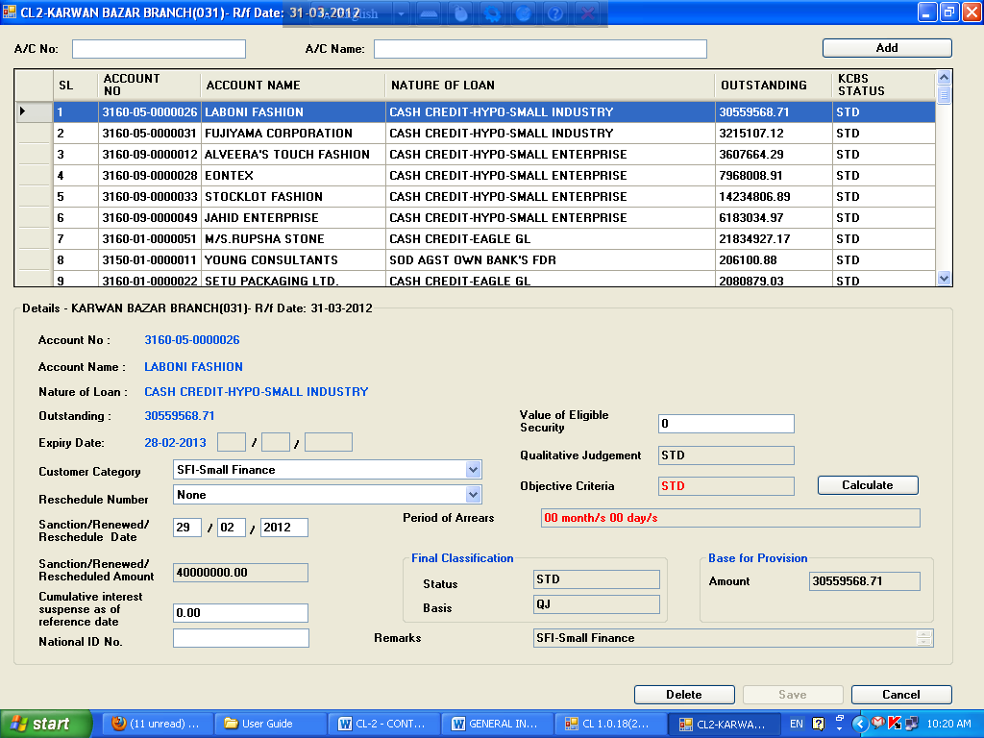

Thereafter user will provide data to the relevant fields and press **‘Calculate’** button. After pressing **‘Calculate’** button data in the following fields will be generated:

1. Period of Arrears
2. Objective Criteria
3. Final Classification a) Status b) Basis
4. Base for provision
5. Remarks

And **‘Save’** button will be enabled.

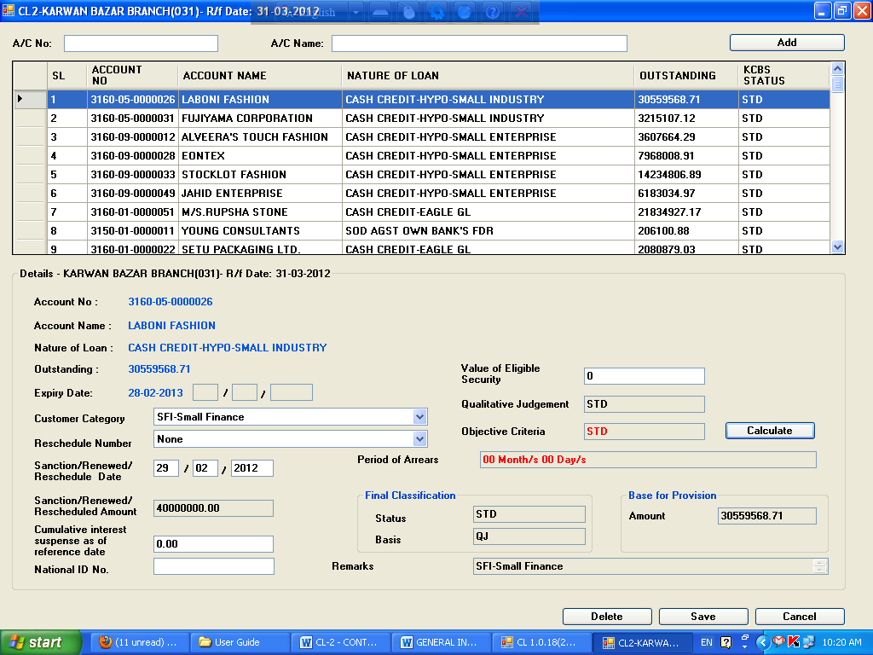

Then by clicking **‘Save’** button, a message will be shown

***‘Do you want to save the change?-Ok/Cancel’***. If user press **‘Ok’** button, data will be saved and stored in the CL database

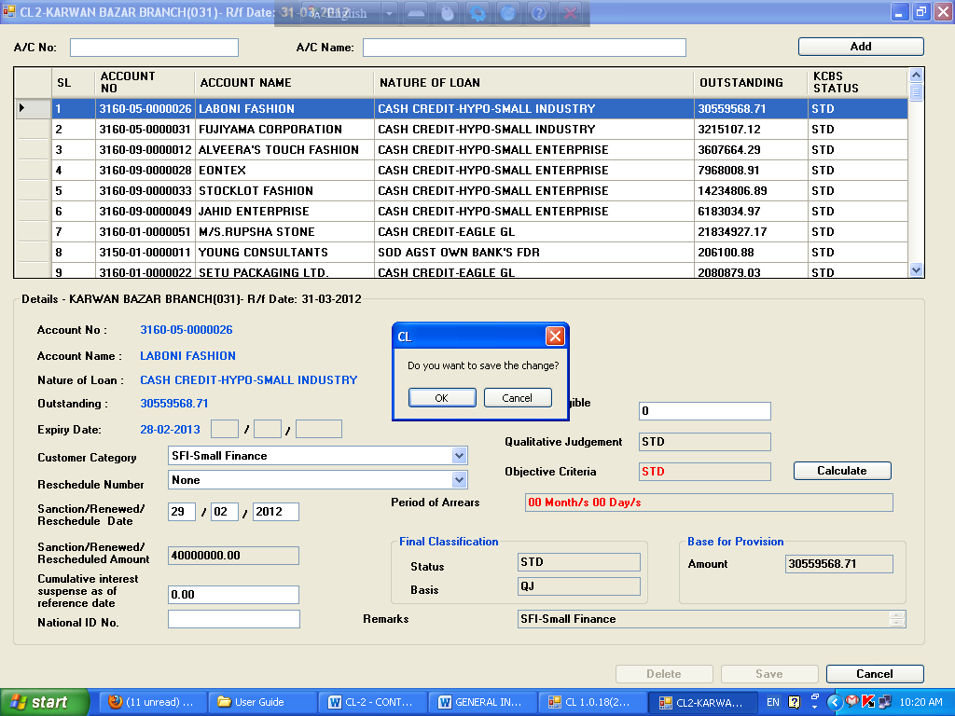

**Update:**

Only saved data can be updated by the user. By double clicking any account in the data grid, a message will be shown ***‘The account is already updated. Do you want to update again?-Yes/No’***. If user press **‘Yes’** button, which is already saved will be fetched under of the data grid box.

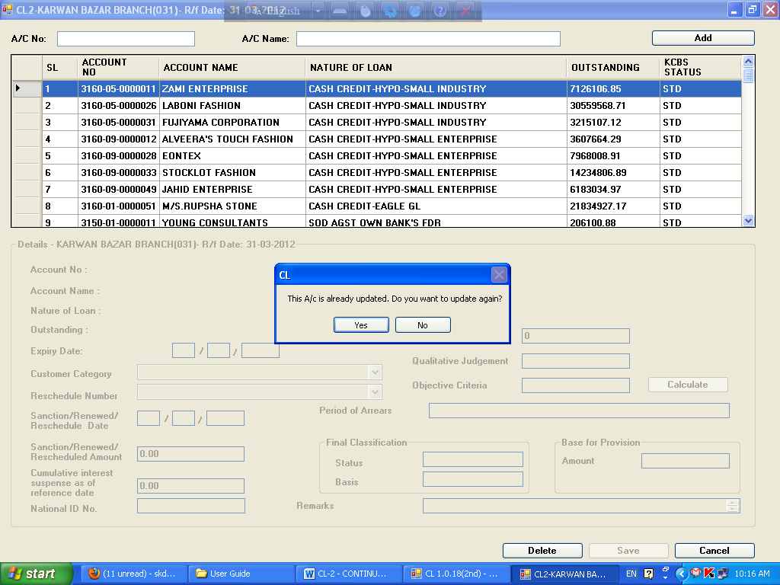

Thereafter user will provide correct data, if any, to the relevant fields and press **‘Calculate’** button.

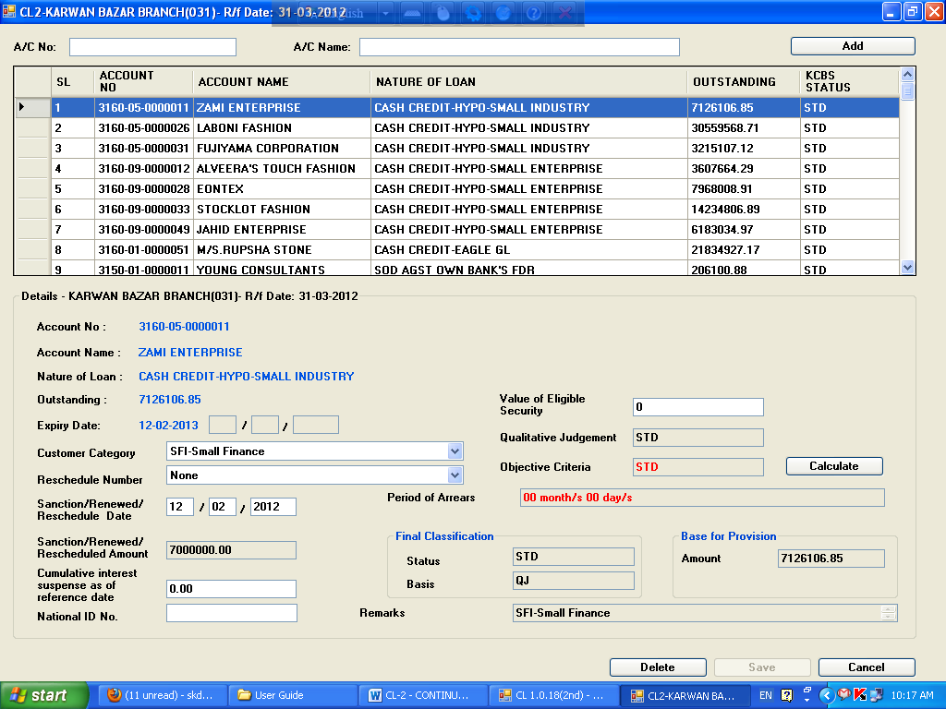

After pressing **‘Calculate’** button date in the following fields will be generate:

1. Period of Arrears
2. Objective Criteria
3. Final Classification a) Status b) Basis
4. Base for provision
5. Remarks

And **‘Save’** button will be enabled.

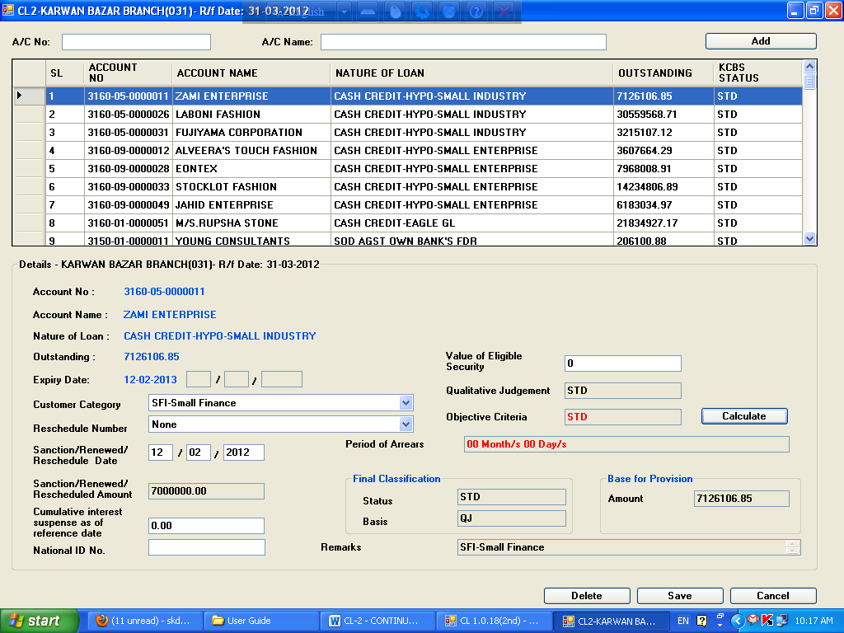

Then by clicking **‘Save’** button, a message will be shown ***‘Do you want to save the change?-Ok/Cancel’***. If user press **‘Ok’** button, data will be saved and stored in the CL database

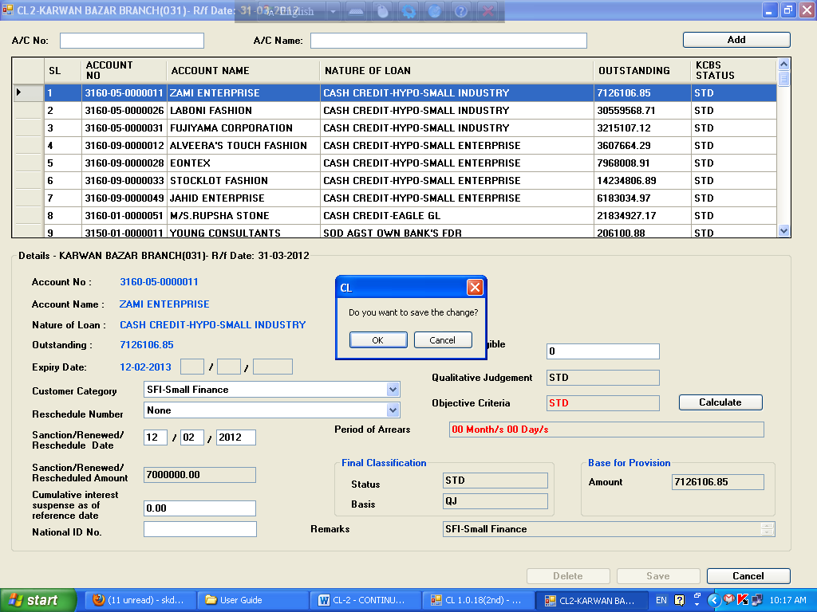

**Delete:**

***Before Update:***

By double clicking any account in the data grid which is already imported or imported through ‘Import Update/Special Import’ option, user can delete any account by double clicking in the data grid, a message will be shown ***‘Do you want to delete-Ok/Cancel’***. If user press **‘Ok’** button, a message will be shown ***‘Data Deleted successfully’***. Then the account will be shifted to ‘Import Update’ and will not consider during generating report.

***After Update:***

By double clicking any account in the data grid which is already updated and stored in the CL database, user can delete any account by double clicking in the data grid; a message will be shown ***‘Do you want to delete-Ok/Cancel’***.

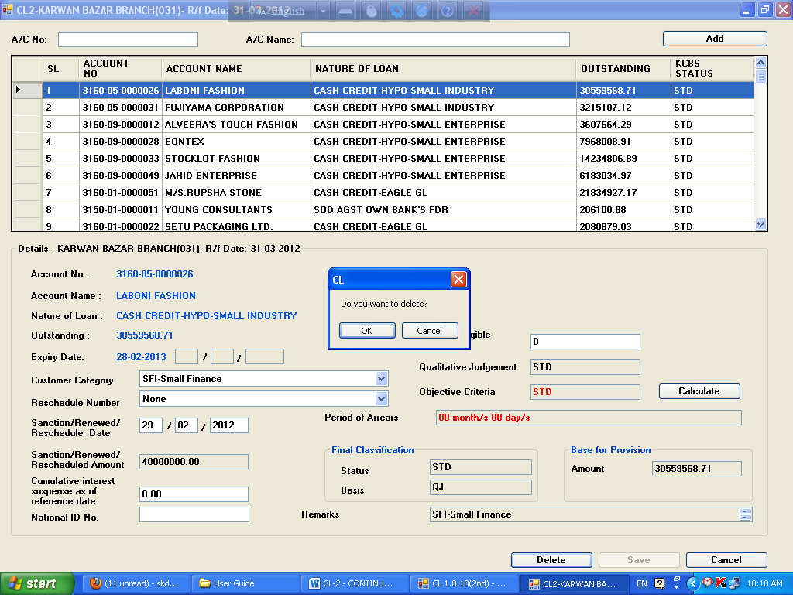

If user presses **‘Ok** button, a message will be shown ***‘Data Deleted successfully’***. Then the account will be shifted to ‘Import Update’ and will not consider during generating report.

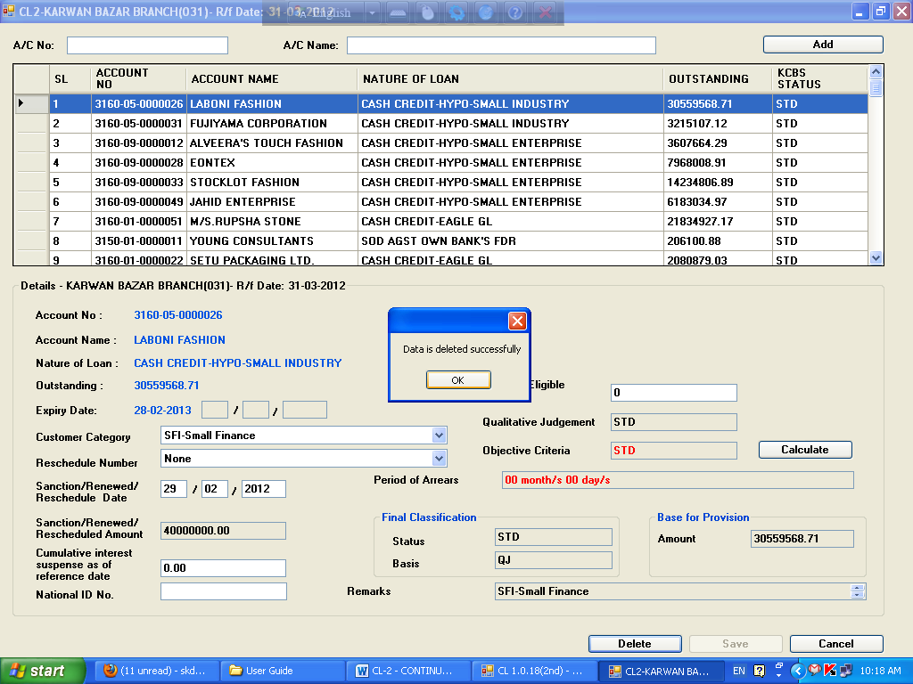

**CL-3 (Demand Loan)**

Under main menu **CL Category**, you will find submenu **CL-3**

**Field description :**

1. **Account No.:** Imported from KCBS
2. **Account Name:** Imported from KCBS
3. **Nature of Loan:** Imported from KCBS according to product name
4. **Outstanding:** Imported from KCBS as on quarter end balance
5. **Expiry date:** Imported from KCBS as on quarter end. **Before quarter end** user can check from Report ‘Balances of Loan Accounts expired for a given date’ and can change through screen nos. 62115, 62120, 10352 (Maturity Date) before quarter end.
6. **Category:** User Input (Select from Drop-Down menu)
7. **Reschedule No.:** User Input (Select from Drop-Down menu)
   1. ***For fresh sanction***: None
   2. ***For rescheduling withoutinterest waiver***
      1. 1st time rescheduling: RS-1
      2. 2nd time rescheduling: RS-2
      3. 3rdtime rescheduling: RS-3
   3. ***For rescheduling withinterest waiver***
      1. 1st time rescheduling: RSIW-1
      2. 2nd time rescheduling: RSIW-2
      3. 3rd time rescheduling: RSIW-3
8. **Sanctioned/Renewed/Rescheduled Date:** User Input
9. **Sanctioned/Renewed/Rescheduled Amount:** Imported from KCBS as on quarter end. For Loan-Approved amount (i.e. Consultation Amount). Once Loan A/c is created user cannot change Sanctioned/Renewed/Rescheduled Amount.
10. **Cumulative Interest Suspense:** User input should be matched with KCBS
11. **National ID No.:** Mandatory for account of Individual
    1. ***Imported from KCBS:*** National ID is required for Individual Customer only. For existing customer User can update it vide KCBS screen No.61200 (Modification of Customer Information)-under Tab name (**Personal Information 2**) - in the field name '**Add. Proof of ID1/2/3**', please select code **1003 (National ID Card)**.

Or,

* 1. ***User Input:*** User can input either 13 or 17 digits, which is applicable, if not found in KCBS database.

1. **Value of Eligible Security:** User input
2. **Qualitative Judgement (QJ) :** Imported from KCBS as on quarter end

User can check NPA status from Report (**Status wise account list – CCOD/Loan accounts)** and mark/unmark NPA in KCBS through screen no.10601 **before quarter end**.

1. **Period of Arrears:** After given above data Software will calculate on the basis of methodology.
2. **Objective Criteria (OB):** Software will determine OB status of the account on the basis of ‘Period of Arrears’.
3. **Final Classification:** Higher between OB and QJ.
4. **Base for Provision:** After given above data Software will calculate.
5. **Remarks:** Customer Category selected above

**Entry in the CL database:**

By double clicking any account in the data grid which is already imported or imported through ‘Import Update’ option, will be fetched under the data grid box with already data imported from KCBS.

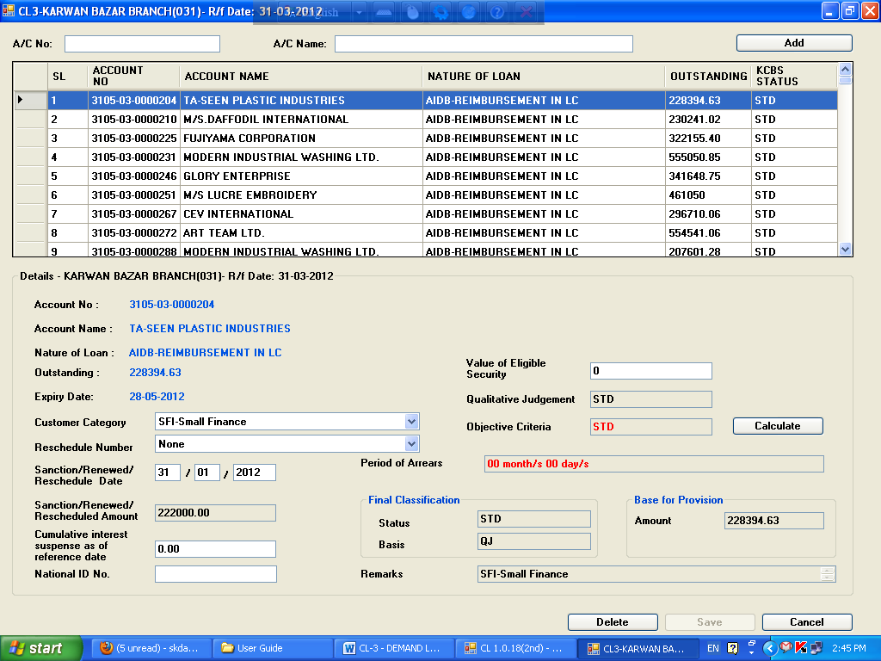

Thereafter user will provide data to the relevant fields and press **‘Calculate’** button. After pressing **‘Calculate’** button data in the following fields will be generated:

1. Period of Arrears
2. Objective Criteria
3. Final Classification a) Status b) Basis
4. Base for provision
5. Remarks

And **‘Save’** button will be enabled.

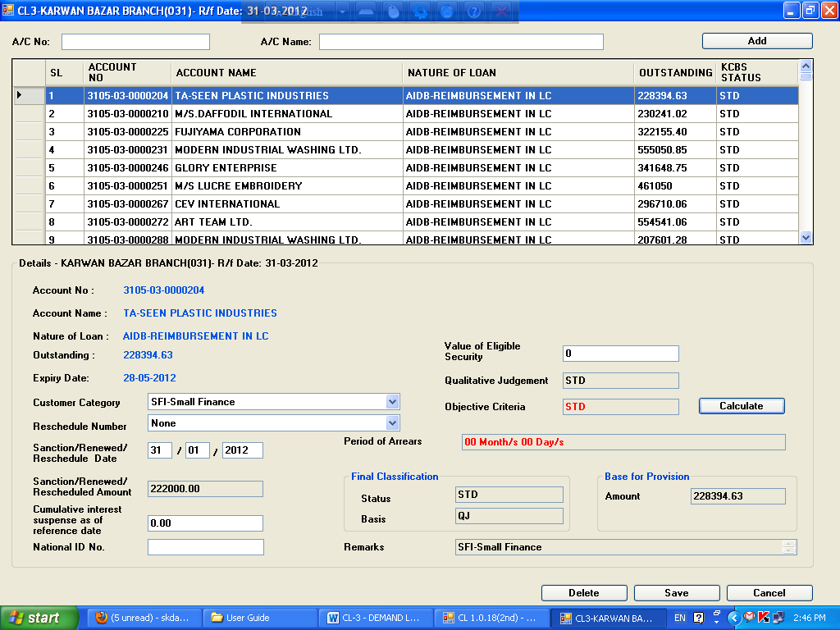

Then by clicking **‘Save’** button data, a message will be shown ***‘Do you want to save the change?-Ok/Cancel’***. If user press **‘Ok’** button, will be saved and stored in the CL database

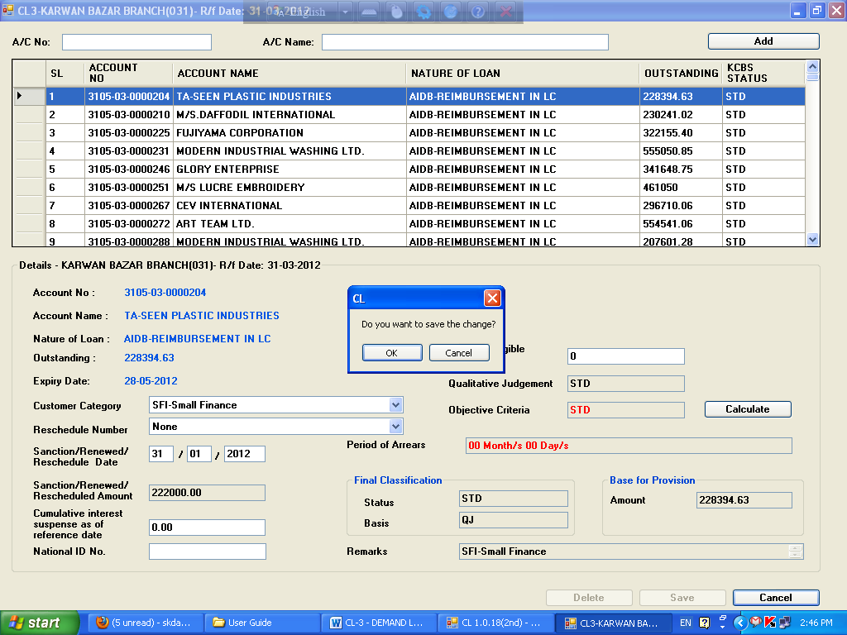

**Update:**

Only saved data can be updated by the user. By double clicking any account in the data grid, a message will be shown ***‘The account is already updated. Do you want to update again?-Yes/No’***. If user press **‘Yes’** button, which is already saved will be fetched under of the data grid box.

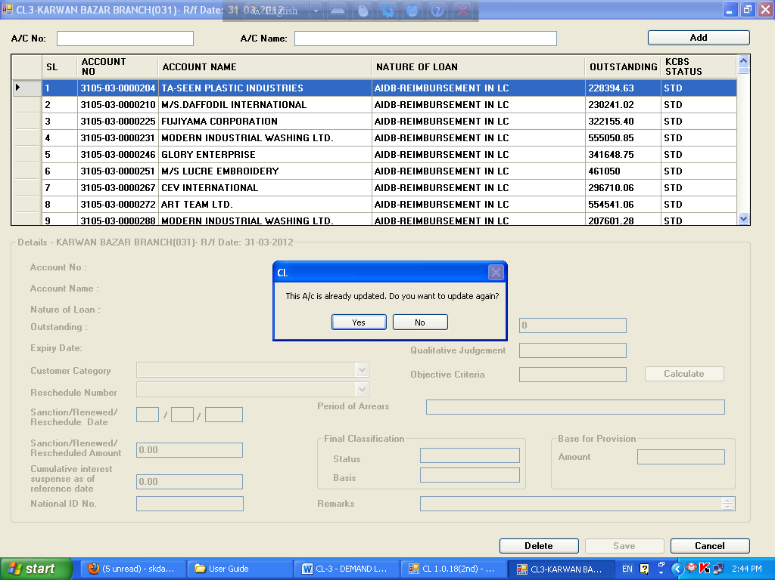

Thereafter user will provide correct data, if any, to the relevant fields and press **‘Calculate’** button.



After pressing **‘Calculate’** button date in the following fields will be generate:

1. Period of Arrears
2. Objective Criteria
3. Final Classification a) Status b) Basis
4. Base for provision
5. Remarks

And **‘Save’** button will be enabled.



Then by clicking **‘Save’** button, a message will be shown ***‘Do you want to save the change?-Ok/Cancel’***. If user press **‘Ok’** button, data will be saved and stored in the CL database



**Delete:**

***Before Update:***

By double clicking any account in the data grid which is already imported or imported through ‘Import Update/Special Import’ option, user can delete any account by double clicking in the data grid, a message will be shown ***‘Do you want to delete-Ok/Cancel’***. If user press **‘Ok’** button, a message will be shown ***‘Data Deleted successfully’***. Then the account will be shifted to ‘Import Update’ and will not consider during generating report.

***After Update:***

By double clicking any account in the data grid which is already updated and stored in the CL database, user can delete any account by double clicking in the data grid; a message will be shown ***‘Do you want to delete-Ok/Cancel’***.

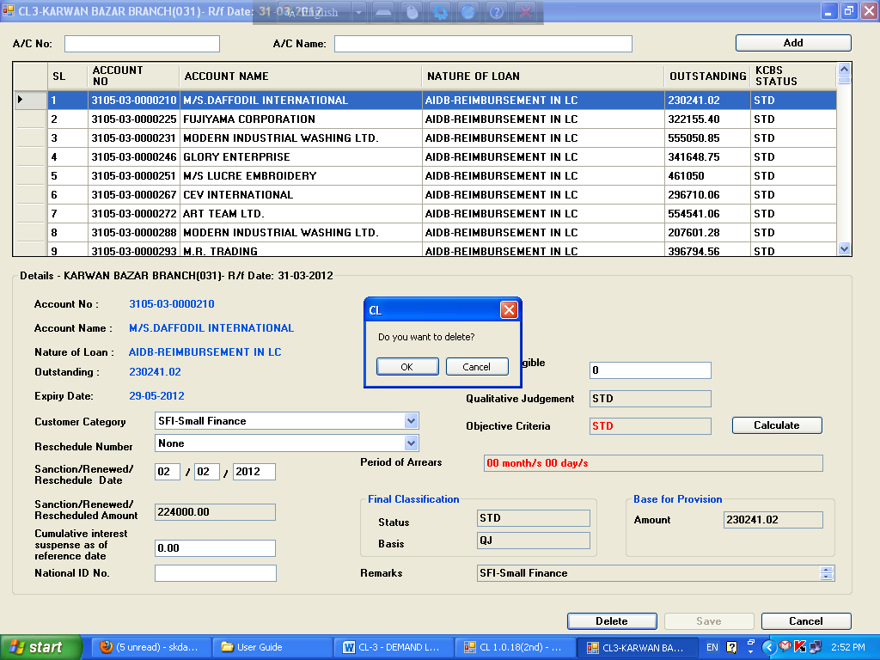

If user presses **‘Ok** button, a message will be shown ***‘Data Deleted successfully’***. Then the account will be shifted to ‘Import Update’ and will not consider during generating report.

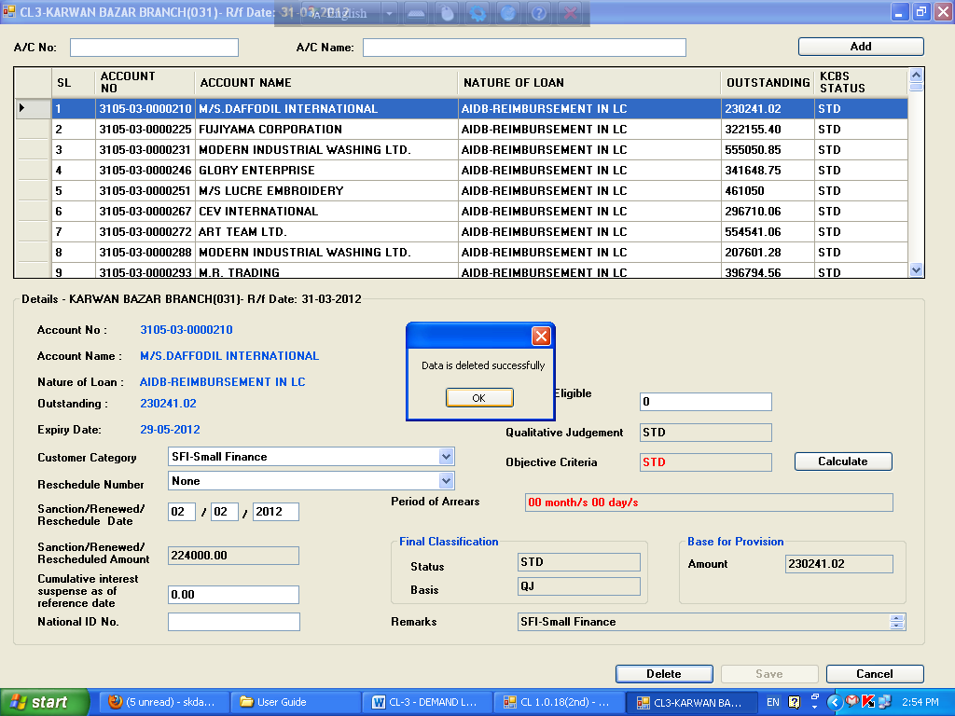

**CL-4: TERM LOAN (UPTO 5 YEARS)**

Under main menu **CL Category**, you will find submenu **CL-4**

**Field description:**

1. **Account No.:** Imported from KCBS
2. **Account Name:** Imported from KCBS
3. **Nature of Loan:** Imported from KCBS according to product name
4. **Outstanding:** Imported from KCBS as on quarter end balance
5. **Expiry date:** Imported from KCBS as on quarter end. **Before quarter end** user can check from Report ‘Balances of Loan Accounts expired for a given date’ and can change through screen nos. 62115, 62120, 10352 (Maturity Date) before quarter end.
6. **Customer Category:** User Input (Select from Drop-Down menu)
7. **Reschedule No.:** User Input (Select from Drop-Down menu)
   1. ***For fresh sanction***: None
   2. ***For rescheduling without interest waiver***
      1. 1st time rescheduling: RS-1
      2. 2nd time rescheduling: RS-2
      3. 3rdtime rescheduling: RS-3
   3. ***For rescheduling with interest waiver***
      1. 1st time rescheduling: RSIW-1
      2. 2nd time rescheduling: RSIW-2
      3. 3rd time rescheduling: RSIW-3
8. **Sanctioned/Renewed/Rescheduled Date:** User Input
9. **Sanctioned/Renewed/Rescheduled Amount:** Imported from KCBS as on quarter end.

For Loans - approved amount (i.e. Consultation Amount). Once Loan A/c is created in KCBS, user cannot change Sanctioned/Renewed/Rescheduled Amount in CL Software.

1. **Installment Size:** User Input
2. **Installment frequency:** User Input (i.e. Monthly/Quarterly/Half-Yearly/Yearly or N/A)
3. **Date of 1st repayment due:** User Input
4. **Amount paid Since Sanctioning/Last Rescheduling:** User Input
5. **Cumulative Interest Suspense:** User input but matched with KCBS
6. **Value of Eligible Security:** User input
7. **National ID No.:** Mandatory for account of individuals only
   1. ***Imported from KCBS:*** National ID is required for Individual Customer only. For existing customer User can update it vide KCBS screen No.61200 (Modification of Customer Information)-under Tab name (**Personal Information 2**) - in the field name '**Add. Proof of ID1/2/3**', please select code **1003 (National ID Card)**.

Or,

* 1. ***User Input:*** User can input either 13 or 17 digits, which is applicable, if not found in KCBS database.

1. Period since 1st Repayment Due: After given above data Software will calculate.
2. **Time equivalent of amount paid:** After given above data Software will calculate.
3. **Qualitative Judgement (QJ):** Imported from KCBS as on quarter end.

User can check NPA status from Report (**Status wise account list – CCOD/Loan accounts)** and mark/unmark NPA in KCBS through screen no.10601 **before quarter end**.

1. **Objective Criteria (OB):** Software will determine OB status of the account on the basis of ‘Period of Arrears’.
2. **Period of Arrears:** After input of above data Software will calculate on the basis of methodology.
3. **Final Classification:** Higher between OB and QJ.
4. **Base for Provision:** After input of above data Software will calculate.
5. **Remarks:** Customer Category selected above.

**Entry in the CL database:**

By double clicking any account in the data grid which is already imported or imported through ‘Import Update/Special Import’ option, will be fetched under the data grid box with already data imported from KCBS.

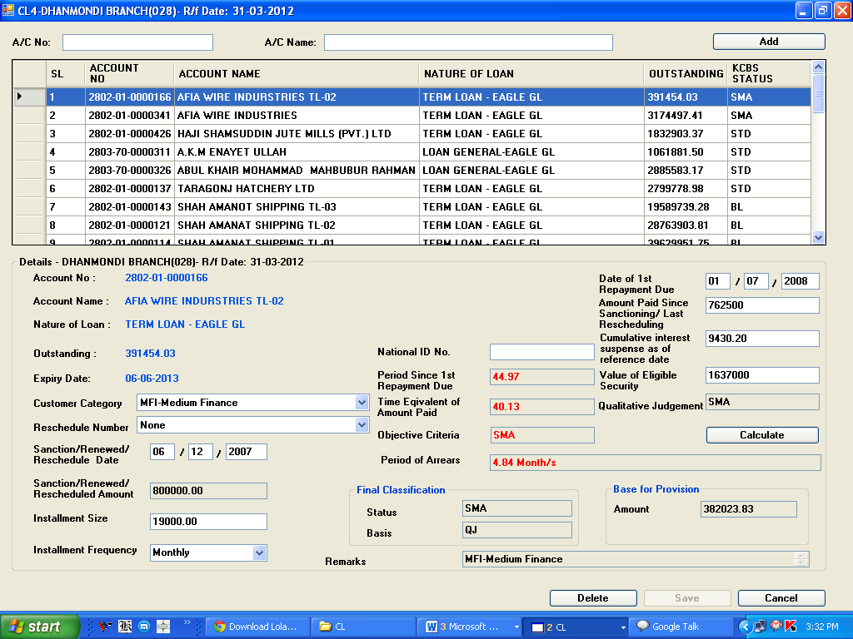

Thereafter user will provide data to the relevant fields and press **‘Calculate’** button. After pressing **‘Calculate’** button data in the following fields will be generated:

* Period of Arrears
* Objective Criteria
* Final Classification a) Status b) Basis
* Base for provision
* Remarks

And **‘Save’** button will be enabled.

Then by clicking **‘Save’** button data, a message will be shown ***‘Do you want to save the change?-OK/Cancel’***. If user presses **‘OK’** button, data will be saved and stored in the CL database.

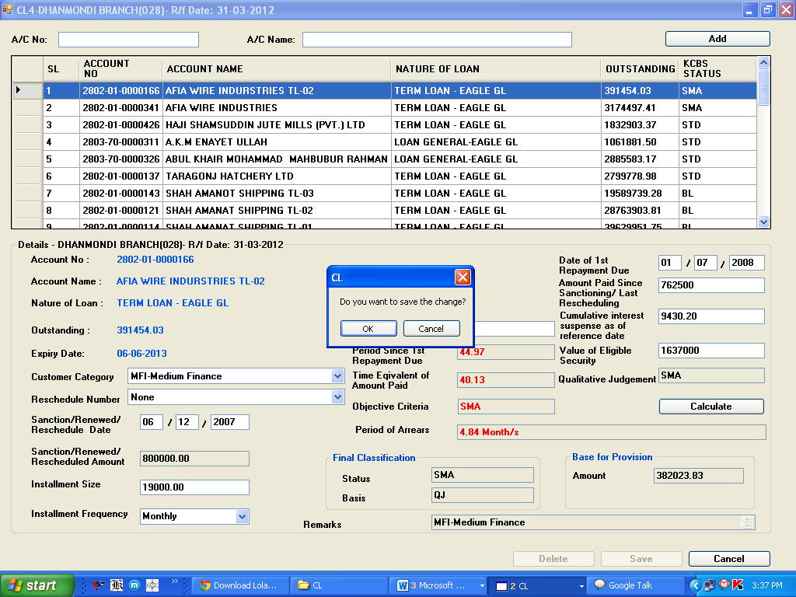

**Update:**

Only saved data can be updated by the user. By double clicking any account in the data grid, a message will be shown ***‘The account already updated. Do you update again?-Yes/No’***. If user press **‘Yes’** button, which is already saved will be fetched under of the data grid box.

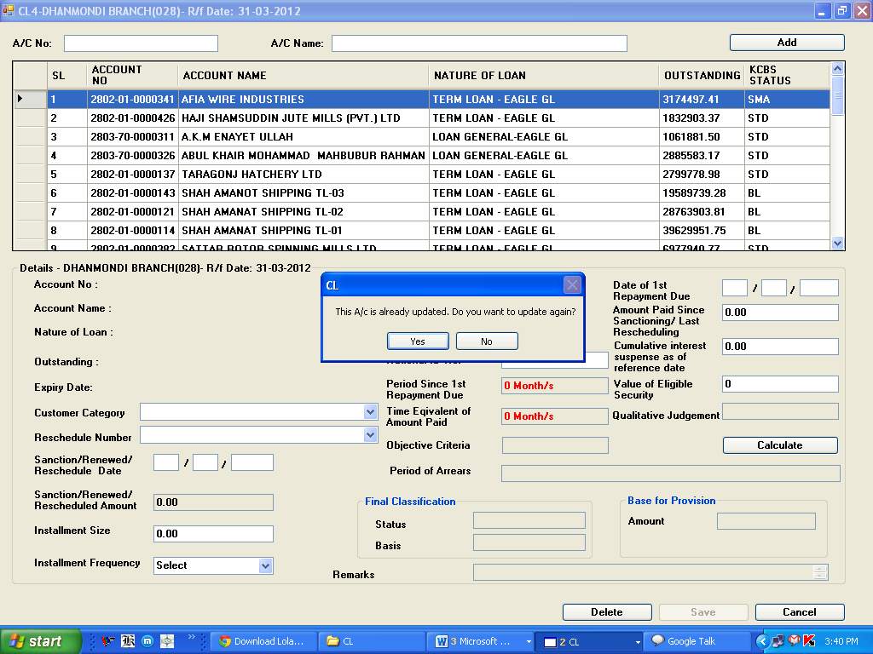

Thereafter user will provide correct data, if any, to the relevant fields and press **‘Calculate’** button. After pressing **‘Calculate’** button data in the following fields will be generated:

* Period of Arrears
* Objective Criteria
* Final Classification a) Status b) Basis
* Base for provision
* Remarks

And **‘Save’** button will be enabled.

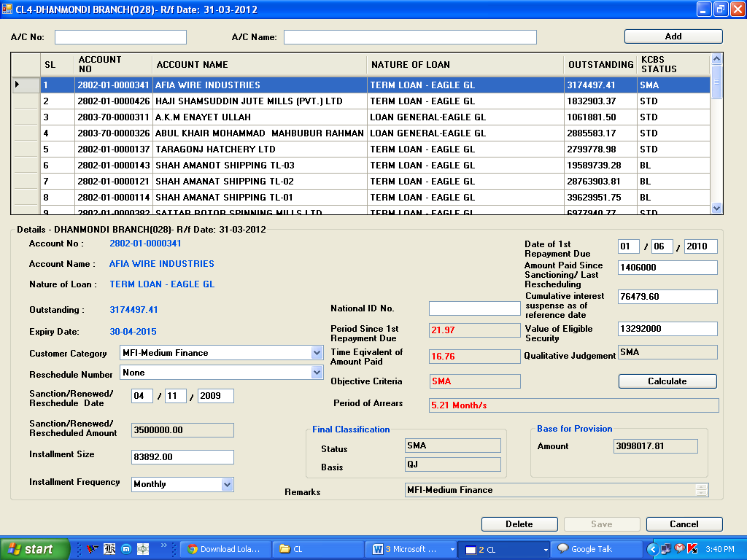

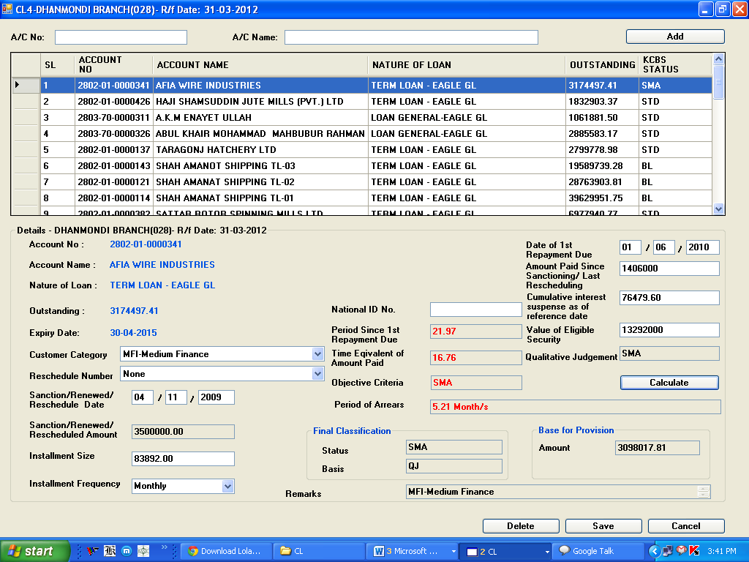

Then by clicking **‘Save’** button, a message will be shown ***‘Do you want to save the change?-Ok/Cancel’***. If user presses **‘Yes’** button, data will be saved and stored in the CL database.

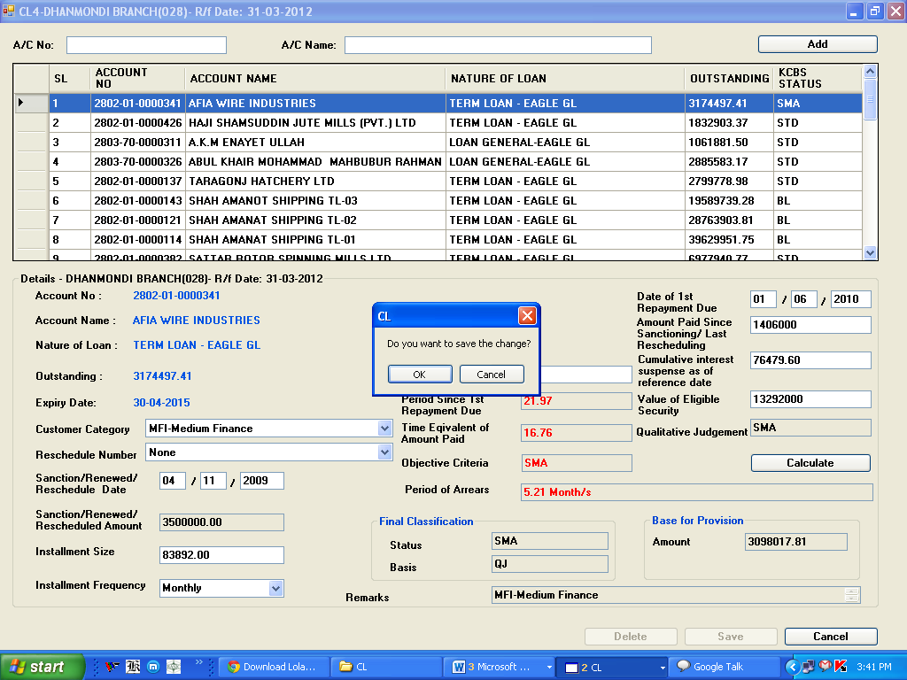

**Delete:**

***Before Update:***

By double clicking any account in the data grid which is already imported or imported through ‘Import Update/Special Import’ option, user can delete any account by double clicking in the data grid, a message will be shown ***‘Do you want to delete-Yes/No’***. If user press **‘Yes’** button, a message will be shown ***‘Deleted successfully’***. Then the account will be shifted to ‘Import Update’ and will not consider during generating report.

***After Update:***

By double clicking any account in the data grid which is already updated and stored in the CL database, user can delete any account by double clicking in the data grid; a message will be shown ***‘Do you want to delete-Ok/Cancel’***.

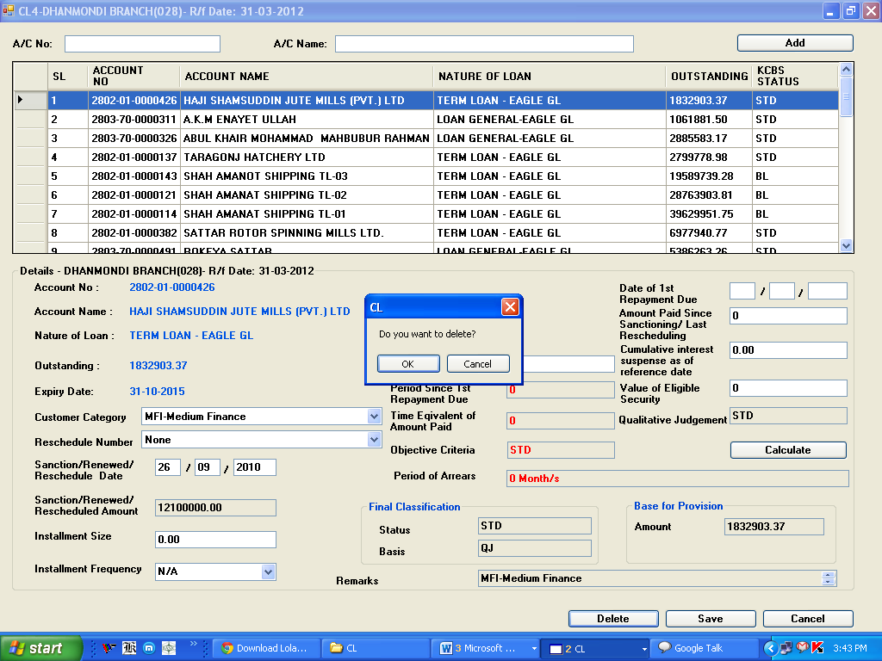

If user press **‘Ok’** button, a message will be shown ***‘Deleted successfully’***. Then the account will be shifted to ‘Import Update’ and will not consider during generating report.

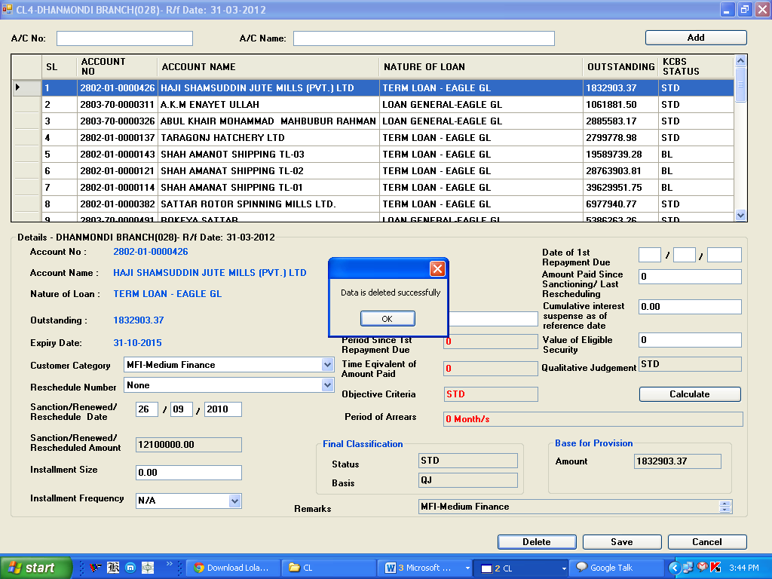

**Un-delete/Import Update:**

If the user wants to un-delete (Undo a delete operation) any account, He/she will go to menu: CL IMPORT -> submenu: Import Update. The list of deleted/un-imported accounts will be shown here.

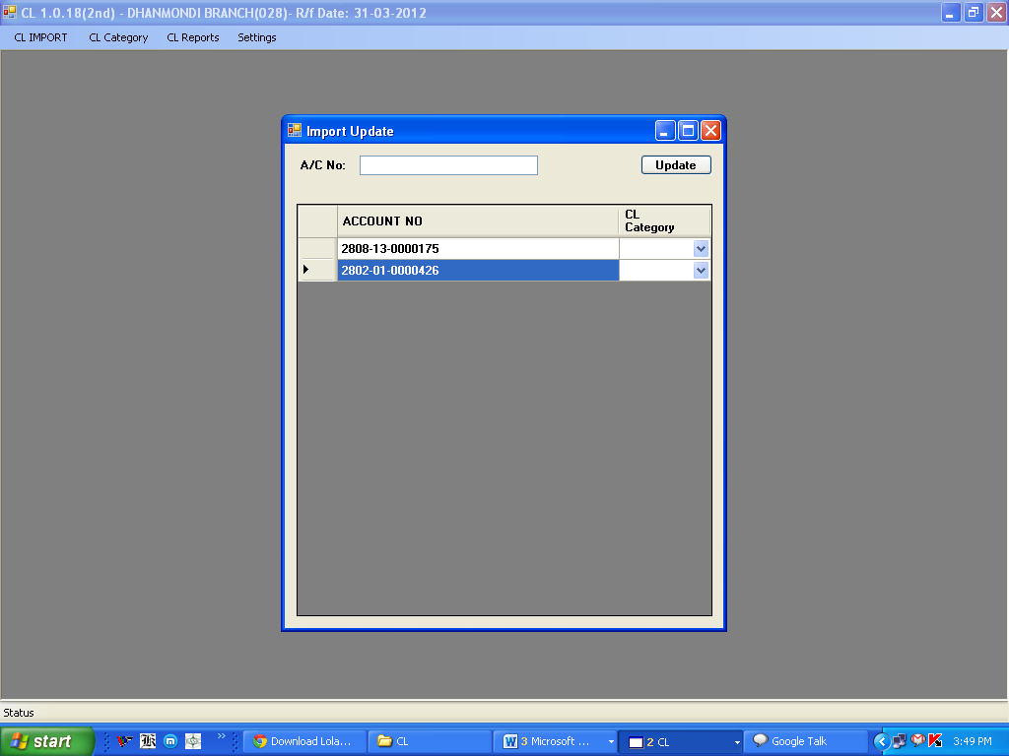

The user can then find (by account number) the account he/she wants to un-delete and then select the CL Category (i.e. 1, 2, 3, 4, 5, S) to which the account is to be imported and then press the Update button:

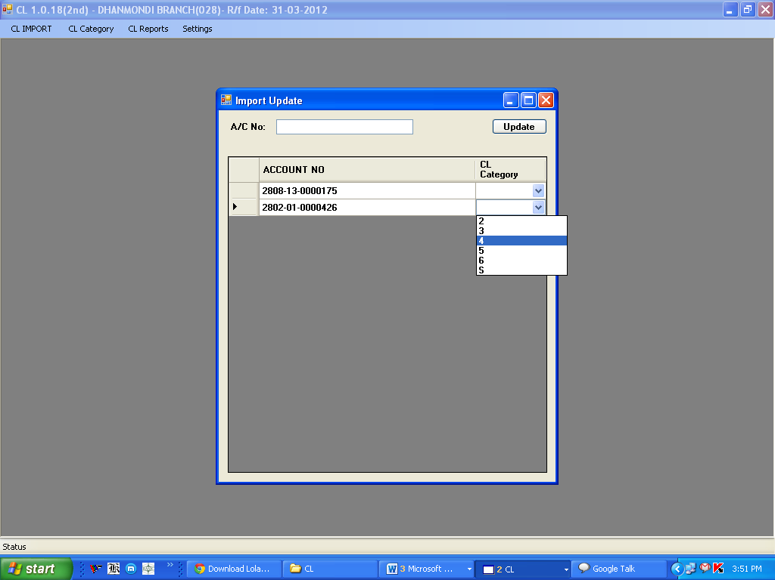

A message box will appear showing that update (import) is successful.

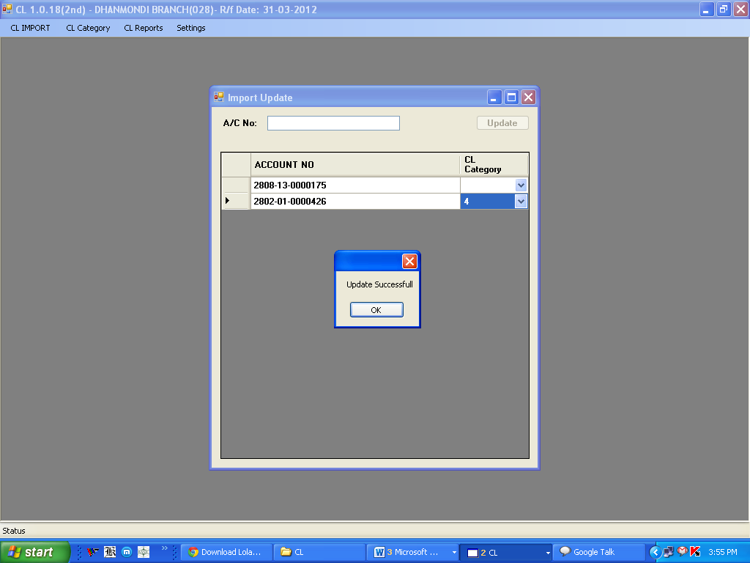

Subsequently, that account will be removed from this list (Import Update).

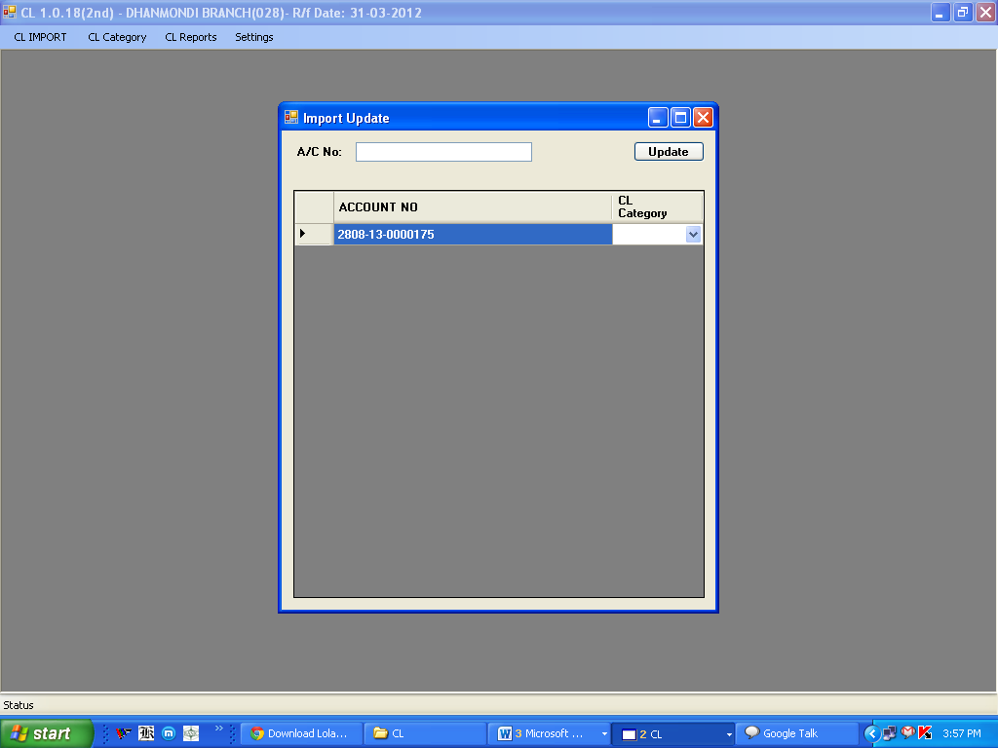

**CL-5: TERM LOAN (MORE THAN 5 YEARS)**

Under main menu **CL Category**, you will find submenu **CL-5**

**Field description:**

1. **Account No.:** Imported from KCBS
2. **Account Name:** Imported from KCBS
3. **Nature of Loan:** Imported from KCBS according to product name
4. **Outstanding:** Imported from KCBS as on quarter end balance
5. **Expiry date:** Imported from KCBS as on quarter end. **Before quarter end** user can check from Report ‘Balances of Loan Accounts expired for a given date’ and can change through screen nos. 62115, 62120, 10352 (Maturity Date) before quarter end.
6. **Customer Category:** User Input (Select from Drop-Down menu)
7. **Reschedule No.:** User Input (Select from Drop-Down menu)
   1. ***For fresh sanction***: None
   2. ***For rescheduling without interest waiver***
      1. 1st time rescheduling: RS-1
      2. 2nd time rescheduling: RS-2
      3. 3rdtime rescheduling: RS-3
   3. ***For rescheduling with interest waiver***
      1. 1st time rescheduling: RSIW-1
      2. 2nd time rescheduling: RSIW-2
      3. 3rd time rescheduling: RSIW-3
8. **Sanctioned/Renewed/Rescheduled Date:** User Input
9. **Sanctioned/Renewed/Rescheduled Amount:** Imported from KCBS as on quarter end.

For Loans - approved amount (i.e. Consultation Amount). Once Loan A/c is created in KCBS, user cannot change Sanctioned/Renewed/Rescheduled Amount in CL Software.

1. **Installment Size:** User Input
2. **Installment frequency:** User Input (i.e. Monthly/Quarterly/Half-Yearly/Yearly or N/A)
3. **Date of 1st repayment due:** User Input
4. **Amount paid Since Sanctioning/Last Rescheduling:** User Input
5. **Cumulative Interest Suspense:** User input but matched with KCBS
6. **Value of Eligible Security:** User input
7. **National ID No.:** Mandatory for account of individuals only
   1. ***Imported from KCBS:*** National ID is required for Individual Customer only. For existing customer User can update it vide KCBS screen No.61200 (Modification of Customer Information)-under Tab name (**Personal Information 2**) - in the field name '**Add. Proof of ID1/2/3**', please select code **1003 (National ID Card)**.

Or,

* 1. ***User Input:*** User can input either 13 or 17 digits, which is applicable, if not found in KCBS database.

1. Period Since 1st Repayment Due: After given above data Software will calculate.
2. **Time equivalent of amount paid:** After given above data Software will calculate.
3. **Qualitative Judgement (QJ):** Imported from KCBS as on quarter end.

User can check NPA status from Report (**Status wise account list – CCOD/Loan accounts)** and mark/unmark NPA in KCBS through screen no.10601 **before quarter end**.

1. **Objective Criteria (OB):** Software will determine OB status of the account on the basis of ‘Period of Arrears’.
2. **Period of Arrears:** After input of above data Software will calculate on the basis of methodology.
3. **Final Classification:** Higher between OB and QJ.
4. **Base for Provision:** After input of above data Software will calculate.
5. **Remarks:** Customer Category selected above.

**Entry in the CL database:**

By double clicking any account in the data grid which is already imported or imported through ‘Import Update/Special Import’ option, will be fetched under the data grid box with already data imported from KCBS.

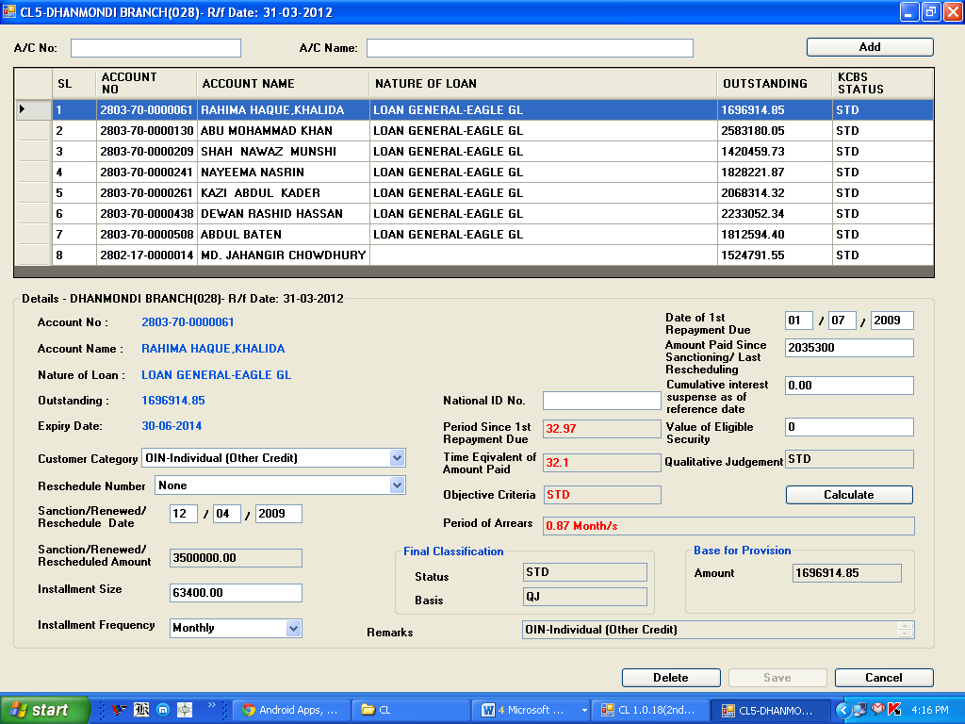

Thereafter user will provide data to the relevant fields and press **‘Calculate’** button. After pressing **‘Calculate’** button, data in the following fields will be generated:

* Period of Arrears
* Objective Criteria
* Final Classification a) Status b) Basis
* Base for provision
* Remarks

And **‘Save’** button will be enabled.

Then by clicking **‘Save’** button data, a message will be shown ***‘Do you want to save the change?-OK/Cancel’***. If user presses **‘OK’** button, data will be saved and stored in the CL database.

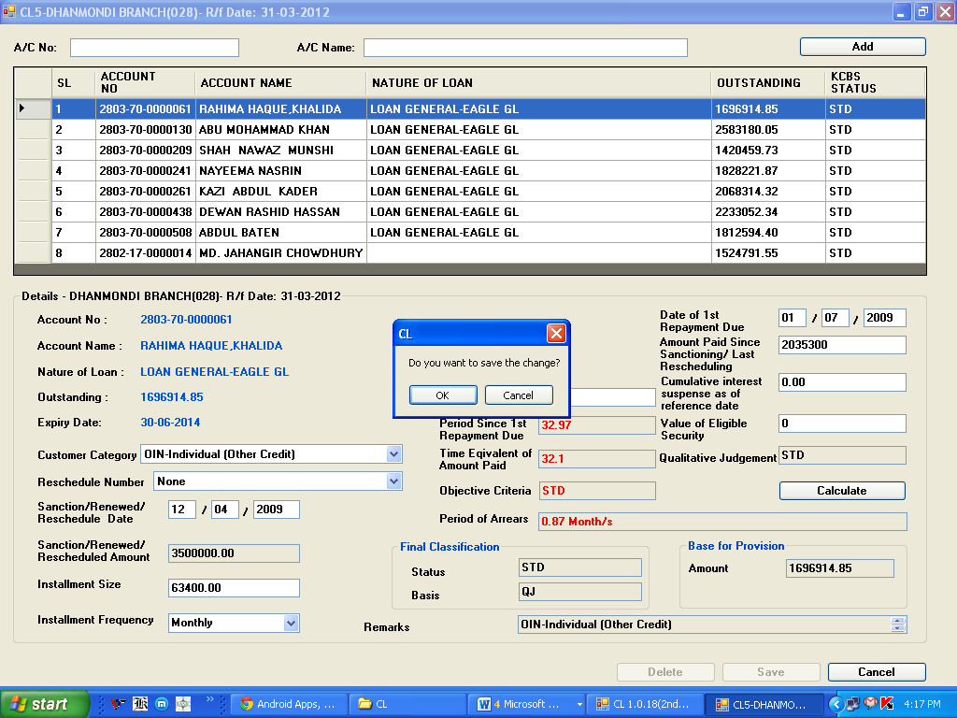

**Update:**

Only saved data can be updated by the user. By double clicking any account in the data grid, a message will be shown ***‘The account already updated. Do you update again?-Yes/No’***. If user press **‘Yes’** button, which is already saved will be fetched under of the data grid box.

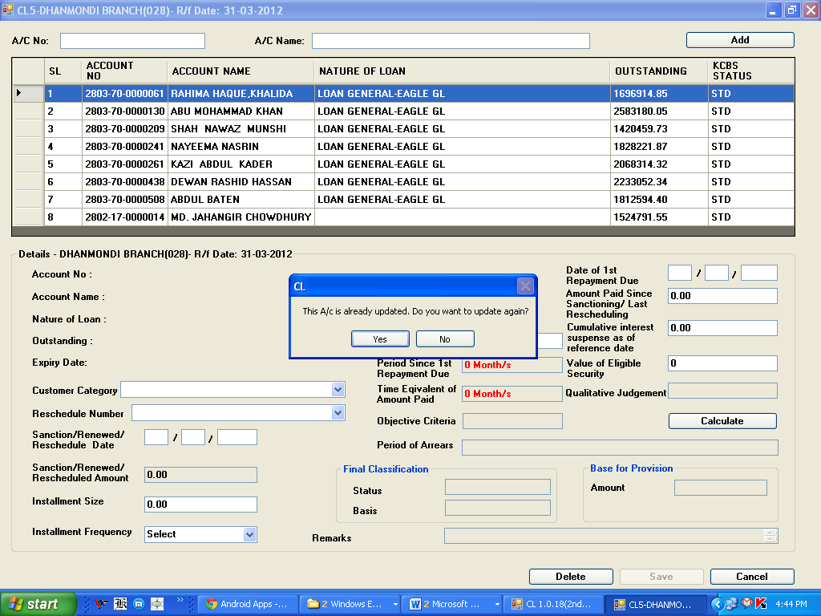

Thereafter user will provide correct data, if any, to the relevant fields and press **‘Calculate’** button. After pressing **‘Calculate’** button, data in the following fields will be generated:

* Period of Arrears
* Objective Criteria
* Final Classification a) Status b) Basis
* Base for provision
* Remarks

And **‘Save’** button will be enabled.

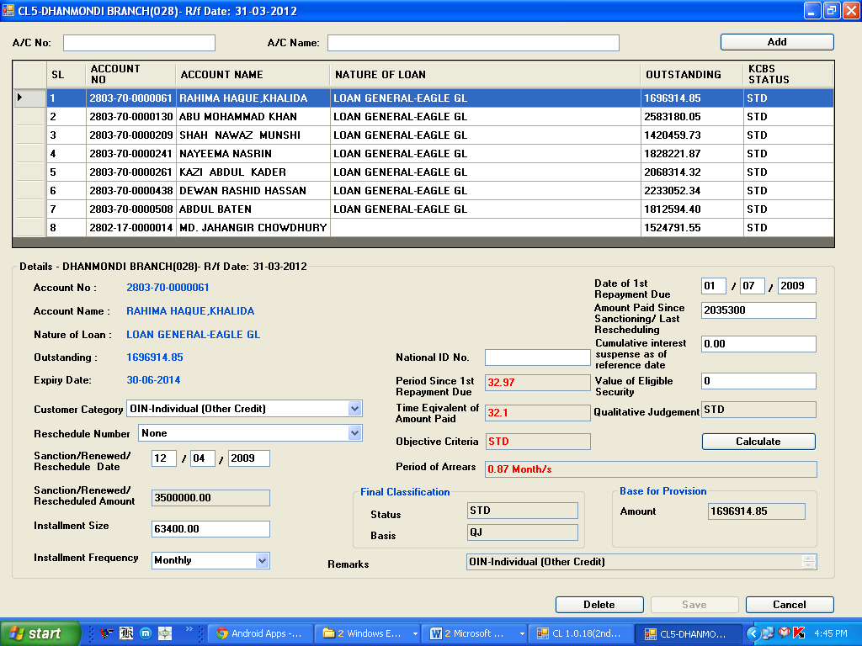

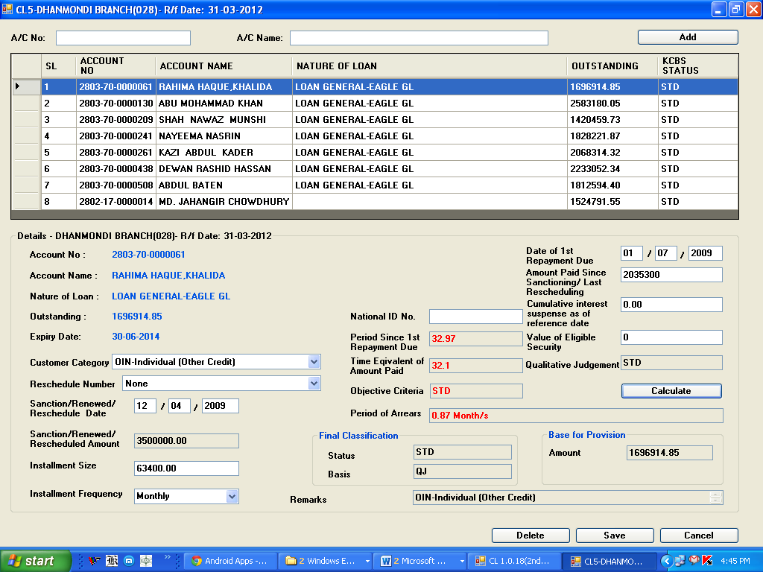

Then by clicking **‘Save’** button, a message will be shown ***‘Do you want to save the change?-Ok/Cancel’***. If user press **‘Yes’** button, data will be saved and stored in the CL database

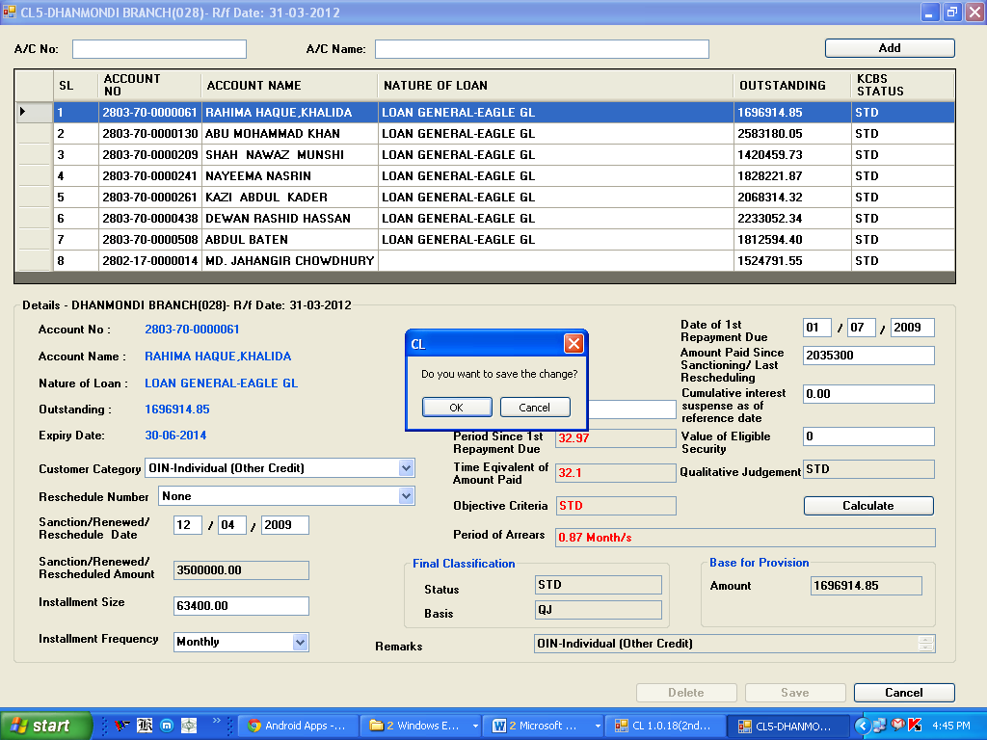

**Delete:**

***Before Update:***

By double clicking any account in the data grid which is already imported or imported through ‘Import Update/Special Import’ option, user can delete any account by double clicking in the data grid, a message will be shown ***‘Do you want to delete?-Yes/No’***. If user press **‘Yes’** button, a message will be shown ***‘Deleted successfully’***. Then the account will be shifted to ‘Import Update’ and will not consider during generating report.

***After Update:***

By double clicking any account in the data grid which is already updated and stored in the CL database, user can delete any account by double clicking in the data grid; a message will be shown ***‘Do you want to delete?-Ok/Cancel’***.

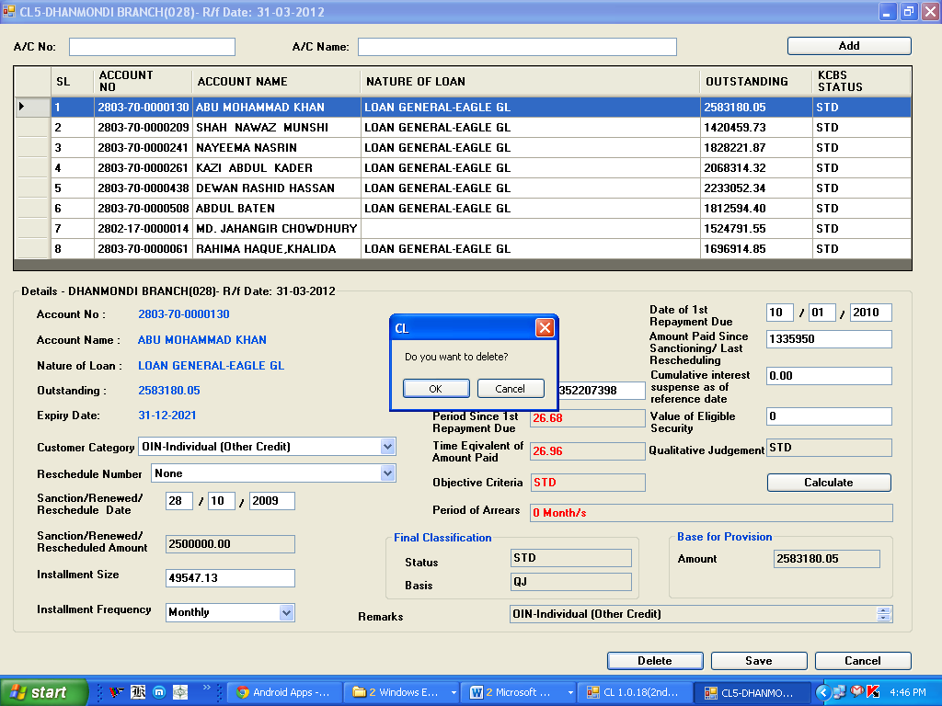

If user press **‘Ok’** button, a message will be shown ***‘Deleted successfully’***. Then the account will be shifted to ‘Import Update’ and will not consider during generating report.

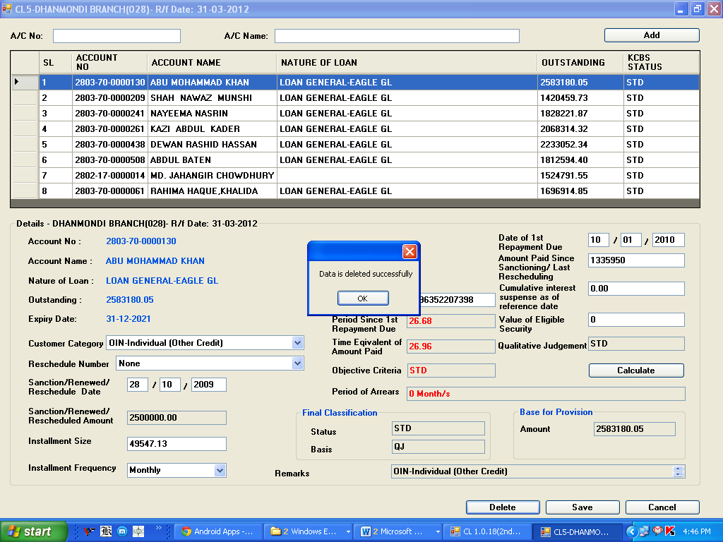

**Un-delete/Import Update:**

If the user wants to un-delete (Undo a delete operation) any account, He/she will go to menu: CL IMPORT -> submenu: Import Update. The list of deleted/un-imported accounts will be shown here.

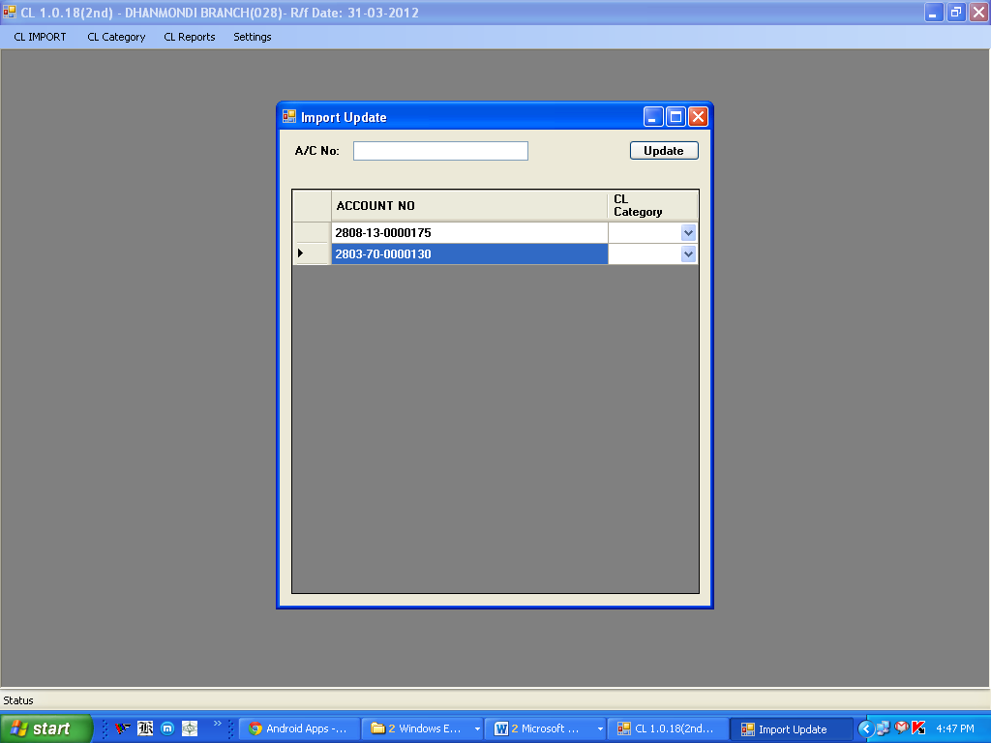

The user can then find (by account number) the account he/she wants to un-delete and then select the CL Category (i.e. 1, 2, 3, 4, 5, S) to which the account is to be imported and then press the Update button:

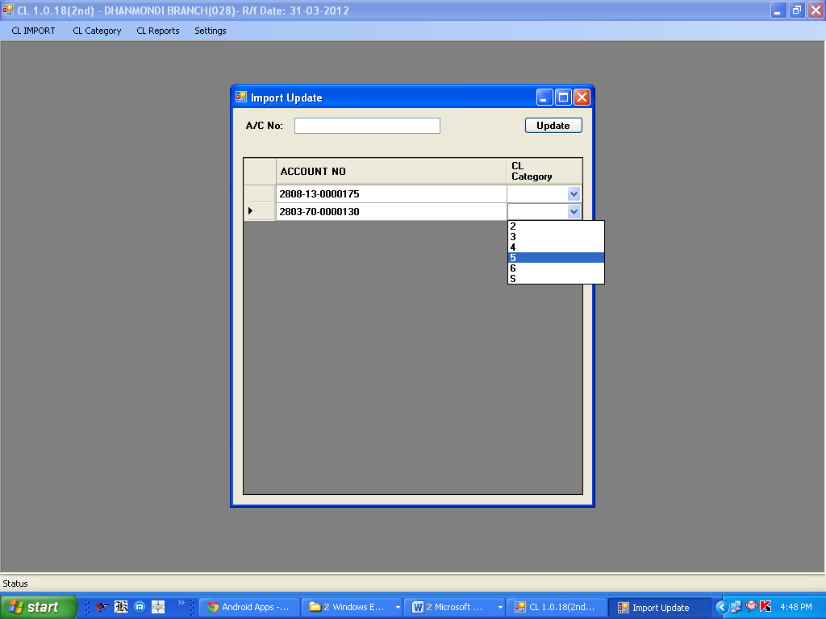

A message box will appear showing that update (import) is successful.

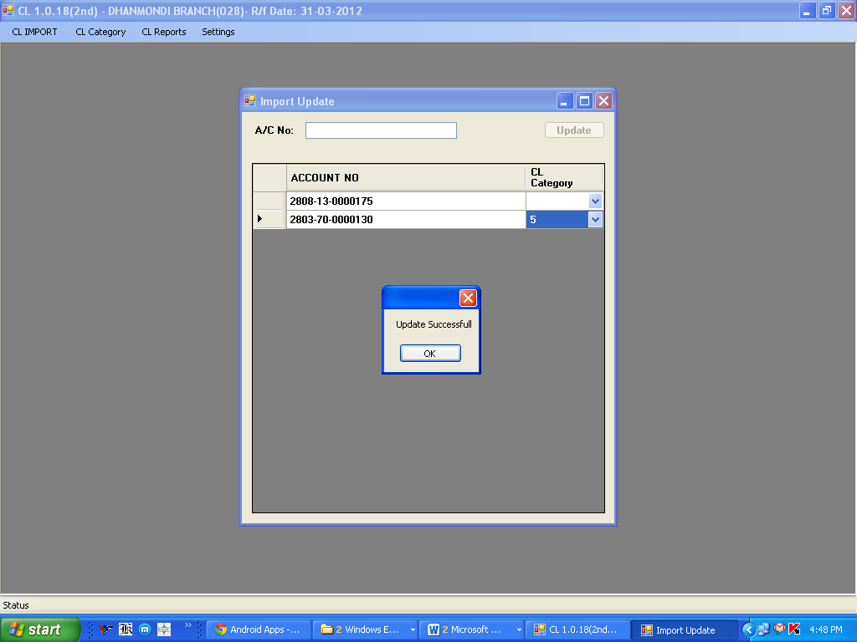

Subsequently, that account will be removed from this list (Import Update).

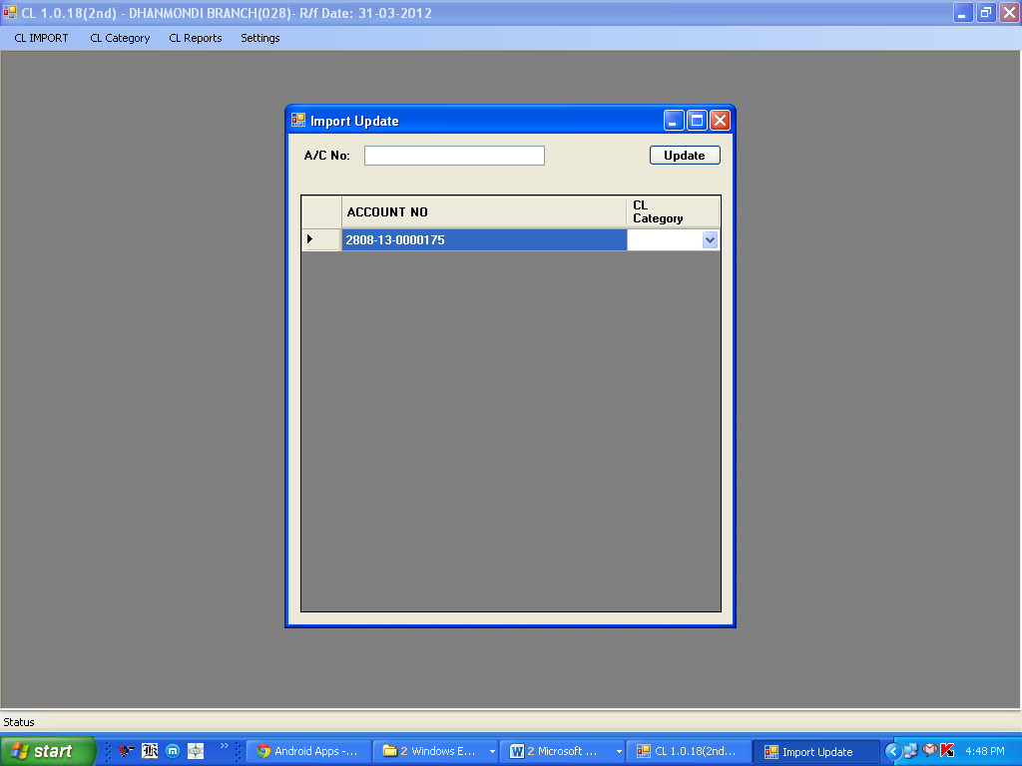

**CL-6 (Short-term Agricultural/Micro Credit)**

Under main menu **CL Category**, you will find submenu **CL-6**

**Field description :**

1. **Account No.:** Imported from KCBS
2. **Account Name:** Imported from KCBS
3. **Nature of Loan:** Imported from KCBS according to product name
4. **Outstanding:** Imported from KCBS as on quarter end balance
5. **Expiry date:** Imported from KCBS as on quarter end. **Before quarter end** user can check from Report ‘Balances of Loan Accounts expired for a given date’ and can change through screen nos. 62115, 62120, 10352 (Maturity Date) before quarter end.
6. **Category:** User Input (Select from Drop-Down menu)
7. **Reschedule No.:** User Input (Select from Drop-Down menu)
   1. ***For fresh sanction***: None
   2. ***For rescheduling without interest waiver***
      1. 1st time rescheduling: RS-1
      2. 2nd time rescheduling: RS-2
      3. 3rdtime rescheduling: RS-3
   3. ***For rescheduling with interest waiver***
      1. 1st time rescheduling: RSIW-1
      2. 2nd time rescheduling: RSIW-2
      3. 3rd time rescheduling: RSIW-3
8. **Sanctioned/Renewed/Rescheduled Date:** User Input
9. **Sanctioned/Renewed/Rescheduled Amount:** Imported from KCBS as on quarter end. For Loan-Approved amount (i.e. Consultation Amount). Once Loan A/c is created user cannot change Sanctioned/Renewed/Rescheduled Amount.
10. **Cumulative Interest Suspense:** User input should be matched with KCBS
11. **National ID No.:** Mandatory for account of Individual
    1. ***Imported from KCBS:*** National ID is required for Individual Customer only. For existing customer User can update it vide KCBS screen No.61200 (Modification of Customer Information)-under Tab name (**Personal Information 2**) - in the field name '**Add. Proof of ID1/2/3**', please select code **1003 (National ID Card)**.

Or,

* 1. ***User Input:*** User can input either 13 or 17 digits, which is applicable, if not found in KCBS database.

1. **Value of Eligible Security:** User input
2. **Qualitative Judgement (QJ) :** Imported from KCBS as on quarter end

User can check NPA status from Report (**Status wise account list – CCOD/Loan accounts)** and mark/unmark NPA in KCBS through screen no.10601 **before quarter end**.

1. **Period of Arrears:** After given above data Software will calculate on the basis of methodology.
2. **Objective Criteria (OB):** Software will determine OB status of the account on the basis of ‘Period of Arrears’.
3. **Final Classification:** Higher between OB and QJ.
4. **Base for Provision:** After given above data Software will calculate.
5. **Remarks:** Customer Category selected above

**Entry in the CL database:**

By double clicking any account in the data grid which is already imported or imported through ‘Import Update’ option, will be fetched under the data grid box with already data imported from KCBS.

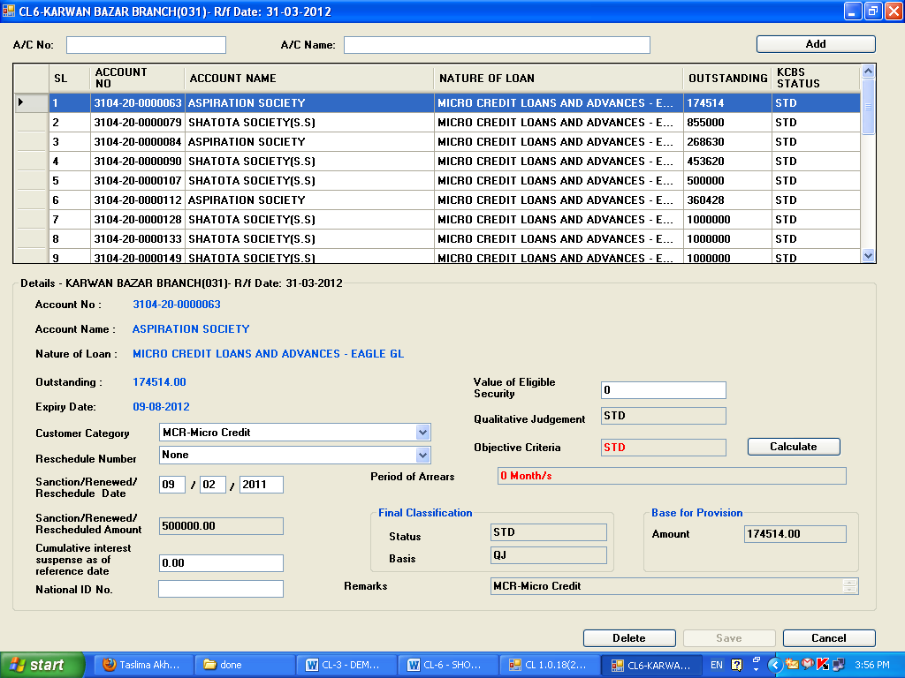

Thereafter user will provide data to the relevant fields and press **‘Calculate’** button. After pressing **‘Calculate’** button data in the following fields will be generated:

* Period of Arrears
* Objective Criteria
* Final Classification a) Status b) Basis
* Base for provision
* Remarks

And **‘Save’** button will be enabled.

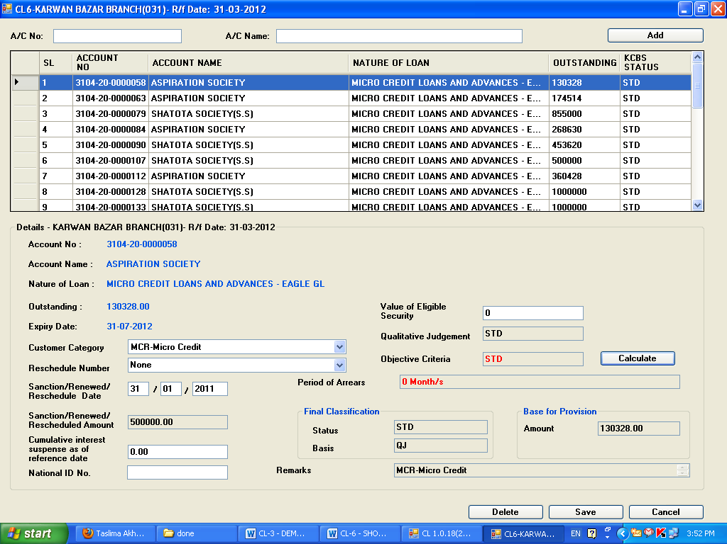

Then by clicking **‘Save’** button data, a message will be shown ***‘Do you want to save the change?-Ok/Cancel’***. If user press **‘Ok’** button, will be saved and stored in the CL database

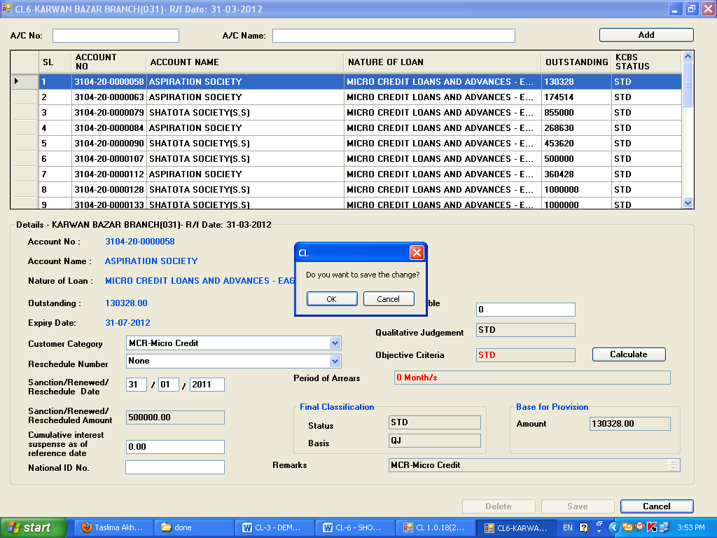

**Update:**

Only saved data can be updated by the user. By double clicking any account in the data grid, a message will be shown ***‘The account tis already updated. Do you want to update again-Yes/No’***. If user press **‘Yes’** button, which is already saved will be fetched under of the data grid box.

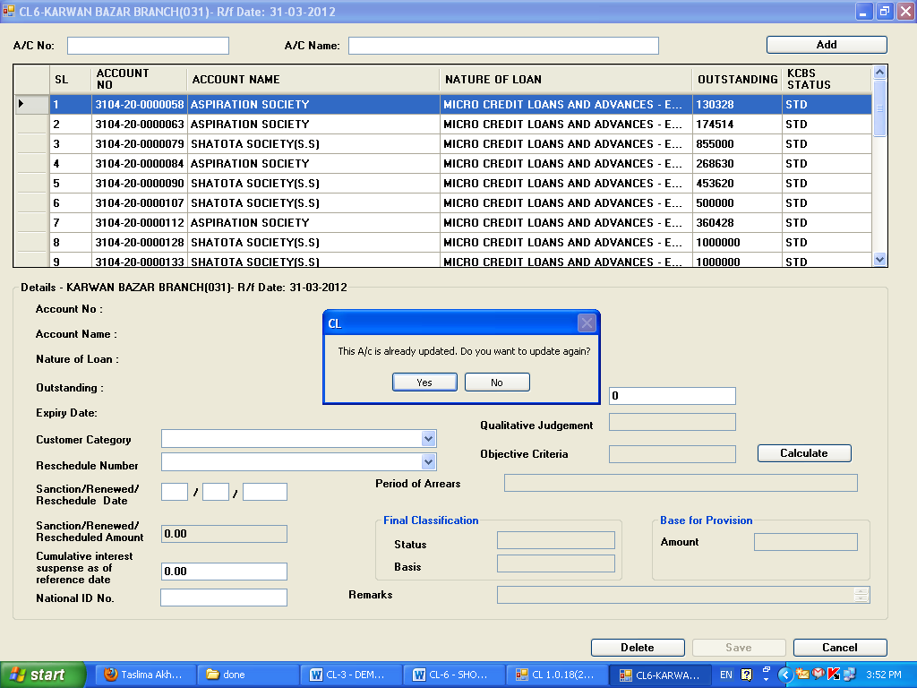

Thereafter user will provide correct data, if any, to the relevant fields and press **‘Calculate’** button. After pressing **‘Calculate’** button data in the following fields will be generated:

* Period of Arrears
* Objective Criteria
* Final Classification a) Status b) Basis
* Base for provision
* Remarks

And **‘Save’** button will be enabled.

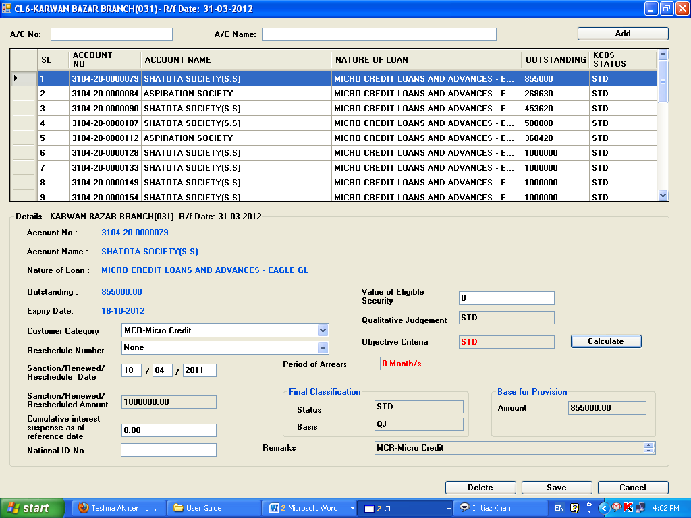

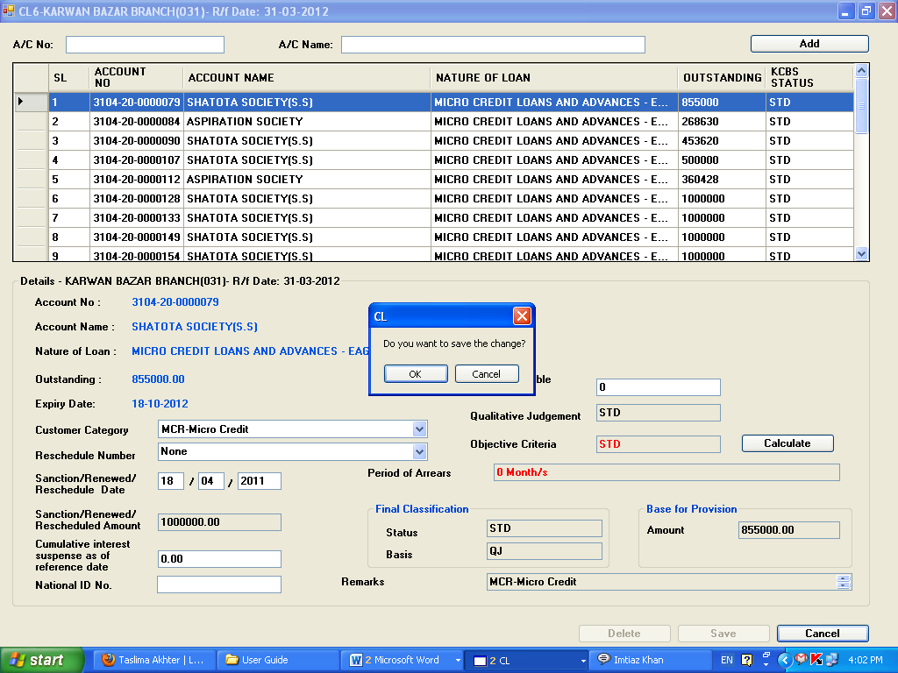

Then by clicking **‘Save’** button data, a message will be shown ***‘Do you want to save the change?-Ok/Cancel’***. If user press **‘Ok’** button, will be saved and stored in the CL database.

**Delete:**

***Before Update:***

By double clicking any account in the data grid which is already imported or imported through ‘Import Update/Special Import’ option, user can delete any account by double clicking in the data grid, a message will be shown ***‘Do you want to delete-Ok/Cancel’***. If user press **‘Ok’** button, a message will be shown ***‘Data Deleted successfully’***. Then the account will be shifted to ‘Import Update’ and will not consider during generating report.

***After Update:***

By double clicking any account in the data grid which is already updated and stored in the CL database, user can delete any account by double clicking in the data grid; a message will be shown ***‘Do you want to delete-Ok/Cancel’***.

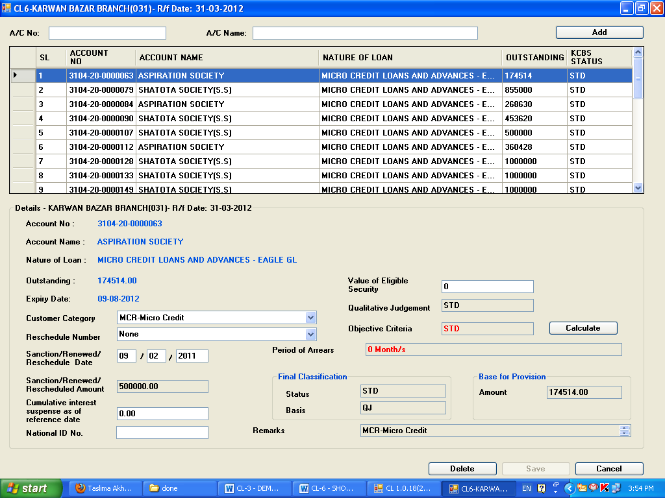

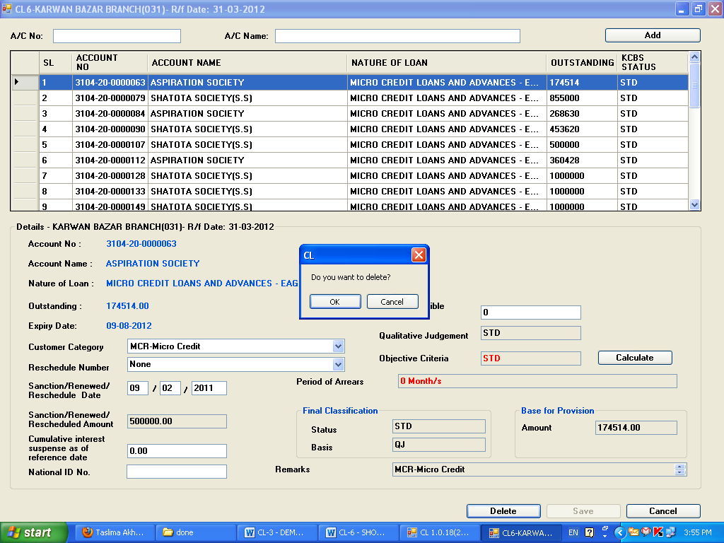

If user presses **‘Ok** button, a message will be shown ***‘Data Deleted successfully’***. Then the account will be shifted to ‘Import Update’ and will not consider during generating report.

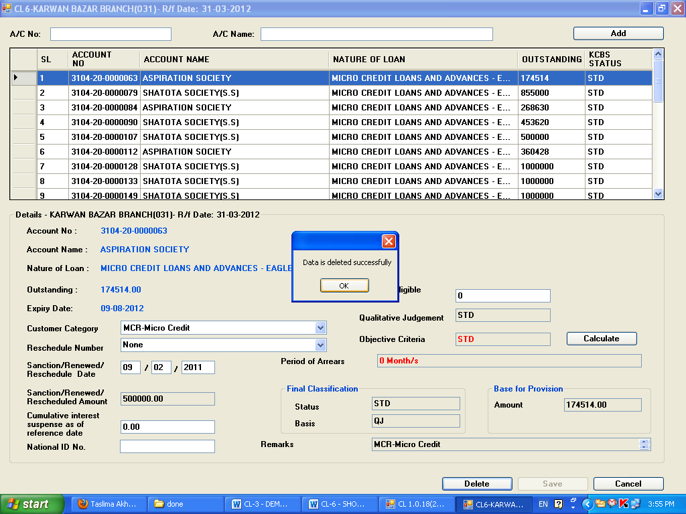

**Staff Loan**

Under main menu **CL Category**, you will find submenu **CL-Staff Loan**

**Field description :**

1. **Account No.:** Imported from KCBS
2. **Account Name:** Imported from KCBS
3. **Nature of Loan:** Imported from KCBS according to product name
4. **Outstanding:** Imported from KCBS as on quarter end balance
5. **Expiry date:** Imported from KCBS as on quarter end. **Before quarter end** user can check from Report ‘Balances of Loan Accounts expired for a given date’ and can change through screen nos. 62115, 62120, 10352 (Maturity Date) before quarter end.
6. **Category:** User Input (Select from Drop-Down menu)
7. **Reschedule No.:** User Input (Select from Drop-Down menu)
   1. ***For fresh sanction***: None
   2. ***For rescheduling withoutinterest waiver***
      1. 1st time rescheduling: RS-1
      2. 2nd time rescheduling: RS-2
      3. 3rdtime rescheduling: RS-3
   3. ***For rescheduling withinterest waiver***
      1. 1st time rescheduling: RSIW-1
      2. 2nd time rescheduling: RSIW-2
      3. 3rd time rescheduling: RSIW-3
8. **Sanctioned/Renewed/Rescheduled Date:** User Input
9. **Sanctioned/Renewed/Rescheduled Amount:** Imported from KCBS as on quarter end. For Loan-Approved amount (i.e. Consultation Amount). Once Loan A/c is created user cannot change Sanctioned/Renewed/Rescheduled Amount.
10. **Cumulative Interest Suspense:** User input should be matched with KCBS
11. **National ID No.:** Mandatory for account of Individual
    1. ***Imported from KCBS:*** National ID is required for Individual Customer only. For existing customer User can update it vide KCBS screen No.61200 (Modification of Customer Information)-under Tab name (**Personal Information 2**) - in the field name '**Add. Proof of ID1/2/3**', please select code **1003 (National ID Card)**.

Or,

* 1. ***User Input:*** User can input either 13 or 17 digits, which is applicable, if not found in KCBS database.

1. **Value of Eligible Security:** Disabled
2. **Qualitative Judgement (QJ) :** Imported from KCBS as on quarter end

User can check NPA status from Report (**Status wise account list – CCOD/Loan accounts)** and mark/unmark NPA in KCBS through screen no.10601 **before quarter end**.

1. **Period of Arrears:** Disabled
2. **Objective Criteria (OB):** Disabled
3. **Final Classification:** Only QJ.
4. **Base for Provision:** After given above data Software will calculate.
5. **Remarks:** Customer Category selected above

**Entry in the CL database:**

By double clicking any account in the data grid which is already imported or imported through ‘Import Update’ option, will be fetched under the data grid box with already data imported from KCBS.

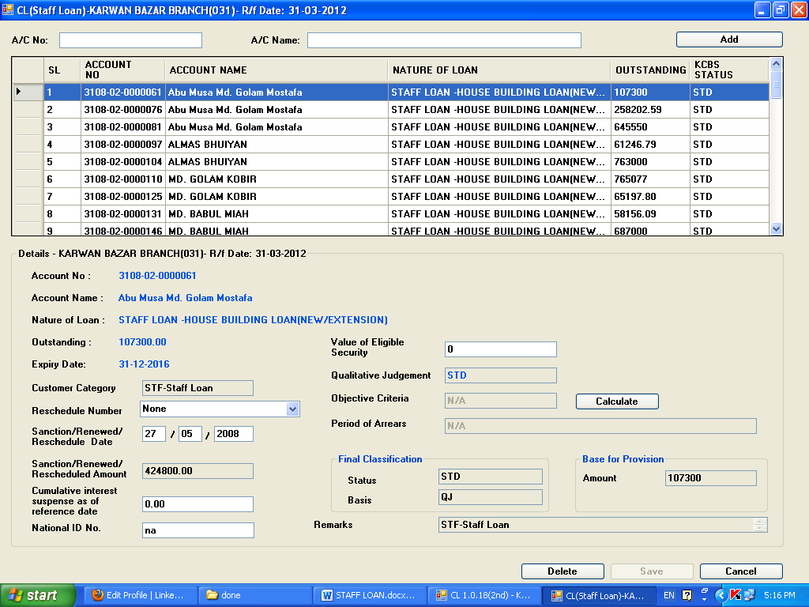

Thereafter user will provide data to the relevant fields and press **‘Calculate’** button. After pressing **‘Calculate’** button data in the following fields will be generated:

1. Final Classification a) Status b) Basis
2. Base for provision
3. Remarks

And **‘Save’** button will be enabled.

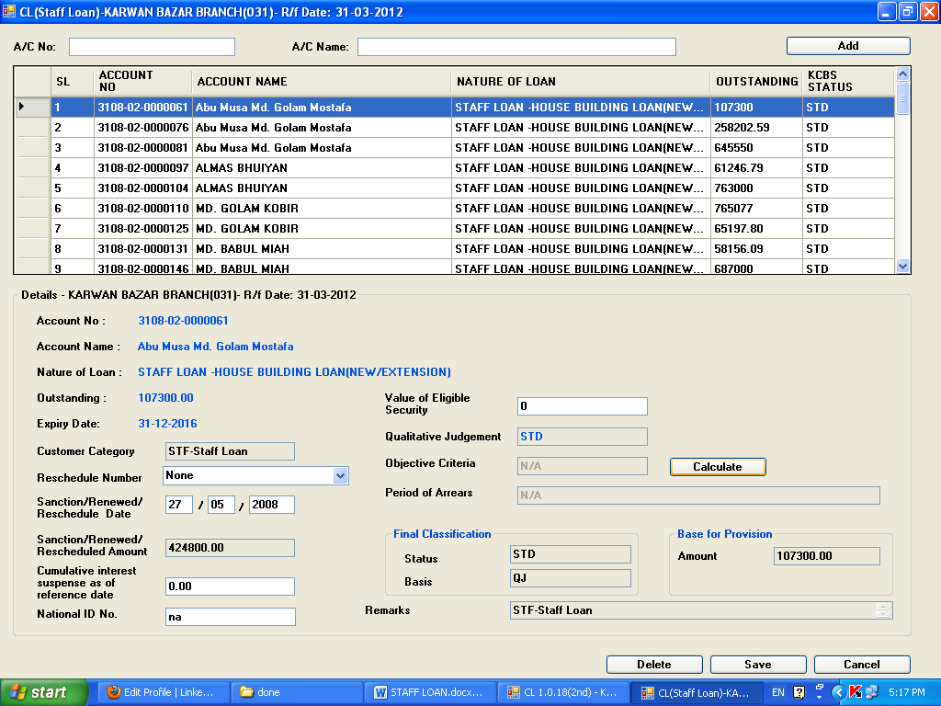

Then by clicking **‘Save’** button data, a message will be shown ***‘Do you want to save the change?-Ok/Cancel’***. If user press **‘Ok’** button, will be saved and stored in the CL database

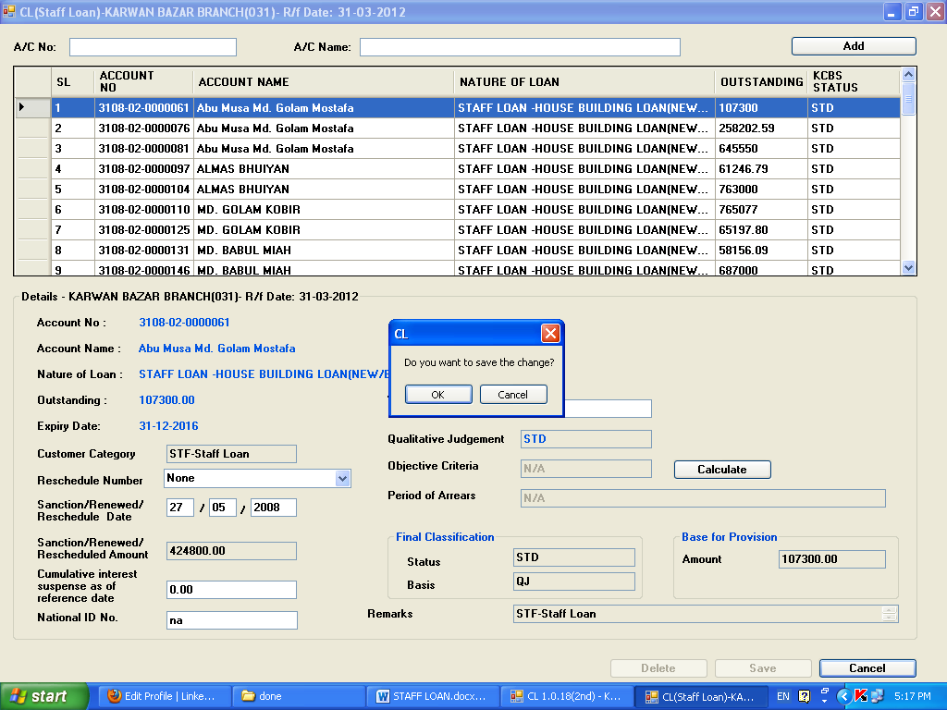

**Update:**

Only saved data can be updated by the user. By double clicking any account in the data grid, a message will be shown ***‘The account tis already updated. Do you want to update again-Yes/No’***. If user press **‘Yes’** button, which is already saved will be fetched under of the data grid box.

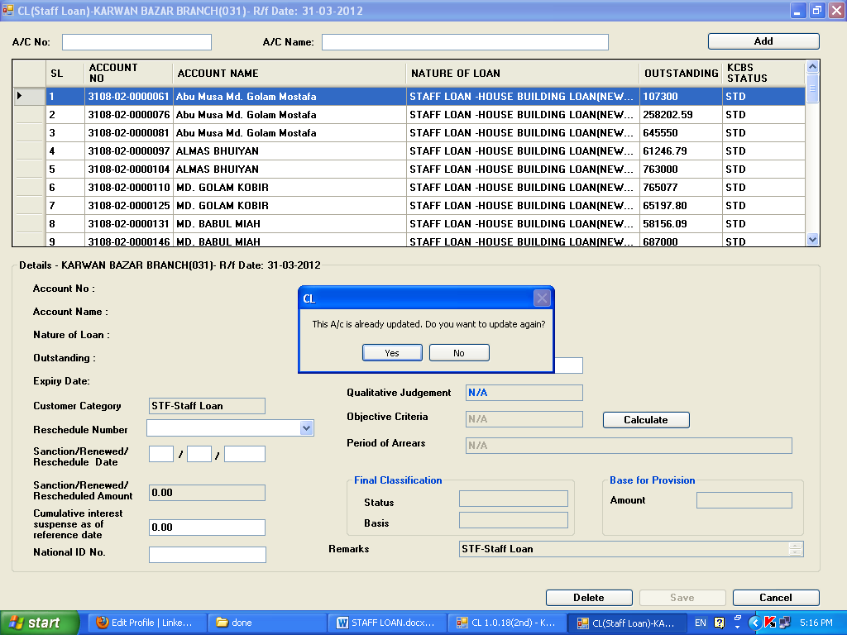

Thereafter user will provide correct data, if any, to the relevant fields and press **‘Calculate’** button.



After pressing **‘Calculate’** button data in the following fields will be generated:

1. Final Classification a) Status b) Basis
2. Base for provision
3. Remarks

And **‘Save’** button will be enabled.



Then by clicking **‘Save’** button data, a message will be shown ***‘Do you want to save the change?-Ok/Cancel’***. If user press **‘Ok’** button, will be saved and stored in the CL database.

**Delete:**

***Before Update:***

By double clicking any account in the data grid which is already imported or imported through ‘Import Update/Special Import’ option, user can delete any account by double clicking in the data grid, a message will be shown ***‘Do you want to delete-Ok/Cancel’***. If user press **‘Ok’** button, a message will be shown ***‘Data Deleted successfully’***. Then the account will be shifted to ‘Import Update’ and will not consider during generating report.

***After Update:***

By double clicking any account in the data grid which is already updated and stored in the CL database, user can delete any account by double clicking in the data grid; a message will be shown ***‘Do you want to delete-Ok/Cancel’***.

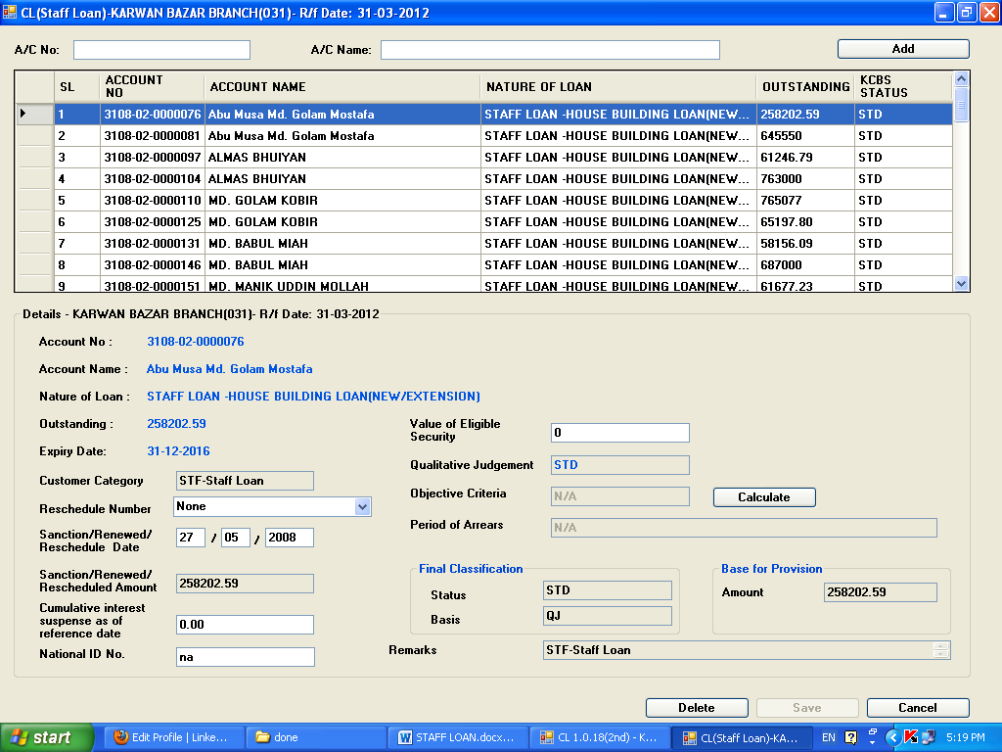

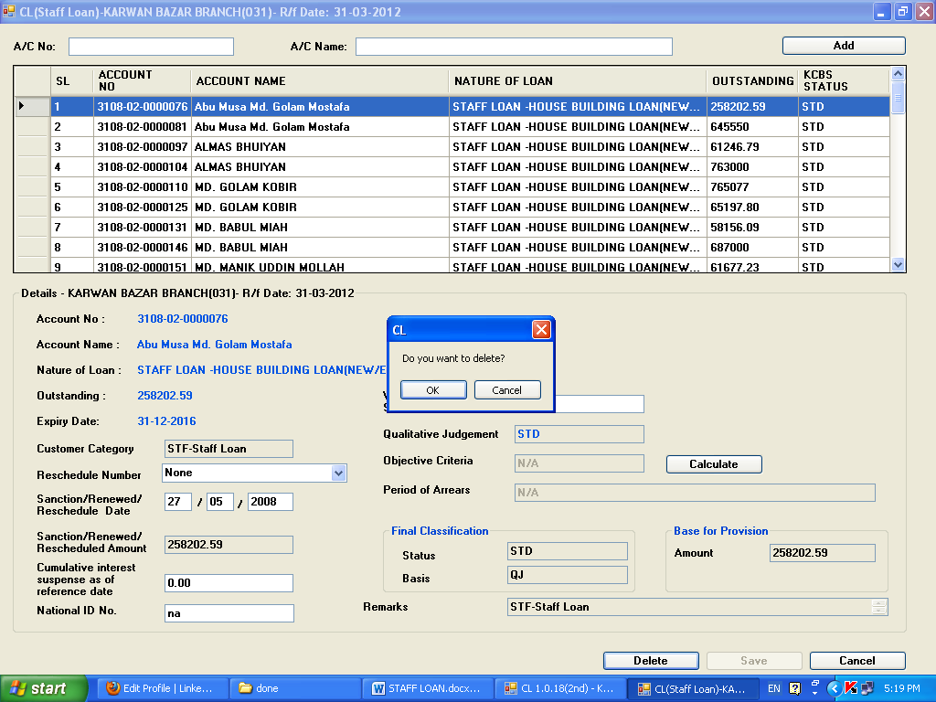

If user presses **‘Ok** button, a message will be shown ***‘Data Deleted successfully’***. Then the account will be shifted to ‘Import Update’ and will not consider during generating report.

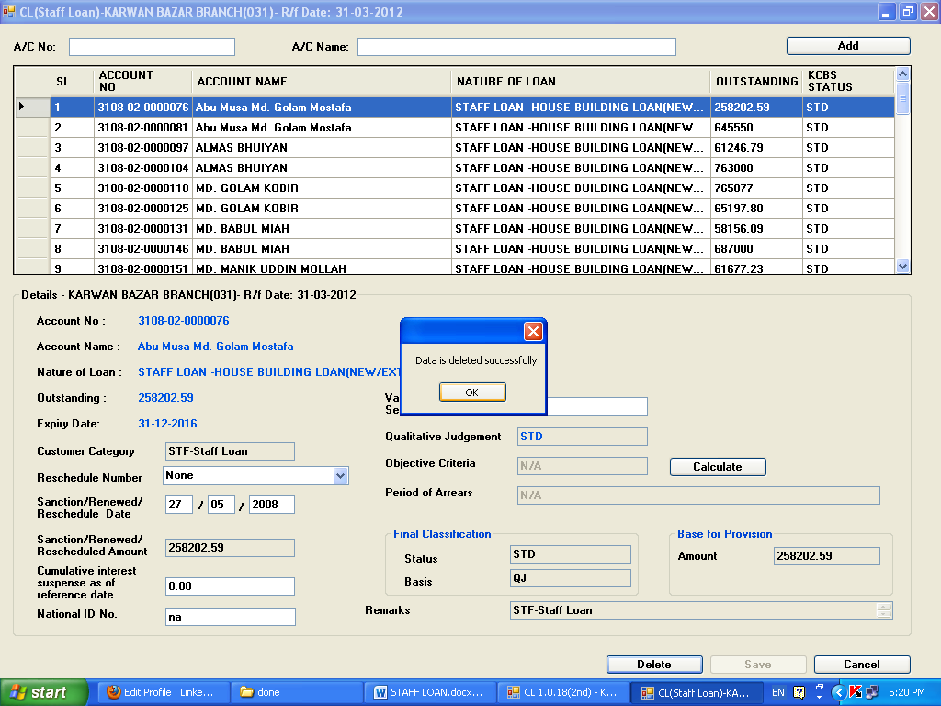

**Coding:**

The coding phase of the CL Software is divided into some phases

**Implementation of User module:**

Login Phase: Following steps are followed at login phase. First DSN is created if not exist. Then connection is opened for database operation. Then check for the user’s existence in the table. If exist then user branch is compared with the machine IP that is used by the user. If true then user is allowed to login into the system. If not then users have to contact to ICT to change the branch.

\*\*\*\*\*\*\*\*\*\*\*\*\*\*\*\*\*\*\* LOG IN PHASE \*\*\*\*\*\*\*\*\*\*\*\*\*\*\*\*\*\*\*\*\*\*\*\*\*\*\*\*\*\*\*\*\*\*\*\*

Try

CreateDSN.Main()

If (OpenConn()) Then

currentUser = UsernameTextBox.Text

My.Settings.UserName = currentUser

If rs1.State = 1 Then

rs1.Close()

End If

rs1.Open("SELECT count(\*) cnt from BASIC\_CL.CL\_USERS WHERE USERID='" & currentUser & "' AND PASSWD='" & encr.Encrypt(PasswordTextBox.Text, "12345") & "' and status='00'", conn, ADODB.CursorTypeEnum.adOpenKeyset)

Dim ii = rs1.Fields("CNT").Value

If ii = 0 Then

MsgBox("Invalid user name or password")

UsernameTextBox.Focus()

Else

If rs.State = 1 Then

rs.Close()

End If

rs.Open("SELECT \* from BASIC\_CL.CL\_USERS WHERE USERID='" & currentUser & "' AND PASSWD='" & encr.Encrypt(PasswordTextBox.Text, "12345") & "' and status='00'", conn, ADODB.CursorTypeEnum.adOpenKeyset)

BranchCode = Trim(rs.Fields("BRN").Value.ToString)

If Trim(rs.Fields("LOG\_STAT").Value.ToString) = "1" Then

MessageBox.Show("This User '" & currentUser & "' is already logged in. Try Later")

UsernameTextBox.Text = ""

PasswordTextBox.Text = ""

Return

End If

Me.Hide()

userLevel = Trim(rs.Fields("USERLEVEL").Value.ToString)

pass = Trim(rs.Fields("PASSWD").Value.ToString)

If BranchCode <> "000102" Then

If rs.State = 1 Then

rs.Close()

End If

rs.Open("SELECT name from combrch where brn = '" & BranchCode & "'", conn, ADODB.CursorTypeEnum.adOpenKeyset)

BranchName = Trim(rs.Fields("NAME").Value.ToString)

Else

BranchName = "ICT"

End If

If rs1.State = 1 Then

rs1.Close()

End If

rs1.Open("select ref\_date from cl\_refdate where sta = '00'", conn, ADODB.CursorTypeEnum.adOpenKeyset)

RefDate = Trim(rs1.Fields("REF\_DATE").Value.ToString)

ShowRefDate = RefDate.Substring(6, 2) + "-" + RefDate.Substring(4, 2) + "-" + RefDate.Substring(0, 4)

If rs.State = 1 Then

rs.Close()

End If

rs.Open("select des from cl\_param where name = 'branchcode'", conn, ADODB.CursorTypeEnum.adOpenKeyset)

brncode = Trim(rs.Fields("DES").Value.ToString)

info = BranchName + "(" + BranchCode.Substring(Integer.Parse(brncode)) + ")" + "- R/f Date: " + ShowRefDate

conn.Execute("Update cl\_users set log\_stat = 1 where userid ='" & currentUser & "' and (log\_stat is null or log\_stat = 0) and status = '00'")

conn.Execute("Update cl\_users set last\_log\_date = TO\_CHAR(SYSDATE,'yyyymmdd'), last\_log\_time = TO\_CHAR(SYSDATE,'hhmmss') where userid ='" & currentUser & "' and status = '00'")

MDIParentCL.Show()

MDIParentCL.MDIParentCL\_Load(Nothing, Nothing)

End If

End If

**Implementation of User and Password Security policy:**

The following function used for storing a secured password as Bangladesh Bank’s password policy.

Function ValidatePassword(ByVal pwd As String) As Boolean

Dim minLength As Integer

Dim numUpper As Integer

Dim numLower As Integer

Dim numNumbers As Integer

Dim numSpecial As Integer

rs1.Open("SELECT \* from HORECON\_param WHERE sta='00'", conn, ADODB.CursorTypeEnum.adOpenKeyset)

If rs1.RecordCount <= 0 Then

MsgBox("Init param failed")

Else

minLength = rs1.Fields("MINLEN").Value

numUpper = rs1.Fields("CHRUPR").Value

numLower = rs1.Fields("CHRLWR").Value

numNumbers = rs1.Fields("CHRNUM").Value

numSpecial = rs1.Fields("CHRSPCL").Value

End If

rs1.Close()

' Replace [A-Z] with \p{Lu}, to allow for Unicode uppercase letters.

Dim upper As New System.Text.RegularExpressions.Regex("[A-Z]")

Dim lower As New System.Text.RegularExpressions.Regex("[a-z]")

Dim number As New System.Text.RegularExpressions.Regex("[0-9]")

' Special is "none of the above".

Dim special As New System.Text.RegularExpressions.Regex("[^a-zA-Z0-9]")

' Check the length.

If Len(pwd) < minLength Then Return False

' Check for minimum number of occurrences.

If upper.Matches(pwd).Count < numUpper Then Return False

If lower.Matches(pwd).Count < numLower Then Return False

If number.Matches(pwd).Count < numNumbers Then Return False

If special.Matches(pwd).Count < numSpecial Then Return False

' Passed all checks.

Return True

End Function

The following code is used to implement to track the force change password at first login and to track the invalid attempt.

'''''''''''' invalid attempt '''''''''''

currentUser = UsernameTextBox.Text

invalid\_attempt = 0

If rs.State = 1 Then

rs.Close()

End If

rs.Open("SELECT inv\_attm FROM horecon\_param", conn, ADODB.CursorTypeEnum.adOpenKeyset)

inv\_attm = rs.Fields("INV\_ATTM").Value

'MessageBox.Show(invalid\_attempt.ToString)

If rs1.State = 1 Then

rs1.Close()

End If

rs1.Open("SELECT \* from HORECON\_USERS WHERE USERID='" & currentUser & "'", conn, ADODB.CursorTypeEnum.adOpenKeyset)

invalid\_attempt = rs1.Fields("INVALID\_ATTEMPT").Value

If invalid\_attempt >= inv\_attm Then

MessageBox.Show("Your account is locked! Please contact administrator.")

UsernameTextBox.Focus()

Exit Sub

End If

My.Settings.UserName = currentUser

If rs.State = 1 Then

rs.Close()

End If

rs.Open("SELECT \* from HORECON\_USERS WHERE USERID='" & currentUser & "' AND PASSWD='" & encr.Encrypt(PasswordTextBox.Text, "12345") & "' and status='00'", conn, ADODB.CursorTypeEnum.adOpenKeyset)

' res not found

If rs.RecordCount <= 0 Then

conn.Execute("Update horecon\_users set invalid\_attempt = nvl(invalid\_attempt,0)+1 where userid = '" & currentUser & "' and status = '00'")

MsgBox("Invalid user name or password")

UsernameTextBox.Focus()

Else

' res found

invalid\_attempt = rs.Fields("INVALID\_ATTEMPT").Value

first\_login\_sta = rs.Fields("FRSTLOGINSTA").Value.ToString

If invalid\_attempt >= inv\_attm Then

MessageBox.Show("Your account is locked! Please contact administrator.")

conn.Execute("Update horecon\_users set invalid\_attempt = nvl(invalid\_attempt,0)+1 where userid = '" & currentUser & "' and status = '00'")

UsernameTextBox.Focus()

Exit Sub

End If

conn.Execute("Update horecon\_users set invalid\_attempt = 0 where userid = '" & currentUser & "' and status = '00'")

userLevel = Trim(rs.Fields("USERLEVEL").Value.ToString)

**Import Data:**

To import the data at every quarter the following procedures are used:

\*\*\*\*\*\*\*\*\* Cl\_Import\_Clmasterlatest \*\*\*\*\*\*\*\*\*

CREATE OR REPLACE PROCEDURE Cl\_Import\_Clmasterlatest(vUser IN VARCHAR2) AS

BEGIN

INSERT INTO cl\_clmaster b (acct,ref\_date,qj\_sta,insertedby,inserteddate,entry\_sta,

brn,grp,cl,bal,lastupdatedby,lastupdateddate,sanc\_amt,nationalid)

SELECT acct,period,sta,'test',SYSDATE,'00',brn,grp,

(

SELECT (CASE WHEN cl2 <> 0 AND (cl2+cl3+cl4+cl5+cl6)=cl2 THEN cl2

WHEN cl3 <> 0 AND (cl2+cl3+cl4+cl5+cl6)=cl3 THEN cl3

WHEN cl4 <> 0 AND (cl2+cl3+cl4+cl5+cl6)=cl4 THEN cl4

WHEN cl5 <> 0 AND (cl2+cl3+cl4+cl5+cl6)=cl5 THEN cl5

WHEN cl6 <> 0 AND (cl2+cl3+cl4+cl5+cl6)=cl6 THEN cl6

WHEN staff = 'S' AND (cl2+cl3+cl4+cl5+cl6)=0 THEN staff

ELSE NULL END) AS cl FROM cl\_type WHERE sta = '00' AND grp = a.grp), outstanding,'test',SYSDATE,sanc\_amt,nationalid

FROM cl\_kcbs a WHERE entry\_sta = '00'

AND period = (SELECT ref\_date FROM cl\_refdate WHERE sta = '00') AND a.acct NOT IN (SELECT acct FROM cl\_clmaster);

INSERT INTO cl\_clmaster

(ACCT,

REF\_DATE,

QJ\_STA,

INSERTEDBY,

INSERTEDDATE,

ENTRY\_STA,

BRN,

CL,

CATEGORY,

SANCTION\_DATE,

RESCHEDULE\_NO,

CNSL\_VAL,

SANC\_AMT,

GRP, INTEREST\_SUSPENSE, NATIONALID,lastupdatedby,lastupdateddate,bal)

(SELECT ACCT,

(SELECT ref\_date FROM cl\_refdate WHERE sta = '00') AS ref\_date,

(SELECT sta FROM cl\_kcbs WHERE acct = a.acct AND period = (SELECT ref\_date FROM cl\_refdate WHERE sta = '00')) qj\_sta,'test import', SYSDATE,

'00', BRN, CL, CATEGORY, SANCTION\_DATE, RESCHEDULE\_NO,

CNSL\_VAL,

(SELECT sanc\_amt FROM cl\_kcbs WHERE acct =a.acct AND period = (SELECT ref\_date FROM cl\_refdate WHERE sta = '00')) AS sanc\_amt,

GRP, INTEREST\_SUSPENSE,

(SELECT nationalid FROM cl\_kcbs WHERE acct =a.acct AND period =

(SELECT ref\_date FROM cl\_refdate WHERE sta = '00')) AS nationalid,

'test import',

SYSDATE,

(SELECT outstanding FROM cl\_kcbs WHERE acct =a.acct AND period = (SELECT ref\_date FROM cl\_refdate WHERE sta = '00')) AS bal

FROM cl\_clmaster a WHERE acct IN

(SELECT acct FROM cl\_kcbs

WHERE period = (SELECT ref\_date FROM cl\_refdate WHERE sta = '00'))

AND

ref\_date IN (SELECT MAX(ref\_date) FROM cl\_clmaster WHERE ref\_date NOT IN (SELECT ref\_date FROM

cl\_refdate WHERE sta = '00') AND acct = a.acct GROUP BY acct

)

)

;

--TRUNCATE TABLE cl\_cl4\_tmp ;

INSERT INTO cl\_cl4\_tmp (

SELECT acct, install\_size, install\_freq,first\_repayment\_due\_date,

first\_repayment\_due\_period,amount\_paid,'20120630',entry\_sta,amt\_paid\_time,lastupdatedby,lastupdateddate

FROM cl\_cl4 WHERE ref\_date = (SELECT prev\_ref\_date FROM cl\_refdate WHERE sta ='00')

);

INSERT INTO cl\_cl4 (SELECT \* FROM cl\_cl4\_tmp);

UPDATE cl\_clmaster SET mark = '' WHERE ref\_date = (SELECT ref\_date FROM cl\_refdate WHERE sta = '00');

END Cl\_Import\_Clmasterlatest;

/

**To import from KCBS:**

\*\*\*\*\*\*\*\*\* Cl\_Import\_Kcbslatest \*\*\*\*\*\*\*\*\*

CREATE OR REPLACE PROCEDURE Cl\_Import\_Kcbslatest(vUname IN VARCHAR2) AS

BEGIN

INSERT INTO cl\_kcbs (acct,cif,brn,grp,name,

--sanc\_date,

reschedule\_no,sanc\_amt,expiry\_date,sta,outstanding,

interest\_suspense,cat,cnsl\_no,cnsl\_val,insertedby,inserteddate,entry\_sta,period,nationalid)

(SELECT a.acct,

a.cif,

a.brn,

a.grp,

(SELECT name FROM cimcusm WHERE cif = a.cif) name,

NVL(a.reschedule\_no,0),

--a.open\_date,

--(case when a.renewal\_date > (case when a.sanction\_date> a.reschedule\_date then a.sanction\_date else a.reschedule\_date end) thne a.renewal\_date

--else (case when a.sanction\_date> a.reschedule\_date then a.sanction\_date else a.reschedule\_date end) end ) as sanc\_date ,

NVL(a.aprv\_amt,'0'),

a.last\_paybk\_date,

trim(LPAD(TO\_CHAR(trim(CASE WHEN b.sta< = '08' THEN '08' ELSE TO\_CHAR(b.sta) END)),2,'0')) AS sta,

TO\_CHAR(CASE WHEN (SELECT int\_calc\_type FROM lnpgrop WHERE grp =a.grp) = 's' THEN NVL(b.bal,'0')+NVL(b.due\_chrg,0)

ELSE NVL(b.bal,0)+NVL(b.due\_chrg,0)+NVL(b.due\_int,0) END) AS bal,

'0' interest\_suspense,

a.category,

'0' cnsl\_no,

'0' cnsl\_val,

'test\_import',

SYSDATE,

'00',

(SELECT ref\_date FROM cl\_refdate WHERE sta = '00') period,

(SELECT trim(subid) FROM cimcusm

WHERE subidtype = '1003'

AND cif = a.cif) nationalid

FROM lnmacct a, ims.lntloan b

WHERE

a.acct = b.acct

AND b.tx\_date = (SELECT ref\_date FROM cl\_refdate WHERE sta = '00')

AND b.sta >=7

UNION ALL

SELECT b.acct,

(SELECT cif FROM dpmacct WHERE acct = b.acct ) AS cif,

b.brn,

b.ln\_grp,

(SELECT name FROM cimcusm WHERE cif = ((SELECT cif FROM dpmacct WHERE acct = b.acct ))) name,

--a.sanc\_date,

0 reschedule\_no,

--a.fst\_loan\_date,

NVL(b.issu\_amt,'0'),

NVL(b.ilb\_end\_date,NULL),

trim(LPAD(TO\_CHAR(trim(CASE WHEN b.sta< = '08' THEN '08' ELSE TO\_CHAR(b.sta) END)),2,'0')) AS sta,

TO\_CHAR(ABS(CASE WHEN (SELECT int\_calc\_type FROM lnpgrop WHERE grp =b.ln\_grp) = 's' THEN NVL(b.bal,0)+NVL(b.due\_chrg,0)

ELSE NVL(b.bal,0)+NVL(b.due\_chrg,0)+NVL(b.due\_int,0) END)) AS bal,

'0' interest\_suspense,

'0' category,

'0' AS cnsl\_no,

'0' AS cnsl\_val,

'test\_import',

SYSDATE,

'00',

(SELECT ref\_date FROM cl\_refdate WHERE sta = '00') period,

(SELECT trim(subid) FROM cimcusm

WHERE subidtype = '1003'

AND cif =(SELECT cif FROM dpmacct WHERE acct = b.acct )) nationalid

FROM ims.lntloan b

WHERE

--a.acct = b.acct

--AND

(CASE WHEN (SELECT int\_calc\_type FROM lnpgrop WHERE grp =b.ln\_grp) = 's' THEN NVL(b.bal,0)+NVL(b.due\_chrg,0)

ELSE NVL(b.bal,0)+NVL(b.due\_chrg,0)+NVL(b.due\_int,0) END)<0

AND b.sta IN ('00','30','31','32','33')

AND b.tx\_date = (SELECT ref\_date FROM cl\_refdate WHERE sta = '00')

AND b.ln\_grp < '90000000000'

UNION ALL

SELECT a.acct,

a.cif,

a.brn,

a.ln\_grp,

(SELECT name FROM cimcusm WHERE cif = a.cif) name,

--a.sanc\_date,

NVL(a.reschedule\_no,0),

--a.fst\_loan\_date,

NVL(a.ilb\_amt,'0'),

NVL(b.ilb\_end\_date,NULL),

trim(LPAD(TO\_CHAR(trim(CASE WHEN b.sta< = '08' THEN '08' ELSE TO\_CHAR(b.sta) END)),2,'0')) AS sta,

'0' bal,

'0' interest\_suspense,

a.category,

'0' AS cnsl\_no,

'0' AS cnsl\_val,

'test\_import',

SYSDATE,

'00',

(SELECT ref\_date FROM cl\_refdate WHERE sta = '00') period,

(SELECT trim(subid) FROM cimcusm

WHERE subidtype = '1003'

AND cif = a.cif) nationalid

FROM dpmloan a, ims.lntloan b

WHERE

a.acct = b.acct

AND b.sta IN ('30','31','32','33')

AND b.bal> 0

AND b.ln\_grp < '90000000000'

AND b.tx\_date = (SELECT ref\_date FROM cl\_refdate WHERE sta = '00')

)

;

--CL\_IMPORT\_CLMASTER;

--CL\_IMPORT\_periodArrear;

END Cl\_Import\_Kcbslatest;

/

**Implementation of CL input Forms**

Sample CL forms codes are given below.

Imports System.Globalization

Public Class CL2

Dim acct\_no As String

Public rs As New ADODB.Recordset

Public rs1 As New ADODB.Recordset

Public rs2 As New ADODB.Recordset

Dim dt As String

Dim grp As String

Dim cat As String

Dim natidlen As String

Dim maxlen As String

CL2\_load defines some features that will initialize when the form loads for first time.

Public Sub CL2\_Load(ByVal sender As System.Object, ByVal e As System.EventArgs) Handles MyBase.Load

natidlen = "select trim(des) as des from cl\_param where name = 'NationalIDLen'"

If rs.State = 1 Then

rs.Close()

End If

rs.Open(natidlen, conn, ADODB.CursorTypeEnum.adOpenKeyset)

maxlen = rs.Fields("DES").Value.ToString()

txtNationalID.MaxLength = maxlen

'TODO: This line of code loads data into the 'DataSet3.VW\_CL2' table. You can move, or remove it, as needed.

GroupBoxDetails.Enabled = False

ButtonSave.Enabled = False

ButtonCalculate.Enabled = False

Me.Text = "CL2-" + info

'TODO: This line of code loads data into the 'DataSetCL3.VW\_CL3' table. You can move, or remove it, as needed.

Me.VW\_CL2TableAdapter.SelectCommand.CommandText = GetParam("fillcl2")

Me.VW\_CL2TableAdapter.Fill(DataSet3.VW\_CL2, BranchCode, "%\_\_\_\_\_\_\_\_\_\_\_\_\_", "%")

GroupBoxDetails.Text = "Details - " + info

If flag = True Then

Sql = GetParam("cat")

If rssql.State = 1 Then

rssql.Close()

End If

rssql.Open(Sql, conn, ADODB.CursorTypeEnum.adOpenKeyset)

Do Until rssql.EOF

ComboBoxCat.Items.Add(rssql.Fields("SHRT").Value.ToString)

rssql.MoveNext()

Loop

Sql = GetParam("reschedule\_no")

If rssql.State = 1 Then

rssql.Close()

End If

rssql.Open(Sql, conn, ADODB.CursorTypeEnum.adOpenKeyset)

Do Until rssql.EOF

CmbRsch.Items.Add(rssql.Fields("code").Value.ToString + ":" + rssql.Fields("name").Value.ToString)

rssql.MoveNext()

Loop

End If

flag = False

End Sub

Private Sub DataGridViewCL3\_CellValueNeeded(ByVal sender As System.Object, ByVal e As System.Windows.Forms.DataGridViewCellValueEventArgs) Handles DataGridViewCL3.CellValueNeeded

If e.RowIndex >= 0 AndAlso e.ColumnIndex = Me.Serial.Index Then

e.Value = e.RowIndex + 1

End If

End Sub

|  |
| --- |
| DataGridViewCL3\_DoubleClick defines the functionalities when a record is double clicked from datagrid and showns in detail view and ready to take input. |

Private Sub DataGridViewCL3\_DoubleClick(ByVal sender As System.Object, ByVal e As System.EventArgs) Handles DataGridViewCL3.DoubleClick

Try

ButtonDel.Enabled = True

Dim acct As Array

txtSta.Text = ""

txtBasis.Text = ""

txtBPAmt.Text = ""

acct = DataGridViewCL3.SelectedRows(0).Cells(1).Value.ToString.Split("-")

acct\_no = acct(0) + acct(1) + acct(2)

acct\_no = acct\_no.PadLeft(16, "0")

grp = acct\_no.Substring(5, 4)

Dim answer As MsgBoxResult

If rssql.State = 1 Then

rssql.Close()

End If

rssql.Open("select nvl(mark,'N') mark from cl\_clmaster where ref\_date = (select ref\_date from cl\_refdate where sta = '00') and acct = '" & acct\_no & "'", conn, ADODB.CursorTypeEnum.adOpenKeyset)

'MessageBox.Show("M")

If rssql.Fields("mark").Value.ToString.Trim = "M" Then

answer = MsgBox("This A/c is already updated. Do you want to update again?", MsgBoxStyle.YesNo)

End If

If answer = MsgBoxResult.Yes Or rssql.Fields("MARK").Value.ToString.Trim = "N" Then

If rssql.State = 1 Then

rssql.Close()

End If

rssql.Open("select nvl((Select nationalid from cl\_clmaster where ref\_date = (select ref\_date from cl\_refdate where sta = '00') and acct = '" & acct\_no & "'),'') as nationalid from dual", conn, ADODB.CursorTypeEnum.adOpenKeyset)

txtNationalID.Text = rssql.Fields("NATIONALID").Value.ToString.Trim

GroupBoxDetails.Enabled = True

ButtonCalculate.Enabled = True

If rs.State = 1 Then

rs.Close()

End If

Sql = "select remarks,nvl(basis,'N/A') as basis,(select short from cl\_sta where sta = final\_sta) as final\_sta,nvl(base\_of\_provision,'0.00') as base\_of\_provision,(select short from cl\_sta where sta = ob\_sta) as ob\_sta from cl\_clmaster where entry\_sta = '00' and" & \_

" ref\_date = (select ref\_date from cl\_refdate where sta = '00')" & \_

"and acct ='" & acct\_no & "'"

rs.Open(Sql, conn, ADODB.CursorTypeEnum.adOpenKeyset)

txtArrear.Text = Trim(DataGridViewCL3.SelectedRows(0).Cells(22).Value.ToString) + " month/s " + Trim(DataGridViewCL3.SelectedRows(0).Cells(14).Value.ToString) + " day/s"

'txtArrear.Text = Trim(DataGridViewCL3.SelectedRows(0).Cells(22).Value.ToString) + " Month/s"

TextBoxObjCri.Text = rs.Fields("OB\_STA").Value.ToString

txtSta.Text = rs.Fields("FINAL\_STA").Value.ToString

txtBasis.Text = rs.Fields("BASIS").Value.ToString

txtBPAmt.Text = rs.Fields("BASE\_OF\_PROVISION").Value.ToString

TextBoxRemark.Text = rs.Fields("REMARKS").Value.ToString

'MessageBox.Show(acct\_no)

LabelAccount.Visible = True

LabelName.Visible = True

LabelNatureLoan.Visible = True

LabelOutstanding.Visible = True

Label11.Visible = True

LabelAccount.Text = DataGridViewCL3.SelectedRows(0).Cells(1).Value.ToString

LabelName.Text = DataGridViewCL3.SelectedRows(0).Cells(2).Value.ToString

LabelNatureLoan.Text = DataGridViewCL3.SelectedRows(0).Cells(3).Value.ToString

LabelOutstanding.Text = FormatNumber(DataGridViewCL3.SelectedRows(0).Cells(4).Value.ToString, 2, TriState.True, TriState.False, TriState.False).ToString

If grp = "1001" Then

Label11.Visible = False

TextBoxdayExp.Enabled = True

TextBoxmonExp.Enabled = True

TextBoxYearExp.Enabled = True

If DataGridViewCL3.SelectedRows(0).Cells(5).Value.ToString <> "" Then

TextBoxdayExp.Text = DataGridViewCL3.SelectedRows(0).Cells(5).Value.ToString.Substring(6, 2)

TextBoxmonExp.Text = DataGridViewCL3.SelectedRows(0).Cells(5).Value.ToString.Substring(4, 2)

TextBoxYearExp.Text = DataGridViewCL3.SelectedRows(0).Cells(5).Value.ToString.Substring(0, 4)

End If

dt = TextBoxYearExp.Text.ToString.PadLeft(4, "0") + TextBoxmonExp.Text.ToString.PadLeft(2, "0") + TextBoxdayExp.Text.ToString.PadLeft(2, "0")

Else

TextBoxdayExp.Text = ""

TextBoxmonExp.Text = ""

TextBoxYearExp.Text = ""

Label11.Visible = True

TextBoxdayExp.Enabled = False

TextBoxmonExp.Enabled = False

TextBoxYearExp.Enabled = False

'MessageBox.Show(DataGridViewCL3.SelectedRows(0).Cells(5).Value.ToString.Substring(0, 4).PadLeft(4, "0"))

Label11.Text = DataGridViewCL3.SelectedRows(0).Cells(5).Value.ToString.Substring(6, 2).PadLeft(2, "0") & "-" & \_

DataGridViewCL3.SelectedRows(0).Cells(5).Value.ToString.Substring(4, 2).PadLeft(2, "0") & "-" & \_

DataGridViewCL3.SelectedRows(0).Cells(5).Value.ToString.Substring(0, 4).PadLeft(4, "0")

If DataGridViewCL3.SelectedRows(0).Cells(5).Value.ToString <> "" Then

dt = DataGridViewCL3.SelectedRows(0).Cells(5).Value.ToString

End If

End If

'LabelQJ.Text = DataGridViewCL3.SelectedRows(0).Cells(6).Value.ToString

' txtResceduleNo.Text = DataGridViewCL3.SelectedRows(0).Cells(8).Value.ToString

txtReschAmt.Text = FormatNumber(DataGridViewCL3.SelectedRows(0).Cells(12).Value.ToString, 2, TriState.True, TriState.False, TriState.False).ToString

txtIntSus.Text = FormatNumber(DataGridViewCL3.SelectedRows(0).Cells(17).Value.ToString, 2, TriState.True, TriState.False, TriState.False).ToString

txtEligSec.Text = FormatNumber(DataGridViewCL3.SelectedRows(0).Cells(19).Value.ToString, 0, TriState.True, TriState.False, TriState.False).ToString

date\_format(DataGridViewCL3.SelectedRows(0).Cells(10).Value.ToString)

TextBoxday.Text = day

TextBoxmon.Text = month

TextBoxyear.Text = year

MessageBox.Show(Trim(DataGridViewCL3.SelectedRows(0).Cells(8).Value.ToString))

If Trim(DataGridViewCL3.SelectedRows(0).Cells(8).Value.ToString) = "0" Then

CmbRsch.Text = "None"

Else

If rssql.State = 1 Then

rssql.Close()

End If

rssql.Open("SELECT code,name FROM cl\_rescheduleno WHERE code = '" & DataGridViewCL3.SelectedRows(0).Cells(8).Value.ToString.Trim & "' and sta = '00'", conn, ADODB.CursorTypeEnum.adOpenKeyset)

CmbRsch.Text = rssql.Fields("code").Value.ToString + ":" + rssql.Fields("name").Value.ToString

End If

'MessageBox.Show(DataGridViewCL3.SelectedRows(0).Cells(15).Value.ToString)

If Trim(DataGridViewCL3.SelectedRows(0).Cells(15).Value.ToString) = "0" Or Trim(DataGridViewCL3.SelectedRows(0).Cells(15).Value.ToString) Is Nothing Then

ComboBoxCat.Text = "Select"

Else

If rssql.State = 1 Then

rssql.Close()

End If

rssql.Open("SELECT subcat||'-'||name AS shrt FROM cl\_cl1 WHERE subcat = '" & DataGridViewCL3.SelectedRows(0).Cells(15).Value.ToString.Trim & "'", conn, ADODB.CursorTypeEnum.adOpenKeyset)

ComboBoxCat.Text = rssql.Fields("SHRT").Value.ToString

End If

Cmbqj.Text = DataGridViewCL3.SelectedRows(0).Cells(6).Value.ToString

If rs.Fields("OB\_STA").Value.ToString <> "" Then

Sql = GetParam("oc\_stacl2")

If rssql.State = 1 Then

rssql.Close()

End If

rssql.Open(Sql + "" & acct\_no & "))", conn, ADODB.CursorTypeEnum.adOpenKeyset)

TextBoxObjCri.Text = rssql.Fields("NAME").Value.ToString

End If

txtArrear.Text = Trim(DataGridViewCL3.SelectedRows(0).Cells(22).Value.ToString.PadLeft(2, "0")) + " month/s " + Trim(DataGridViewCL3.SelectedRows(0).Cells(14).Value.ToString.PadLeft(2, "0")) + " day/s"

Else

Try

GroupBoxDetails.Enabled = False

Dim iTest As Integer

If DataGridViewCL3.Rows.Count = DataGridViewCL3.SelectedRows(0).Index + 1 Then

iTest = 0

DataGridViewCL3.Rows(iTest).Selected = True

Else

iTest = DataGridViewCL3.SelectedRows(0).Index + 1

DataGridViewCL3.Rows(iTest).Selected = True

End If

DataGridViewCL3.FirstDisplayedScrollingRowIndex = iTest

Catch ex As Exception

MsgBox(ex.ToString)

End Try

End If

Catch ex As Exception

MsgBox(ex.ToString)

End Try

End Sub

|  |
| --- |
| ButtonCalculate\_Click is used to genarate result based on the given inputs in the detailed view. |

Private Sub ButtonCalculate\_Click(ByVal sender As System.Object, ByVal e As System.EventArgs) Handles ButtonCalculate.Click

Try

If TextBoxday.Text = "" Or TextBoxmon.Text = "" Or TextBoxyear.Text = "" Then

MessageBox.Show("Blank Sanction/Renewed/Rescheduled Date.Value Needed..")

TextBoxday.Text = ""

TextBoxmon.Text = ""

TextBoxyear.Text = ""

TextBoxday.Focus()

Return

End If

If Trim(TextBoxyear.Text) + Trim(TextBoxmon.Text) + Trim(TextBoxday.Text) > DataGridViewCL3.SelectedRows(0).Cells(5).Value.ToString Then

If grp = "1001" Then

If Trim(TextBoxyear.Text) + Trim(TextBoxmon.Text) + Trim(TextBoxday.Text) > TextBoxYearExp.Text.Trim.PadLeft(4, "0") + TextBoxmonExp.Text.Trim.PadLeft(2, "0") + TextBoxdayExp.Text.Trim.PadLeft(2, "0") Then

MessageBox.Show("Sanction Date should be less than Expiry Date.")

TextBoxyear.Text = ""

TextBoxmon.Text = ""

TextBoxday.Text = ""

TextBoxday.Focus()

Return

End If

Else

MessageBox.Show("Sanction Date should be less than Expiry Date.")

TextBoxyear.Text = ""

TextBoxmon.Text = ""

TextBoxday.Text = ""

TextBoxday.Focus()

Return

End If

End If

If Trim(TextBoxyear.Text) + Trim(TextBoxmon.Text) + Trim(TextBoxday.Text) < "19890101" Then

MessageBox.Show("Invalid Date.")

TextBoxyear.Text = ""

TextBoxmon.Text = ""

TextBoxday.Text = ""

TextBoxday.Focus()

Return

End If

If Trim(TextBoxday.Text) > "31" Then

MessageBox.Show("Invalid Day.")

TextBoxyear.Text = ""

TextBoxmon.Text = ""

TextBoxday.Text = ""

TextBoxday.Focus()

Return

End If

If Trim(TextBoxmon.Text) > "12" Then

MessageBox.Show("Invalid Month.")

TextBoxyear.Text = ""

TextBoxmon.Text = ""

TextBoxday.Text = ""

TextBoxday.Focus()

Return

End If

|  |
| --- |
| For TOD type account Expiry date will be user input. |

'\*\*\*\*\*\*\*\*\*\*\*\*\*\* validation for TOD \*\*\*\*\*\*\*\*\*\*\*\*\*\*\*\*\*\*\*\*

If grp = "1001" Then

If (TextBoxdayExp.Text = "" Or TextBoxmonExp.Text = "" Or TextBoxYearExp.Text = "") And TextBoxdayExp.Enabled = True Then

MessageBox.Show("Blank Expiry Date.Value Needed..")

TextBoxdayExp.Text = ""

TextBoxmonExp.Text = ""

TextBoxYearExp.Text = ""

TextBoxdayExp.Focus()

Return

End If

If Trim(TextBoxyear.Text) + Trim(TextBoxmon.Text) + Trim(TextBoxday.Text) > Trim(TextBoxYearExp.Text) + Trim(TextBoxmonExp.Text) + Trim(TextBoxdayExp.Text) Then

MessageBox.Show("Sanction Date should be less than Expiry Date.")

TextBoxyear.Text = ""

TextBoxmon.Text = ""

TextBoxday.Text = ""

TextBoxday.Focus()

Return

End If

If Trim(TextBoxYearExp.Text) + Trim(TextBoxmonExp.Text) + Trim(TextBoxdayExp.Text) < "19890101" Then

MessageBox.Show("Invalid Date.")

TextBoxYearExp.Text = ""

TextBoxmonExp.Text = ""

TextBoxdayExp.Text = ""

TextBoxdayExp.Focus()

Return

End If

If Trim(TextBoxdayExp.Text) > "31" Then

MessageBox.Show("Invalid Day.")

TextBoxYearExp.Text = ""

TextBoxmonExp.Text = ""

TextBoxdayExp.Text = ""

TextBoxdayExp.Focus()

Return

End If

If Trim(TextBoxmonExp.Text) > "12" Then

MessageBox.Show("Invalid Month.")

TextBoxYearExp.Text = ""

TextBoxmonExp.Text = ""

TextBoxdayExp.Text = ""

TextBoxdayExp.Focus()

Return

End If

dt = TextBoxYearExp.Text.ToString.PadLeft(4, "0") + TextBoxmonExp.Text.ToString.PadLeft(2, "0") + TextBoxdayExp.Text.ToString.PadLeft(2, "0")

End If

date\_monthdiff\_mnthday(dt, RefDate)

txtArrear.Text = month.PadLeft(2) + " Month/s " + day.PadLeft(2) + " Day/s"

'MessageBox.Show(month.ToString + day.ToString)

ButtonSave.Enabled = True

Dim dm\_flag

Dim period

If month = "00" Then

If day = "00" Or day = "0" Then

dm\_flag = "d"

period = "00"

Else

dm\_flag = "d"

period = day.PadLeft(2, "0")

End If

Else

dm\_flag = "m"

period = month.PadLeft(2, "0")

End If

If rs1.State = 1 Then

rs1.Close()

End If

rs1.Open("SELECT NVL(name,'-') AS name FROM cl\_objcri WHERE sta =(" & \_

"SELECT MAX(sta) FROM cl\_objcri WHERE d\_m\_flag3 = '" & dm\_flag & "' AND cl3 <= '" & period & "')", conn, ADODB.CursorTypeEnum.adOpenKeyset)

|  |
| --- |
| Define the objective criteria and show it in the corresponding field. |

TextBoxObjCri.Text = rs1.Fields("NAME").Value.ToString

Dim i As Integer = 0

Dim j As Integer = 0

Dim k As Integer = 0

If rs1.State = 1 Then

rs1.Close()

End If

rs1.Open("select sta from cl\_sta where short='" & Cmbqj.Text.Trim & "'", conn, ADODB.CursorTypeEnum.adOpenKeyset)

i = rs1.Fields("sta").Value

If rs2.State = 1 Then

rs2.Close()

End If

rs2.Open("select sta from cl\_sta where short='" & TextBoxObjCri.Text.Trim & "'", conn, ADODB.CursorTypeEnum.adOpenKeyset)

j = rs2.Fields("sta").Value

|  |
| --- |
| Determining the Basis of the final status. |

'MessageBox.Show(i.ToString + j.ToString)

If i < j Then

txtSta.Text = TextBoxObjCri.Text

'txtSta.Text = Cmbqj.Text

txtBasis.Text = "OB"

k = j

Else

txtSta.Text = Cmbqj.Text

'txtSta.Text = TextBoxObjCri.Text

txtBasis.Text = "QJ"

k = i

End If

|  |
| --- |
| Calculating the base for provision depending on the value of outstanding, interest suspense , eligible security and final status. |

If k >= 31 Then

txtBPAmt.Text = FormatNumber((FormatNumber(LabelOutstanding.Text, 2) - \_

FormatNumber(txtIntSus.Text, 2) \_

- FormatNumber(txtEligSec.Text, 0)), 2, TriState.True, TriState.False, TriState.False).ToString

ElseIf k = 8 Then

txtBPAmt.Text = LabelOutstanding.Text

ElseIf k = 30 Then

txtBPAmt.Text = LabelOutstanding.Text - txtIntSus.Text

End If

If txtBPAmt.Text < 0 Then

txtBPAmt.Text = "0.00"

End If

Catch ex As Exception

MsgBox(ex.ToString)

End Try

End Sub

Private Sub TextBoxAcno\_TextChanged(ByVal sender As System.Object, ByVal e As System.EventArgs) Handles TextBoxAcno.TextChanged

Dim acct As String = "%" + TextBoxAcno.Text.PadRight(13, "\_")

Me.VW\_CL2TableAdapter.SelectCommand.CommandText = GetParam("fillcl2")

Me.VW\_CL2TableAdapter.Fill(DataSet3.VW\_CL2, BranchCode, acct, "%" + TextBoxacname.Text + "%")

End Sub

Private Sub TextBoxacname\_TextChanged(ByVal sender As System.Object, ByVal e As System.EventArgs) Handles TextBoxacname.TextChanged

Dim acct As String = "%" + TextBoxacname.Text + "%"

Me.VW\_CL2TableAdapter.SelectCommand.CommandText = GetParam("fillcl2")

Me.VW\_CL2TableAdapter.Fill(DataSet3.VW\_CL2, BranchCode, "%" + TextBoxAcno.Text.PadRight(13, "\_"), acct)

End Sub

Private Sub ButtonCancel\_Click(ByVal sender As System.Object, ByVal e As System.EventArgs) Handles ButtonCancel.Click

Me.Close()

End Sub

|  |
| --- |
| Update the account record. |

Private Sub ButtonSave\_Click(ByVal sender As System.Object, ByVal e As System.EventArgs) Handles ButtonSave.Click

Try

If (ComboBoxCat.Text = "Select") Or (ComboBoxCat.Text = "") Then

MessageBox.Show("Category is not selected.")

Return

End If

If ComboBoxCat.Text = "Select" Then

cat = "0"

Else

cat = ComboBoxCat.Text.Substring(0, 3)

End If

ButtonSave.Enabled = False

ButtonDel.Enabled = False

Dim resc\_no

If CmbRsch.Text = "None" Then

resc\_no = "0"

Else

resc\_no = CmbRsch.Text.Substring(0, CmbRsch.Text.IndexOf(":"))

End If

conn.Execute("update cl\_kcbs set expiry\_date = '" & dt & "' where acct = '" & acct\_no & "' and period = (select ref\_date from cl\_refdate where sta = '00')")

Sql = "update cl\_clmaster set " & \_

"category ='" & cat & \_

"',reschedule\_no ='" & resc\_no & \_

"',sanction\_date = '" & Trim(TextBoxyear.Text) + Trim(TextBoxmon.Text) + Trim(TextBoxday.Text) & \_

"',sanc\_amt =" & txtReschAmt.Text & \_

",interest\_suspense =" & txtIntSus.Text & \_

",cnsl\_val =" & txtEligSec.Text & \_

",qj\_sta = (select sta from cl\_sta where short ='" & Cmbqj.Text.ToString & \_

"'),ob\_sta= (select sta from cl\_sta where short ='" & TextBoxObjCri.Text.ToString & \_

"'),final\_sta=(select sta from cl\_sta where short = '" & txtSta.Text.ToString & \_

"'),basis ='" & txtBasis.Text & \_

"',period\_arear\_mon='" & Trim(month) & "', period\_arear\_day = '" & Trim(day) & "'" & \_

",base\_of\_provision= '" & txtBPAmt.Text & \_

"',remarks = '" & TextBoxRemark.Text & \_

"',lastupdatedby = '" & currentUser & \_

"',lastupdateddate = sysdate" & \_

",nationalid = '" & txtNationalID.Text & \_

"',mark='M' where acct = '" & acct\_no & "'"

If MsgBox("Do you want to save the change?", MsgBoxStyle.OkCancel, AcceptButton) = MsgBoxResult.Ok Then

conn.Execute(Sql)

If rssql.State = 1 Then

rssql.Close()

End If

If txtNationalID.Text <> "" Then

rssql.Open("Select count(\*) as cnt from cl\_natid where acct = '" & acct\_no & "'", conn, ADODB.CursorTypeEnum.adOpenKeyset)

If rssql.Fields("CNT").Value = 0 Then

conn.Execute("insert into cl\_natid (acct,nationalid) values ('" & acct\_no & "', '" & txtNationalID.Text.Trim & "')")

ElseIf rssql.Fields("CNT").Value > 0 Then

conn.Execute("update cl\_natid set nationalid = '" & txtNationalID.Text.Trim & "' where acct = '" & acct\_no & "'")

End If

End If

Dim iTest As Integer

If DataGridViewCL3.Rows.Count = DataGridViewCL3.SelectedRows(0).Index + 1 Then

iTest = 0

DataGridViewCL3.Rows(iTest).Selected = True

Else

iTest = DataGridViewCL3.SelectedRows(0).Index

DataGridViewCL3.Rows(iTest).Selected = True

End If

GroupBoxDetails.Enabled = False

CL2\_Load(Nothing, Nothing)

GroupBoxDetails.Enabled = False

DataGridViewCL3.FirstDisplayedScrollingRowIndex = iTest

DataGridViewCL3.Rows(iTest).Selected = True

End If

Catch ex As Exception

MsgBox(ex.ToString)

End Try

End Sub

|  |
| --- |
| Validation of some text fields. |

Private Sub txtReschAmt\_KeyPress(ByVal sender As System.Object, ByVal e As System.Windows.Forms.KeyPressEventArgs) Handles txtReschAmt.KeyPress

Dim keyInput As String = e.KeyChar.ToString()

Dim decimalSeparator As String = "."

If [Char].IsDigit(e.KeyChar) Then

txtReschAmt.Text = txtReschAmt.Text

' Digits are OK

ElseIf keyInput.Equals(decimalSeparator) Then

txtReschAmt.Text = txtReschAmt.Text

ElseIf e.KeyChar = vbBack Then

txtReschAmt.Text = txtReschAmt.Text

ElseIf e.KeyChar = Microsoft.VisualBasic.ChrW(Keys.Enter) Then

txtIntSus.Focus()

txtReschAmt.Text = FormatNumber(txtReschAmt.Text, 2, TriState.True, TriState.False, TriState.False)

Else

MessageBox.Show("Invalid amount. Only digits and decimal separator is allowed.")

txtReschAmt.Text = txtReschAmt.Text

e.Handled = True

End If

End Sub

Private Sub txtIntSus\_KeyPress(ByVal sender As System.Object, ByVal e As System.Windows.Forms.KeyPressEventArgs) Handles txtIntSus.KeyPress

Dim keyInput As String = e.KeyChar.ToString()

Dim decimalSeparator As String = "."

If e.KeyChar = Microsoft.VisualBasic.ChrW(Keys.Enter) Then

txtIntSus.Text = FormatNumber(txtIntSus.Text, 2, TriState.True, TriState.False, TriState.False)

txtNationalID.Focus()

ElseIf keyInput.Equals(decimalSeparator) Then

txtIntSus.Text = txtIntSus.Text

ElseIf e.KeyChar = vbBack Then

txtIntSus.Text = txtIntSus.Text

ElseIf [Char].IsDigit(e.KeyChar) Then

txtIntSus.Text = txtIntSus.Text

Else

MessageBox.Show("Invalid amount. Only digits and decimal separator is allowed.")

txtIntSus.Text = txtIntSus.Text

e.Handled = True

End If

End Sub

Private Sub txtEligSec\_KeyPress(ByVal sender As System.Object, ByVal e As System.Windows.Forms.KeyPressEventArgs) Handles txtEligSec.KeyPress

Dim keyInput As String = e.KeyChar.ToString()

Dim decimalSeparator As String = "."

If [Char].IsDigit(e.KeyChar) Then

txtEligSec.Text = txtEligSec.Text

ElseIf e.KeyChar = vbBack Then

txtEligSec.Text = txtEligSec.Text

ElseIf e.KeyChar = Microsoft.VisualBasic.ChrW(Keys.Enter) Then

ButtonCalculate.Focus()

Else

MessageBox.Show("Invalid amount. Only digits is allowed.")

txtEligSec.Text = txtEligSec.Text

e.Handled = True

End If

End Sub

Private Sub txtResceduleNo\_KeyPress(ByVal sender As System.Object, ByVal e As System.Windows.Forms.KeyPressEventArgs)

Dim keyInput As String = e.KeyChar.ToString()

If e.KeyChar = Microsoft.VisualBasic.ChrW(Keys.Enter) Then

CmbRsch.Text = CmbRsch.Text.PadLeft(3, "0")

TextBoxday.Focus()

End If

End Sub

Private Sub TextBoxmon\_KeyPress(ByVal sender As System.Object, ByVal e As System.Windows.Forms.KeyPressEventArgs) Handles TextBoxmon.KeyPress

Dim keyInput As String = e.KeyChar.ToString()

If e.KeyChar = Microsoft.VisualBasic.ChrW(Keys.Enter) Then

TextBoxmon.Text = TextBoxmon.Text.PadLeft(2, "0")

TextBoxyear.Focus()

End If

End Sub

Private Sub TextBoxyear\_KeyPress(ByVal sender As System.Object, ByVal e As System.Windows.Forms.KeyPressEventArgs) Handles TextBoxyear.KeyPress

Dim keyInput As String = e.KeyChar.ToString()

If e.KeyChar = Microsoft.VisualBasic.ChrW(Keys.Enter) Then

TextBoxyear.Text = TextBoxyear.Text.PadLeft(4, "0")

txtReschAmt.Focus()

End If

End Sub

Private Sub TextBoxday\_KeyPress(ByVal sender As System.Object, ByVal e As System.Windows.Forms.KeyPressEventArgs) Handles TextBoxday.KeyPress

Dim keyInput As String = e.KeyChar.ToString()

If e.KeyChar = Microsoft.VisualBasic.ChrW(Keys.Enter) Then

TextBoxday.Text = TextBoxday.Text.PadLeft(2, "0")

TextBoxmon.Focus()

End If

End Sub

Private Sub DataGridViewCL3\_CellFormatting(ByVal sender As System.Object, ByVal e As System.Windows.Forms.DataGridViewCellFormattingEventArgs) Handles DataGridViewCL3.CellFormatting

End Sub

Private Sub Label19\_Click(ByVal sender As System.Object, ByVal e As System.EventArgs) Handles Label19.Click

End Sub

Private Sub Buttonadd\_Click(ByVal sender As System.Object, ByVal e As System.EventArgs) Handles Buttonadd.Click

cl\_type = "2"

Acctlist.Show()

End Sub

Private Sub ButtonDel\_Click(ByVal sender As System.Object, ByVal e As System.EventArgs) Handles ButtonDel.Click

If MsgBox("Do you want to delete?", MsgBoxStyle.OkCancel, AcceptButton) = MsgBoxResult.Ok Then

conn.Execute("update cl\_clmaster set cl = '',mark = '' where acct = '" & acct\_no & "' and ref\_date = (select ref\_date from cl\_refdate where sta = '00') and entry\_sta = '00'")

MessageBox.Show("Data is deleted successfully")

GroupBoxDetails.Enabled = False

ButtonSave.Enabled = False

ButtonDel.Enabled = False

CL2\_Load(Nothing, Nothing)

End If

End Sub

Private Sub ButtonUnmark\_Click(ByVal sender As System.Object, ByVal e As System.EventArgs)

conn.Execute("update cl\_clmaster set mark = 'U' where acct = '" & acct\_no & "' and ref\_date = (select ref\_date from cl\_refdate where sta = '00') and entry\_sta = '00'")

MessageBox.Show("Data is unmarked successfully")

GroupBoxDetails.Enabled = False

ButtonSave.Enabled = False

ButtonDel.Enabled = False

CL2\_Load(Nothing, Nothing)

End Sub

Private Sub TextBoxday\_LostFocus(ByVal sender As Object, \_

ByVal e As System.EventArgs) Handles TextBoxday.LostFocus

TextBoxday.Text = TextBoxday.Text.PadLeft(2, "0")

End Sub

Private Sub TextBoxmon\_LostFocus(ByVal sender As Object, \_

ByVal e As System.EventArgs) Handles TextBoxmon.LostFocus

TextBoxmon.Text = TextBoxmon.Text.PadLeft(2, "0")

End Sub

Private Sub TextBoxyear\_LostFocus(ByVal sender As Object, \_

ByVal e As System.EventArgs) Handles TextBoxyear.LostFocus

TextBoxyear.Text = TextBoxyear.Text.PadLeft(4, "0")

End Sub

Private Sub GroupBoxDetails\_Enter(ByVal sender As System.Object, ByVal e As System.EventArgs) Handles GroupBoxDetails.Enter

End Sub

Private Sub ComboBoxCat\_SelectedIndexChanged(ByVal sender As System.Object, ByVal e As System.EventArgs) Handles ComboBoxCat.SelectedIndexChanged

TextBoxRemark.Text = ComboBoxCat.Text

End Sub

Private Sub txtNationalID\_KeyPress(ByVal sender As System.Object, ByVal e As System.Windows.Forms.KeyPressEventArgs) Handles txtNationalID.KeyPress

Dim keyInput As String = e.KeyChar.ToString()

Dim decimalSeparator As String = "."

If [Char].IsDigit(e.KeyChar) Then

txtNationalID.Text = txtNationalID.Text

ElseIf e.KeyChar = vbBack Then

txtNationalID.Text = txtNationalID.Text

ElseIf e.KeyChar = Microsoft.VisualBasic.ChrW(Keys.Enter) Then

txtEligSec.Focus()

Else

MessageBox.Show("Invalid amount. Only digits is allowed.")

txtNationalID.Text = txtNationalID.Text

e.Handled = True

End If

End Sub

Private Sub TextBoxdayExp\_KeyPress(ByVal sender As System.Object, ByVal e As System.Windows.Forms.KeyPressEventArgs) Handles TextBoxdayExp.KeyPress

Dim keyInput As String = e.KeyChar.ToString()

If e.KeyChar = Microsoft.VisualBasic.ChrW(Keys.Enter) Then

TextBoxdayExp.Text = TextBoxdayExp.Text.PadLeft(2, "0")

TextBoxmonExp.Focus()

End If

End Sub

Private Sub TextBoxmonExp\_KeyPress(ByVal sender As System.Object, ByVal e As System.Windows.Forms.KeyPressEventArgs) Handles TextBoxmonExp.KeyPress

Dim keyInput As String = e.KeyChar.ToString()

If e.KeyChar = Microsoft.VisualBasic.ChrW(Keys.Enter) Then

TextBoxmonExp.Text = TextBoxmonExp.Text.PadLeft(2, "0")

TextBoxYearExp.Focus()

End If

End Sub

Private Sub TextBoxYearExp\_KeyPress(ByVal sender As System.Object, ByVal e As System.Windows.Forms.KeyPressEventArgs) Handles TextBoxYearExp.KeyPress

Dim keyInput As String = e.KeyChar.ToString()

If e.KeyChar = Microsoft.VisualBasic.ChrW(Keys.Enter) Then

TextBoxYearExp.Text = TextBoxYearExp.Text.PadLeft(2, "0")

ComboBoxCat.Focus()

End If

End Sub

Private Sub ComboBoxCat\_KeyPress(ByVal sender As System.Object, ByVal e As System.Windows.Forms.KeyPressEventArgs) Handles ComboBoxCat.KeyPress

If e.KeyChar = Microsoft.VisualBasic.ChrW(Keys.Enter) Then

CmbRsch.Focus()

End If

End Sub

Private Sub VWCL2BindingSource\_CurrentChanged(ByVal sender As System.Object, ByVal e As System.EventArgs) Handles VWCL2BindingSource.CurrentChanged

End Sub

End Class

**4. Integration and Testing**

As we use email in every stage of System Development life cycle, most UAT observation raise through mail. Some example given below and some mail print-out attached here.

1. Screen : Import Update Screen:

Observation: Some A/cs CL Type Not Set  
Those are like: 1550-05-XXXXXXX  
                        1560-01-XXXXXXX  
  
FYI:  
These are continuous loan i.e. CL type;2  
for 5005: G3-105, GRP-03050010001  
for 6001: G3-150, GRP-53111610

1. CL-2 (CL entry table)

1.) Category not updated according to my list already provided

2.) Period of arrears will be Months and Days instead of Days and Months

3.) National ID No. will be non-mandatory field because it will be applicable for Individual customer only, so if it is provided in KCBS that will be populated here otherwise user will give input and will not be duplicated

4.) Base for Provision is taking negative amount (1550-05-0000038)

5.) Saved Account will go to last i.e. the A/c which is to be update that will appear first row after saving previous one.

6.) After 'Cumulative interest suspense' cursor is going to 'Value of eligible security' rather it should go to 'National ID No.' and after 'National ID No.' it is going to Remarks rather it should go to 'Value of eligible security'

7.) Qualitative judgement should come from KCBS. (Uneditable))

8.) In Qualitative Judgement field: 00-N, 08-ST/OD,................... Here should show STD, SMA, SS, DF, BL. Same as Objective Criteria.

9.) Nature of Loan : Only product name will come, no G3

10.) In Reference Date and CL Report Month should be 3, 6, 9, 12

1. CL-3 (CL entry table)

1.) Category not updated according to my list already provided

2.) Period of arrears will be Months and Days instead of Days and Months

3.) National ID No. will be non-mandatory field because it will be applicable for Individual customer only, so if it is provided in KCBS that will be populated here otherwise user will give input and will not be duplicated

4.) Saved Account will go to last i.e. the A/c which is to be update that will appear first row after saving previous one.

5.) After 'Cumulative interest suspense' cursor is going to 'Value of eligible security' rather it should go to 'National ID No.' and after 'National ID No.' it is going to Remarks rather it should go to 'Value of eligible security'

6.) Qualitative judgement should come from KCBS. (Uneditable))

7.) In Qualitative Judgement field: 00-N, 08-ST/OD,................... Here should show STD, SMA, SS, DF, BL. Same as Objective Criteria.

8.) Nature of Loan : Only product name will come, no G3

9.) In Reference Date and CL Report Month should be 3, 6, 9, 12

10.) A/c No.1503-40-0000213 outstanding balance in report 95,21,705.06 whereas in software 84,98,209.09.

Also 1503-40-0000220, 1503-40-0000242, 1503-40-0000401, 1503-40-0001675, 1503-40-0002742 outstanding amount differs

11.) Follows account Amount sanctioned in report taking as outstanding balance in CL software 1503-40-0001953, 1503-40-0002438, 1503-40-0002459, 1503-40-0002464, 1503-40-0002470, 1503-40-0002651

11.) A/c No.1503-40-0001953 in report showing 14M 18D but in program it is 14 months 17 days

1. CL-4 (CL entry table)

1.) Category not updated according to my list already provided

2.) National ID No. will be non-mandatory field because it will be applicable for Individual customer only, so if it is provided in KCBS that will be populated here otherwise user will give input and will not be duplicated

3.) A/c No.1502-01-0000287: In report 'Period since 1st repayment Due'=61 whether in CL program it is 60.

4.) A/c No.1502-01-0000287: In report 'Period of Arrears'=39 whether in CL program it is 38.

5.) In entry table and Report : 'Period since 1st repayment Due', 'Tiime Equivalent of amount paid and 'Period of Arrears' should be reported as M(Month) D(Day).

6.) 'Period of Arrears' will not be negative. If customer pays more then it will be 0 (Zero)

7.) Sometimes Loan amount cannot be disbursed fully hence installment size cannot be determined therefor for validation in 'Installment Size' will not be wise decision. 8.) Saved Account will go to last i.e. the A/c which is to be update that will appear first row after saving previous one.

9.) A/c No.1502-01-0000873: In report 'Balance Outstanding'=79,44,255.28 whether in CL program it is 76,43,938.76.

10.) Sometimes cursor moves to field by pressing TAB and sometimes ENTER, it should one either TAB or ENTER (for all 2, 3, 4, 5, 6, Staff).

11.) Qualitative judgement should come from KCBS. (Uneditable))

12.) In Qualitative Judgement field: 08-ST/OD,................... Here should show STD, SMA, SS, DF, BL. Same as Objective Criteria.

13.) Nature of Loan : Only product name will come, no G3

14.) In Reference Date and CL Report Month should be 3, 6, 9, 12

1. CL-5 (CL entry table)

1.) Category not updated according to my list already provided

2.) National ID No. will be non-mandatory field because it will be applicable for Individual customer only, so if it is provided in KCBS that will be populated here otherwise user will give input and will not be duplicated

3.) In entry table and Report : 'Period since 1st repayment Due', 'Tiime Equivalent of amount paid and 'Period of Arrears' should be reported as M(Month) D(Day).

4.) 'Period of Arrears' will not be negative. If customer pays more then it will be 0 (Zero)

5.) Sometimes Loan amount cannot be disbursed fully hence installment size cannot be determined therefor for validation in 'Installment Size' will not be wise decision.

6.) Saved Account will go to last i.e. the A/c which is to be update that will appear first row after saving previous one.

7.) Sometimes cursor moves to field by pressing TAB and sometimes ENTER, it should one either TAB or ENTER (for all 2, 3, 4, 5, 6, Staff).

7.) Qualitative judgement should come from KCBS. (Uneditable))

8.) In Qualitative Judgement field: 08-ST/OD,................... Here should show STD, SMA, SS, DF, BL. Same as Objective Criteria.

9.) Nature of Loan : Only product name will come, no G3

10.) In Reference Date and CL Report Month should be 3, 6, 9, 12

11.) Sanctioned/Renewed/Rescheduled Amount will be mandatory field

Please take care others not tested here due to unavailability of data which was in CL-4like,

a) A/c No.1502-01-0000287: In report 'Period since 1st repayment Due'=61 whether in CL program it is 60.

b) A/c No.1502-01-0000287: In report 'Period of Arrears'=39 whether in CL program it is 38.

c) A/c No.1502-01-0000873: In report 'Balance Outstanding'=79,44,255.28 whether in CL program it is 76,43,938.76.

**5. Installation**

Notify all users / Branches about new CL software with operational manual

|  |
| --- |
| **New CL Software** |

|  |  |
| --- | --- |
|  | Sun, Apr 15, 2012 at 12:50 PM |
|  | |
| |  |  |  |  |  |  |  |  |  |  |  |  |  |  |  |  |  |  | | --- | --- | --- | --- | --- | --- | --- | --- | --- | --- | --- | --- | --- | --- | --- | --- | --- | --- | | Dear Sir,  We have attached herewith 4 (Four) documents :  1)      1.) Operation Manual  2)      2.) Highlights of CL software.  3)      3.) Customer Category    You are requested to tell the user to input in New CL software as input was given in Old CL Software within  19.04.2012 (Thursday), so that user can tally between both software, if any difference arise, please send mail to me. After completion of updating in New CL program, please send hard copies of CL-1 of both software.   |  |  | | --- | --- | | With best Regards.  **SANJAY KUMAR DATTA** Assistant General Manager BASIC Bank Limited ICT Division, Head Office **3 attachments** | | | |  |  |  | | --- | --- | --- | | [https://mail.google.com/mail/u/0/images/doc.gif](https://mail.google.com/mail/u/0/?ui=2&ik=898b783c3e&view=att&th=136b4c497ffd4036&attid=0.1&disp=attd&safe=1&zw) |  | **Highlights of CL Circular.doc** 79K | |  | | |  |  |  | | --- | --- | --- | | [https://mail.google.com/mail/u/0/images/doc.gif](https://mail.google.com/mail/u/0/?ui=2&ik=898b783c3e&view=att&th=136b4c497ffd4036&attid=0.2&disp=attd&safe=1&zw) |  | **Customer Category.doc** 46K | |  | | |  |  |  | | --- | --- | --- | | [https://mail.google.com/mail/u/0/images/doc.gif](https://mail.google.com/mail/u/0/?ui=2&ik=898b783c3e&view=att&th=136b4c497ffd4036&attid=0.3&disp=attd&safe=1&zw) |  | **Operation Manual.doc** 706K | |  | | | |

**6. Maintenance**

After installation in all branches some problems occurs and they are solved at runtime. There were two types of issues.

1. Front End Issue

2. Back End Issue

Front end issues are issues those cannot be solved without providing new exe. If this issue turns to a major issue then we deliver a show stopper ticket. If the issue is a minor issue then the problem is noted down and it is resolved with the next version.

Black end issue is the issue that can be solved at runtime. Changes in procedures or views, Data base fields, parameter fields, backend queries are back end issue that can be solved at runtime.

Following are some issues that are solved after installation.

**Observation:**

**Problem 1:**

In CL software I have found that total 11360 A/cs imported.  
Total No. of A/c <0 and reported in liquidity statement-Loan-8770 and CCOD & TOD-2313 total 11083  
In CL, Following balances must match with Balance Sheet  
1) Total Loans and Advances  
2) Total Interest Suspense (Though it is now user input)  
But there is a problem regarding 2 A/c as Follows:  
1) 2110-01-0002749, Status-B/L, Balance as on 31.03.2012 Tk.800.50 Cr. But there is Interest Suspense Amount is Tk.33, 833.83 (Branch Reported)  
2) 1550-05-0000158, Status-SMA, Balance as on 31.03.2012 Tk.1345.00 Cr. But there is Interest Suspense Amount is Tk.59, 485.87 (Branch reported)  
Since at present we are not considering Interest Suspense Amount for importing data to CL software so these accounts are great concern.  
My suggestion during import consider Status (30,31,32,33) also with negative balance  
if Status (30,31,32,33) if any positive balance is found  
then that account will be imported and balance make '0' (Zero) forcefully .

Status of the problem: Solved

**Problem 2**

One account was deleted from CL-4, thereafter Import updated to CL-3. Then the user wanted to update the account, a message was shown. However after pressing OK, SW allowed to update the account.

Reported by: Sholoshahar Branch via Mr. Sanjay Kumar Datta, AGM, IT

Reporting Date: May 16, 2012

Assigned to: Ms. KashfiaRahman, AM

Status: Solved

Delivery Date: May 17, 2012

**Problem 3**

In Cl 4 Base for provision Col 31 calculation ignorsfraction,therefore amount of provision required differs.

Reported by: Narsingdi Branch vi Mr. Gholam Shafi Khan, DM

Reporting Date: April 20, 2012

Assigned to: Mr. Sanjay Kumar Datta, AGM / Ms. Kashfia, AM  
Comment: I would like to inform you that this issue occurs at CL 4 and 5 when status is '31','32','33'. We will look into the matter in the new version that will be given before June'2012.   
Status : Solved

Delivery Date: June12, 2012

**Version CL 3.1.0**

**1. Requirement Analysis:**

Refer to BRPD Circular No.07 dated June 14, 2012 and attached CL formats on the captioned subject. Considering difficulties reported by banks and the business community, certain instructions of the circular have been reviewed; revised circular with the modifications is issued hereunder: Bangladesh Bank has, over the last several years, positioned the banks on a path towards higher regulatory capital ratios and a more precise calculation of each individual bank’s need for capital, through a gradual implementation of internationally recognized capital standards. The enforcement of a stricter regulatory capital regime also requires measures to improve the accuracy of financial data which are used internally, stated in the audited financial statements and reported to Bangladesh Bank as per rules. For both the bank’s managerial and Bangladesh Bank’s supervisory purposes, as well as for accurate valuation of a bank’s capital in all of its financial reports is necessary.

An accurate valuation of capital relies, in turn, on an accurate valuation of assets. Loan loss Provisioning – the recognition that some or all of the required payments on a loan may never be made – is the single most important aspect of asset valuation to bankers and bank supervisors. It is important because loans typically make up 50% or more of the total assets of the bank. Basel II and Basel III devote a great deal of attention to the distinction between “expected losses” and “unexpected losses” on the bank’s loan portfolio. The purpose of provisioning is to take into account expected losses. Expected losses can be assigned to loans based on a loan classification system, which has been utilized in Bangladesh for many years and is being updated with this circular.

Bangladesh Bank also wishes to stress that it is the responsibility of bank management to adopt and implement proper accounting and reporting, and that correct classification and provisioning is a part of that responsibility. Loan classification and provisioning must be a key component of a regular internal loan review process that looks at the current likelihood that the borrower will repay. The value of the formed allowance that results from the provisioning process should reflect all expected losses resulting from credit exposures. Bangladesh Bank has established requirements for general loan loss provisions, in certain percentages, for certain categories of loans that are unclassified or in the Special Mention Account. As the name suggests, general provisions are assigned to take into account the expected losses on pools of loans that are thought to have similar characteristics. The characteristics of each individual loan are not analyzed. Put differently, it is not known or even assumed which loan or loans in the pool are going to result in loan losses; it is simply taken as given that in such large pools, even those currently unclassified, there will undoubtedly be individual loans that in the future will not be repaid. Ideally, the percentages of provision that are applied to each pool are determined based on historical loss experience of similar loan pools. Banks are encouraged to calculate these historical loss experiences on the loan pools for which Bangladesh Bank has indicated general provision percentages, and use these data if they result in higher provisions than are required in this circular. Because general provisions are not formed based on expectations of loss on any individual loan, they are allowed to be included in the calculation of Tier 2 capital, subject to some restrictions. In contrast, specific provisions (established on loans that are classified as Sub-standard, Doubtful or Bad/Loss) are set up on a loan-by-loan basis after careful analysis of each individual loan’s probability of repayment. For loans placed into any of these classification categories, weaknesses have been identified that cast doubt on the borrower’s ability or intent to make all contractual payments in a timely manner. For this reason, specific provisions are not allowed to be included in the calculation of Tier 2 capital.

**1. Categories of Loans and Advances:**

All loans and advances will be grouped into four (4) categories for the purpose of classification, namely-

(a) Continuous Loan

(b) Demand Loan

(c) Fixed Term Loan and

(d) Short-term Agricultural & Micro- Credit.

**a)** Continuous Loan: The loan accounts in which transactions may be made within certain limit and have an expiry date for full adjustment will be treated as Continuous Loan. Examples are: Cash Credit, Overdraft, etc.

**b)** Demand Loan: The loans that become repayable on demand by the bank will be treated as Demand Loan. If any contingent or any other liabilities are turned to forced loan (i.e. without any prior approval as regular loan) those too will be treated as Demand Loan. Such as: Forced Loan against Imported Merchandise, Payment against Document, Foreign Bill Purchased, and Inland

Bill Purchased, etc.

**c)** Fixed Term Loan: The loans, which are repayable within a specific time period under a specific repayment schedule, will be treated as Fixed Term Loan.

**d)** Short-term Agricultural & Micro-Credit: Short-term Agricultural Credit will include the short-term credits as listed under the Annual Credit Program issued by the Agricultural Credit and Financial Inclusion Department (ACFID) of Bangladesh Bank. Credits in the agricultural sector repayable within 12 (twelve) months will also be included herein. Short-term Micro-

Credit will include any micro-credits not exceeding an amount determined by the ACFID of

Bangladesh Bank from time to time and repayable within 12 (twelve) months, be those termed in any names such as Non-agricultural credit, Self-reliant Credit, Weaver's Credit or Bank's individual project credit.

**2. Basis for Loan Classification:**

**a) Objective Criteria:**

(1) Past Due/Over Due:

(i) Any Continuous Loan if not repaid/renewed within the fixed expiry date for repayment or after the demand by the bank will be treated as past due/overdue from the following day of the expiry date.

(ii) Any Demand Loan if not repaid within the fixed expiry date for repayment or after the demand by the bank will be treated as past due/overdue from the following day of the expiry date.

(iii) In case of any installment(s) or part of installment(s) of a Fixed Term Loan is not repaid within the fixed expiry date, the amount of unpaid installment(s) will be treated as past due/overdue from the following day of the expiry date.

(iv) The Short-term Agricultural and Micro-Credit if not repaid within the fixed expiry date for repayment will be considered past due/overdue after six months of the expiry date.

(2) All unclassified loans other than Special Mention Account (SMA) will be treated as Standard.

(3) A Continuous loan, Demand loan or a Term Loan which will remain overdue for a period of 02 (two) months or more, will be put into the "Special Mention Account (SMA)". This will help banks to look at accounts with potential problems in a focused manner and it will capture early warning signals for accounts showing first sign of weakness. Loans in the "Special Mention Account (SMA)" will have to be reported to the Credit Information Bureau (CIB) of Bangladesh Bank.

(4) Loans except Short-term Agricultural & Micro-Credit in the "Special Mention

Account" and “Sub-Standard” will not be treated as defaulted loan for the purpose of section

27KaKa(3) [read with section 5(GaGa)] of the Banking Companies Act, 1991.

(5) Any continuous loan will be classified as:

i. *‘Sub-standard’* if it is past due/overdue for 03 (three) months or beyond but less than 06 (six) months.

ii. *‘Doubtful’* if it is past due/overdue for 06 (six) months or beyond but less than 09

(nine) months

iii. *‘Bad/Loss’* if it is past due/overdue for 09 (nine) months or beyond.

(6) Any Demand Loan will be classified as:

i. *‘Sub-standard’* if it remains past due/overdue for 03 (three) months or beyond but not over 06 (six) months from the date of expiry or claim by the bank or from the date of creation of forced loan.

ii. *‘Doubtful’* if it remains past due/overdue for 06 (six) months or beyond but not over 09 (nine) months from the date of expiry or claim by the bank or from the date of creation of forced loan.

iii. *‘Bad/Loss’* if it remains past due/overdue for 09 (nine) months or beyond from the date of expiry or claim by the bank or from the date of creation of forced loan.

(7) In case of any installment(s) or part of installment(s) of a Fixed Term Loan is not repaid within the due date, the amount of unpaid installment(s) will be termed as ‘past due or overdue installment’. In case of Fixed Term Loans: -

i. If the amount of past due installment is equal to or more than the amount of installment(s) due within 03 (three) months, the entire loan will be classified as ''Sub-standard''.

ii. If the amount of past due installment is equal to or more than the amount of installment(s) due within 06 (six) months, the entire loan will be classified as ''Doubtful".

iii. If the amount of 'past due installment is equal to or more than the amount of installment(s) due within 09 (nine) months, the entire loan will be classified as ''Bad/Loss''.

Explanation: If any Fixed Term Loan is repayable on monthly installment basis, the amount of installment(s) due within 06 (six) months will be equal to the sum of 06 monthly installments. Similarly, if the loan is repayable on quarterly installment basis, the amount of installment(s) due within 06 (six) months will be equal to the sum of 2 quarterly installments.

(8) The Short-term Agricultural and Micro-Credit will be considered irregular if not repaid within the due date as stipulated in the loan agreement. If the said irregular status continues, the credit will be classified as 'Substandard ' after a period of 12 months, as 'Doubtful' after a period of 36 months and as 'Bad/Loss' after a period of 60 months from the stipulated due date as per the loan agreement.

**b) Qualitative Judgement:**

If any uncertainty or doubt arises in respect of recovery of any Continuous Loan, Demand Loan or Fixed Term Loan, the same will have to be classified on the basis of qualitative judgement be it classifiable or not on the basis of objective criteria. If any situational changes occur in the stipulations in terms of which the loan was extended or if the capital of the borrower is impaired due to adverse conditions or if the value of the collateral decreases or if the recovery of the loan becomes uncertain due to any other unfavorable situation, the loan will have to be classified on the basis of qualitative judgement .

Despite the probability of any loan being affected due to the reasons stated above or for any other reasons, if there is any hope for change of the existing condition by resorting to proper steps, the loan, on the basis of qualitative judgement, will be classified as 'Sub-standard '. But even after resorting to proper steps, there exists no certainty of total recovery of the loan, it will be classified as ' Doubtful ' and even after exerting the all-out efforts, there exists no chance of recovery, it will be classified as ' Bad/Loss ' on the basis of qualitative judgement.

For incorporating qualitative judgement, banks must focus on the likelihood that the borrower will repay all amounts due in a timely manner, using their own judgement and the following assessment factors:

(1) **Special Mention**

i. Assets must be classified no higher than Special Mention if any of the following deficiencies of bank management is present: the loan was not made in compliance with the bank’s internal policies; failure to maintain adequate and enforceable documentation; or poor control over collateral.

ii. Assets must be classified no higher than Special Mention if any of the following deficiencies of the obligor is present: occasional overdrawn within the past year, below-average or declining profitability; barely acceptable liquidity; problems in strategic planning.

(2) **Sub-standard**

i. Assets must be classified no higher than Sub-standard if any of the following deficiencies of the obligor is present: recurrent overdrawn, low account turnover, competitive difficulties, location in a volatile industry with an acute drop in demand; very low profitability that is also declining; inadequate liquidity; cash flow less than repayment of principal and interest; weak management; doubts about integrity of management; conflict in corporate governance; unjustifiable lack of external audit; pending litigation of a significant nature.

ii. Assets must be classified no higher than Sub-standard if the primary sources of repayment are insufficient to service the debt and the bank must look to secondary sources of repayment, including collateral.

iii. Assets must be classified no higher than Substandard if the banking organization has acquired asset without types of adequate documentation of the obligor’s net worth, profitability, liquidity and cash flow that are required in the banking organization’s lending policy, or there are doubts about the validity of that documentation.

(3) **Doubtful**

Assets must be classified no higher than Doubtful if any of the following deficiencies of the obligor is present: permanent overdrawn; location in an industry with poor aggregate earnings or loss of markets; serious competitive problems; failure of key products; operational losses; illiquidity, including the necessity to sell assets to meet operating expenses; cash flow less than required interest payments; very poor management; non-cooperative or hostile management; serious doubts of the integrity of management; doubts about true ownership; complete absence of faith in financial statements.

(4) **Bad/Loss**

Assets must be classified no higher than Bad/Loss if any of the following deficiencies of the obligor are present: the obligor seeks new loans to finance operational losses; location in an industry that is disappearing; location in the bottom quartile of its industry in terms of profitability; technological obsolescence; very high losses; asset sales at a loss to meet operational expenses; cash flow less than production costs; no repayment source except liquidation; presence of money laundering, fraud, embezzlement, or other criminal activity; no

further support by owners.

**c) Improvement in Classification:**

From time to time, in the judgement of the bank, the condition of a loan may improve and it may be justified to move it to a more favorable classification category. The decision to move a loan to a more favorable classification category must be accompanied by analysis showing that there has been improvement in the payment performance of the loan and/or in the financial condition of the borrower. The decision to move a loan from Bad/Loss to Doubtful or Substandard, or from Doubtful to Substandard, may, with appropriate justification, be taken by the Chief Credit Officer, with the concurrence of the Chief Financial Officer. The decision to move a loan from

Substandard, Doubtful, or Bad/Loss to Special Mention Account or to declassify it completely must be taken by the Board of Directors, with appropriate justification presented by the branch manager who originated the loan in question and the Managing Director.

A bank may request the concerned Department of Banking Inspection of Bangladesh Bank to review the classification of any loan for which there is a disagreement on classification that is not resolved during the on-site inspection. Bangladesh Bank will respond to the bank within 15 days of receiving such request. However, in any case where there is a lingering disagreement between the classification determined by bank management and the classification determined by Bangladesh Bank, the judgement of Bangladesh Bank will prevail. Any loan classified during Bangladesh Bank’s on-site inspection on the basis of qualitative judgement cannot be declassified without the consent of Bangladesh Bank.

**3. Accounting of the Interest of Classified Loans:**

If any loan or advance is classified as 'Sub-standard' and 'Doubtful', interest accrued on such loan will be credited to Interest Suspense Account, instead of crediting the same to Income Account.

In case of rescheduled loans the unrealized interest, if any, will be credited to Interest Suspense Account, instead of crediting the same to Income Account.

As soon as any loan or advance is classified as 'Bad/Loss', charging of interest in the same account will cease. In case of filing a law-suit for recovery of such loan, interest for the period till filing of the suit can be charged in the loan account in order to file the same for the amount of principal plus interest. But interest thus charged in the loan account has to be preserved in the 'Interest Suspense' account. If any interest is charged on any 'Bad/Loss' account for any other special reason, the same will be preserved in the 'Interest Suspense' account. If classified loan or part of it is recovered i.e., real deposit is effected in the loan account, first the interest charged and accrued but not charged is to be recovered from the said deposit and the principal to be adjusted afterwards.

**4. Maintenance of Provision:**

**a) General Provision:** Banks will be required to maintain General Provision in the following way:

(1) @ 0.25% against all unclassified loans of Small and Medium Enterprise (SME) as defined by the SME & Special Program Department of Bangladesh Bank from time to time and @ 1% against all unclassified loans (other than loans under Consumer Financing, Loans to Brokerage House, Merchant Banks, Stock dealers etc., Special Mention Account as well as SME Financing)

(2) @ 5% on the unclassified amount for Consumer financing whereas it has to be maintained @ 2% on the unclassified amount for (i) Housing Finance and (ii) Loans for Professionals to set up business under Consumer Financing Scheme.

(3) @ 2% on the unclassified amount for Loans to Brokerage House, Merchant Banks, Stock dealers, etc.

(4) @ 5% on the outstanding amount of loans kept in the 'Special Mention Account'.

(5) @1% on the off-balance sheet exposures. (Provision will be on the total exposure and amount of cash margin or value of eligible collateral will not be deducted while computing off balance sheet exposure)

**b) Specific Provision:** Banks will maintain provision at the following rates in respect of classified Continuous, Demand and Fixed Term Loans:

(1) Sub-standard : 20%

(2) Doubtful : 50%

(3) Bad/Loss : 100%

**c) Provision for Short-term Agricultural and Micro-Credits:**

(1) All credits except 'Bad/Loss' (i.e. 'Doubtful', 'Sub-standard', irregular and regular credit accounts): 5%

(2) 'Bad/Loss’: 100%

**5. Provisions to Cover All Expected Losses:**

The expressed minimum percentages of provisions in Paragraph 4 for exposures in each classification category are absolute minimums, and banks are encouraged to set aside higher provisions if expected losses on the loan pools (for general provisions) or individual loans (for specific provisions) warrant.

**6. Base for Provision:**

For eligible collaterals of the following types, provision will be maintained at the stated rates in Para 4 on the outstanding balance of the classified loans less the amount of Interest Suspense and the value of eligible collateral:

a. Deposit with the same bank under lien against the loan,

b. Government bond/savings certificate under lien,

c. Guarantee given by Government or Bangladesh Bank.

For all other eligible collaterals, the provision will be maintained at the stated rates in Para 4 on the balance calculated as the greater of the following two amounts:

i. outstanding balance of the classified loan less the amount of Interest Suspense and the value of eligible collateral

ii.15% of the outstanding balance of the loan. However, the base for provision shall be further reviewed towards closer convergence with international best practice standards.

**7. Eligible Collateral:**

In the definition of 'Eligible Collateral' as mentioned in the above paragraph the following collateral will be included as eligible collateral in determining base for provision:

-100% of deposit under lien against the loan

-100% of the value of government bond/savings certificate under lien

-100% of the value of guarantee given by Government or Bangladesh Bank

-100% of the market value of gold or gold ornaments pledged with the bank.

- 50% of the market value of easily marketable commodities kept under control of the bank

- Maximum 50% of the market value of land and building mortgaged with the bank

- 50% of the average market value for last 06 months or 50% of the face value, whichever is less, of the shares traded in stock exchange.

**Determination of Market Value of Eligible Collateral:**

In determining market value of easily marketable commodities, land and building, banks are advised to follow the instructions mentioned below:

(a) Easily marketable goods will mean pledged, easily en-cashable/saleable goods that remain under full control of the bank. However, while the concerned bank branch official will conduct periodic inspection to verify as to whether requirements have been met such as the suitability of goods for use, expiry period, appropriateness of documentary evidences, and up to date insurance cover, the same will have to be assessed by the professional assessor from time to time.

(b) For land and building, banks will have to ensure whether title documents are in order and concerned land and building will have to be valued by the professional valuation firm along with completion of proper documentation in favour of the bank. In the absence of a professional valuation firm, a certificate in favour of such valuation will have to be collected from a specialized engineer. Nevertheless, temporary houses including tin-shed structure shall not be shown as building.

(c) In order to facilitate the on-site inspection by Bangladesh Bank’s Department of Banking Inspection, banks are also advised to maintain a complete statement of eligible collateral on a separate sheet in the concerned loan file. Information such as a description of eligible collateral, their assessment by a recognized firm, marketability of the commodity, control of the bank, and reasons for considering eligible collateral etc. will have to be included in that sheet.

**8.** In terms of the above policies, the banks will conduct their classification- activities on quarterly basis. These activities must include periodic revaluations of collateral, no less frequently than one year for movables and no less frequently than three years for immovable.

The classification of each individual loan must be justified in writing and the documentation must contain the signatures of both the persons assigning the classification and the person reviewing it. These written justifications must be maintained in the loan files and be available for viewing by the Bangladesh Bank inspection teams. In this connection revised forms for loan classification, provisioning and interest suspense that is CL-1 to CL-5 have been enclosed herewith which will replace the existing ones.

(i) CL-1 is the compilation/summary of 5 other forms. This form is for showing summary of classification status for different loan categories mentioned earlier along with staff loan.

(ii) CL-2 is for reporting loan classification of Continuous Loan

(iii) CL-3 is for reporting loan classification of Demand Loan

(iv) CL-4 is for reporting loan classification of Term Loan

(v) CL-5 is for reporting loan classification of Short-term Agricultural and Micro-Credit.

Bank branches shall send the completed forms (CL-1 to CL-5) to their Head Office. The Head

Offices of banks should make arrangements for scrutiny of all the forms prepared by the branches. Where necessary, they should carry out corrections and ensure maintenance of the corrected forms in the records of the branch. After scrutiny of all forms (CL-1, CL-2, CL-3, CL-4 and CL-5) prepared by branches and being satisfied with the results, they should prepare a consolidated position of classification, provisions and interest suspense using form CL-1 and send the same to the Banking Regulation and Policy Department of Bangladesh Bank and upload in Enterprise Data Warehouse (EDW) of Bangladesh Bank. Banks are also advised to preserve the CL statements in both their Head Offices and branches for inspection by the Bangladesh Bank inspection team.

**9.** Banks having Offshore Banking Unit (OBU) will report to Bangladesh Bank in similar way in a separate CL-1 named OBU SUMMARY OF LOAN CLASSIFICATION AND PROVISION (Enclosed herewith). In this regard, concerned banks will prepare and send data on OBU transactions for A, B and C type in separate worksheets along with the consolidated statement through the said separate CL-1 named OBU SUMMARY OF LOAN CLASSIFICATION AND PROVISION to the Banking Regulation and Policy Department and Credit Information Bureau (CIB) of Bangladesh Bank.

**10.** Banks are advised to submit detailed statements through CL-1 in respect of classification, provision and interest suspense accounts within 25 days from the reference date and ensure correct and timely submission of CL-1 failing to which penalty may be imposed on the concerned non compliant bank.



 







**2. System Design and Analysis**

**Change No.1: Special Mention Account**

**New Circular--**

2.A.(3) A Continuous loan, Demand loan or a Term Loan which will remain overdue for a period of **02 (two) months or more**, will be put into the "Special Mention Account(SMA)" …………

**Old Circular--**

A Continuous credit, Demand loan or a Term Loan which will remain overdue for a period of 90 days or more, will be put into the "Special Mention Account(SMA)"………..

**Change No.2: Continuous Loan—CL-2**

**New Circular--**

2.A.(5) Any continuous loan will be classified as:

i. *‘Sub-standard’*if it is past due/overdue for **03**(three) months or beyond but less than **06**(six) months.

ii. *‘Doubtful’*if it is past due/overdue for **06**(six) months or beyond but less than **09**(nine) months

iii. *‘Bad/Loss’*if it is past due/overdue for **09**(nine) months or beyond.

**Old Circular--**

Any **continuous loan**will be classified as:

**'Sub-standard'**if it is past due/overdue for 6 months or beyond but less than 9 months.

**`Doubtful'**if it is past due/overdue for 9 months or beyond but less than 12 months

**`Bad/Loss'**if it is past due/overdue for 12 months or beyond.

**Change No.3: Demand Loan—CL-3**

**New Circular--**

2. A. (6) Any Demand Loan will be classified as:

i. ‘Sub-standard’ if it remains past due/overdue for 03 (three) months or beyond but not over 06 (six) months from the date of expiry or claim by the bank or from the date of creation of forced loan.

ii. ‘Doubtful’ if it remains past due/overdue for 06 (six) months or beyond but not over 09 (nine) months from the date of expiry or claim by the bank or from the date of creation of forced loan.

iii. ‘Bad/Loss’ if it remains past due/overdue for 09 (nine) months or beyond from the date of expiry or claim by the bank or from the date of creation of forced loan.

**Old Circular:**

**(5)**Any **Demand Loan**will be classified as:

**'Sub-standard'**if it remains past due/overdue for 6 months or beyond but not over 9 months from the date of claim by the bank or from the date of creation of forced loan.

**`Doubtful'**if it remains past due/overdue for 9 months or beyond but not over 12 months from the date of claim by the bank or from the date of creation of forced loan.

**`Bad/Loss'**if it remains past due/overdue for 12 months or beyond from the date of claim by the bank or from the date of creation of forced loan.

**Change No.4: Term Loan—CL-4**

Combined CL4 & CL5 (together) i.e. neither upto 5 years nor more than 5 years

**New Circular--**

2.A.(7) In case of any installment(s) or part of installment(s) of a Fixed Term Loan is not repaid within the due date, the amount of unpaid installment(s) will be termed as ‘past due or overdue installment’. In case of Fixed Term Loans: -

i. If the amount of past due installment is equal to or more than the amount of installment(s) due within 03 (three) months, the entire loan will be classified as ''Sub-standard''.

ii. If the amount of past due installment is equal to or more than the amount of installment(s) due within 06 (six) months, the entire loan will be classified as ''Doubtful".

iii. If the amount of 'past due installment is equal to or more than the amount of installment(s) due within 09 (nine) months, the entire loan will be classified as ''Bad/Loss''.

**Old Circular--**

**(6)**In case of any installment(s) or part of installment(s) of a **Fixed Term Loan**is not repaid within the due date, the amount of unpaid installment(s) will be termed as `defaulted installment'.

**(6.1)**In case of **Fixed Term Loans**, which are repayable within **maximum five years of time**: -

If the amount of **'defaulted installment'**is equal to or more than the amount of installment(s) due within 6 (six) months, the entire loan will be classified as **''Sub-standard''**.

If the amount of **'defaulted installment'**is equal to or more than the amount of installment(s) due within 12 (twelve) months, the entire loan will be classified as **''Doubtful"**.

If the amount of **'defaulted installment'**is equal to or more than the amount of installment(s) due within 18 (eighteen) months, the entire loan will be classified as **''Bad/Loss''.**

**(6.2)**In case of **Fixed Term Loans**, which are repayable in **more than five years**of time: -

If the amount of 'defaulted installment' is equal to or more than the amount of installment(s) due within 12 (twelve) months, the entire loan will be classified as **''Sub-standard''**.

If the amount of 'defaulted installment' is equal to or more than the amount of installment(s) due within 18 (eighteen) months, the entire loan will be classified as **''Doubtful"**.

If the amount of 'defaulted installment' is equal to or more than the amount of installment(s) due within 24 (twenty four) months, the entire loan will be classified as **''Bad/Loss''.**

**Change No.5: Provision to Cover All Expected Losses**

**New Circular--**

**5. Provisions to Cover All Expected Losses:**

The expressed minimum percentages of provisions in Paragraph 4 for exposures in each classification category are absolute minimums, and banks are encouraged to set aside higher provisions if expected losses on the loan pools (for general provisions) or individual loans (for specific provisions) warrant.

**Old Circular--**

Nothing mentioned.

**Change No.6: Base For Provision**

**New Circular--**

The provision will be maintained at the above rate on the balance calculated as the **greater** of the following two amounts:

a) The outstanding balance of the loan less the amount of Interest Suspense and the value of eligible collateral; and

***b) 20% of the outstanding balance of the loan.***

**Old Circular--**

Provision will be maintained at the above rate on the balance to be ascertained by deducting the amount of 'Interest Suspense' and value of eligible securities from the outstanding balance of classified accounts.

--Some reports level change for this Attached herewith original Master Circular: Loan Classification and Provisioning No.BRPD Circular No.07 dated June 14, 2012 for your kind perusal.

**Customer Category in CL Software**



**Period wise Basis for Loan Classification**

* 1. **3.1. CL-2 :Continuous Loan:**



* 1. **3.2. CL-3 : Demand Loan:**



* 1. **3.3. CL-4 : Fixed Term Loan:**





**Rate for Provision :**



**Calculation of Period of Arrears :**

**CL-2: Continuous Loan:**

Period of Arrears: Reference Date – Expiry date

**CL-3: Demand Loan:**

Period of Arrears: Reference Date – Expiry date

**CL-4 : Fixed Term Loan:**

Say,

Reference Date: 30-09-2012

Date of 1st Repayment Due: 01-01-2010

**Total No. of Months since Date of 1st Repayment Due: 33 Months**

Installment Size: 100000.00

Installment Frequency: Monthly

Amount paid since last Sanctioning: 3150000

**Time Equivalent of amount paid: (**3150000**X 1) /** 100000.00**= 31.5 Months**

**So Period of Arrears = 1.5 months**

* 1. **5.4. CL-6 : Short-term Agricultural and Micro-Credit**

Period of Arrears: (Reference Date – Expiry date )

* 1. **5.5. Staff Loan**

Not Assigned since Classification Status calculation on the basis of Qualitative Judgement.

**Base for Provision:**

**For Standard:** Outstanding Balance

**For SMA:** Outstanding – Interest Suspense

**For Classified accounts i.e. SS, DF, BL-**

**1) If the eligible securities are:**

(a) Deposit with the same bank under lien against the loan,

(b) Government bond/savings certificate under lien,

(c) Guarantee given by Government or Bangladesh Bank.

**Then Base for provision = Outstanding Balance - Interest Suspense - Value of eligible security**

2) If the **eligible securities** are:

1. (a) Deposit with the other bank under lien against the loan,
2. (b) Gold or gold ornaments pledged with the bank.
3. (c) Easily marketable commodities kept under control of the bank
4. (e) Land and building mortgaged with the bank
5. (f) Shares traded in stock exchange.

**Then Base for provision = Outstanding Balance - Interest Suspense - Value of eligible security or 15% of the outstanding balance--Whichever is greater.**

**Basis for Classification:**

If Objective Criteria (OB) and Qualitative Judgement (QJ) Status same for any account then Final Status will be on the basis of QJ.

**CL Category**

Under main menu **CL Category**, user will find submenus **CL-2, CL-3, CL-4, CL-5, CL-Staff Loan, Off-Balance Sheet Exposure and Update Actual Provision.** By selecting any category user can update the account.



**Off Balance Sheet Exposer:**



According to Head Office letter reference No. BASIC/HO/RECOVERY/2012/15378 dated September 19, 2012; all the GL accounts under the following master GL accounts may be included in the list of Off-Balance Sheet items to enter into CL-1:

1. (a) Letter of Credit including BB L/C
2. (b) Letter of Guarantee
3. (c) Acceptance and Endorsement

In this screen, ‘Balance’ against respective GL head will be imported, the user will double-click and pressing ‘Calculate’ button, software will calculate ‘Base for Provision’ and Required Provision. Thereafter by pressing ‘Save’ button data will be saved and stored in the CL database.

**Update Actual Provision**

According to Head Office letter reference No. BASIC/HO/RECOVERY/2012/15378 dated September 19, 2012, as actual provision entry is passed by Head office, in Branch level, ‘Amount of actual provision’ and the ‘Amount of required provision’ may be considered the same and therefore, ‘Amount of actual provision’ will be filled by the branches in Column 13 of CL-1. However, there should be an option to edit figure in Column 13 of CL-1 by Head Office as well as branches (as per Head Office’s instruction), if required. (This can be done through ‘**Update Actual Provision**’ under the menu **CL Category**.)

As mentioned above, ‘Update Actual Provision’ window is designed to provide the CL users with the option to edit the field of ‘**Actual Provision**’. Initially, the amount recorded (calculated & consolidated from individual accounts) in the column of ‘**Required Provision**’ also appear **concurrently** in the column of ‘Actual Provision’ by default. However, when it becomes desirable to edit the figures in the column of ‘Actual Provision’, it can be done by simply selecting the cell(s) under Actual Provision and then putting figure(s). Once the CL users edit all required cells under ‘Actual Provision’ column, **Calculate** and **Update** buttons will have to be pressed, respectively, to record the figures.

**CL Reports:**

Under main menu **CL Reports**, user will find submenu **CL 1, CL 2, CL 3, CL-4, CL-5 (STAC and MC), Staff Loan**, here user at Branch level can easily take CL report by selecting from drop down and user at Head Office level can easily take Consolidated CL report by selecting from drop down. It is mentionable that while user will take ‘CL-1’ report; then a message will be shown that is ***‘Total No. of Imported Accounts is XXX and Total No. of Saved Accounts is XXX. Do you want to continue? Yes/No’,*** if user selects **‘Yes’,** then Report will show and user can take print out.

**CL 1 - Summary of Loan Classification and Provision**

-- Full Amount

-- Amount in Thousand

-- Full Amount and No. of Accounts

-- Amount in Thousand and No. of Accounts

CL 2 - Continuous Loan

CL 3 - Demand Loan

CL 4 - Fixed Term Loan

CL 5 - Short Term Agricultural Credit & Micro Credit

Staff Loan - Staff Loan



**Import Report**

1. 

Here list of imported accounts from KCBS will be shown. Here **‘Marked’** implies the account(s) is already updated in CL software and **‘Unmarked’** implies not the account (s) not yet updated in CL software.

**Matching Reports**

1. 

**Interest Suspense Matching Report**

Here account-wise **‘Interest Suspense’** amount between KCBS and CL software matching report will be shown.

**Eligible Security Matching Report**

Here account-wise **‘Eligible Security’** amount between KCBS and CL software matching report will be shown.

**Base for Provision Matching Report**

Base for Provision is calculated as under:

* 1. **Standard:** Outstanding Balance
  2. **For Unclassified accounts i.e. Standard & SMA:** Base for provision will be 'Outstanding Balance'
  3. **For Classified accounts i.e. SS, DF, BL-**

1. **1) If the eligible securities are:**
2. (a) Deposit with the same bank under lien against the loan,
3. (b) Government bond/savings certificate under lien,
4. (c) Guarantee given by Government or Bangladesh Bank.

**Then Base for provision = Outstanding Balance - Interest Suspense - Value of eligible security**

1. **2) If the eligible securities are:**
2. (d) Deposit with the other bank under lien against the loan,
3. (e) Gold or gold ornaments pledged with the bank.
4. (f) Easily marketable commodities kept under control of the bank
5. (g) Land and building mortgaged with the bank
6. (h) Shares traded in stock exchange.

**Then Base for provision = Outstanding Balance - Interest Suspense - Value of eligible security or 15% of the outstanding balance--Whichever is greater.**

In this report ‘Base for Provision’ is on the basis of (1) and ‘Calculated Base for Provision’ is on the basis of (2). If both are matched then it shows as ‘**Yes’** i.e. Amount based-Base for Provision and it shows as ‘**No’** i.e. % based-Base for Provision. **Misc. Reports**

1. 

**Balance for Off-Balance Sheet Exposure**

Here Off-Balance Exposure amount will be shown.

**CL Position**

With the help of this report the user can view whether all accounts are duly saved or not.

1. **Archives**
2. Under ‘Archive’ menu user will find old reports based on previous Bangladesh Bank’s circulars, old methodology used, Bangladesh Bank’s old circulars and old user guide.

**Other reports**

* 1. 6.3.1. List of Accounts – Different status on the basis of QJ/OB
  2. 6.3.2. List of Accounts – QJ to OB
  3. 6.3.3. List of Accounts status is less on the basis of QJ than OB
  4. 6.3.4. List of Accounts status is greater on the basis of QJ than OB
  5. 6.3.5. List of Accounts – Interest Suspense
  6. 6.3.6. List of Accounts – Base for Provision
  7. 6.3.7. List of Accounts – Required Provision Under main menu **Help**, user will find following sub menus:

1. **Methodology Used**: Here user will find what methodology used in the software.

2. **Bangladesh Bank Circular:** Here user will find Bangladesh Bank’s Circular relating to CL.

3. **User Guide:** Here user will find user guide for each types of CL operation.

**Settings**

**[a] For Change Password:** Under main menu **Settings**, user will find submenu **Change Password.** Here user can change password anytime.

**[b] For Log out:** Under main menu **Settings**, user will find submenu **Log Out.** Here users can logout anytime.

**[c] For Customer Category:** Under main menu **Settings**, user will find submenu **Customer Category.** Here user can view the Acronyms of all customer categories’ with elaboration.

**[d] For Rate of Provision:** Under main menu **Settings**, user will find submenu **Rate of Provision.** Here user can view Rate of Provision in effect for the selected period for all customer categories.

**Only for Head Office**

**[e] Allow/Stop:** Under main menu **Settings**, user will find submenu **Allow/Stop Branch.** Here Head Office user can allow/stop ‘All Branch’/’Any Branch’ to update in CL software

**3. Implementation:**

Following changes are done in the released version.

1) Base for provision matching report footer added.

2) General info and methodology added.

1. CL 4 formula is changed. Please check the calculation.

1) Interest Suspense (KCBS) in 'CL Position' report not showing any value.

2) 'Base for Provision Matching' Report--  
        a) Group by CL, Order by Account no.  
        b) A/c No.2002-01-0000870: Base for provision-1140422.16 and Calculated Base for Provison-0.00 showing Matched-**Yes**  
        c) Provide a foot note:  
                Yes-Amount based - Base for Provision  
                No-% based - Base for Provision

3) CL-5 Report (attached file:Report CL5.pdf)

4)  Please rename :

|  |  |
| --- | --- |
| COF | Cottage Finance (as per Bangladesh Bank) |
| MIF | Micro Finance (as per Bangladesh Bank) |
| MFI | Medium Finance (as per Bangladesh Bank) |
| SFI | Small Finance (as per Bangladesh Bank) |

|  |  |
| --- | --- |
| COB | Cottage Finance (as per BASIC) |
| MIB | Micro Finance (as per BASIC) |
| MFB | Medium Finance  (as per BASIC) |
| SFB | Small Finance  (as per BASIC) |
| OCF | Cottage Finance (Other) |
| OMF | Micro Finance (Other) |
| OME | Medium Finance (Other) |
| OSF | Small Finance (Other) |

5) In CL-2/3/4/5 Tab order is not correct i.e. after 'National ID No.' field it goes to 'Value of Eligible Security' then 'Calculate' then 'Type of Eligible Security' rather it should go 'Type of Eligible Security' then 'Value of Eligible Security' then 'Calculate'

6) Updating in new account (File attached:Display.pdf)  
  
7) 'CL Position' - Head Office report there shoud have Sl No.  
-OK (But there is a problem while trying to take 06 - 2012; Some msg may be put here like 'Data is available from Septmber-2012' for all reports under 'Misc Reports'-Menu)

8) File Attached: Allow Stop.pdf; observation is there.

**Following changes are implemented at the new version of CL.**

**New setup will run parallel to the older version CL 2.0.0.**

1) **Type of Eligible Security**  
Please put here 'Select' as like 'Customer Category'. If user does not select from the drop-down then a Message will prompt like 'Customer Category'-'Please select Type of Eligible Security' because user may initially skip the field if we not impose condition.

2) After save a message will prompt 'Data saved successfully'.

3) Customer Category will be as follows:

|  |  |  |  |  |  |  |  |  |
| --- | --- | --- | --- | --- | --- | --- | --- | --- |
| **CAT** | **SUBCAT** | **NAME** | **CL-2** | **CL-3** | **CL-4** | **CL-5** | **CL-6** | **STAFF** |
| BH/MB/SD | BHS | Loans to Brokerage House against Shares | Y | Y | Y | Y | N | N |
| BH/MB/SD | INS | Loans to Individual dealing share business | Y | Y | Y | Y | N | N |
| BH/MB/SD | MBS | Loans to Merchant Bank against Shares | Y | Y | Y | Y | N | N |
| BH/MB/SD | SDS | Loans to Stock Dealer against Shares | Y | Y | Y | Y | N | N |
| OTH | AGF | Agro based Finance | Y | Y | Y | Y | N | N |
| OTH | APP | Agriculture Primary Products | Y | Y | Y | Y | N | N |
| OTH | LFI | Large Finance | Y | Y | Y | Y | N | N |
| OTH | MCR | Micro Credit | Y | Y | Y | Y | N | N |
| OTH | OFI | Other Finance | Y | Y | Y | Y | N | N |
| OTH | OIN | Individual (Other Credit) | Y | Y | Y | Y | N | N |
| OTH | OMC | Other Micro Credit | Y | Y | Y | Y | N | N |
| OTH | OSA | Other Short Term Agri Credit | Y | Y | Y | Y | N | N |
| SMEF | COF | Cottage Finance (BB Circular) | Y | Y | Y | Y | N | N |
| SMEF | MIF | Micro Finance (BB Circular) | Y | Y | Y | Y | N | N |
| SMEF | MFI | Medium Finance (BB Circular) | Y | Y | Y | Y | N | N |
| SMEF | SFI | Small Finance (BB Circular) | Y | Y | Y | Y | N | N |
| MC | MCR | Micro Credit | N | N | N | N | Y | N |
| STAC | STA | Short Term Agriculture Credit | N | N | N | N | Y | N |
| STF | STF | Staff Loan | N | N | N | N | N | Y |
| OTH | COB | Cottage Finance (BASIC) | Y | Y | Y | Y | N | N |
| OTH | MIB | Micro Finance (BASIC) | Y | Y | Y | Y | N | N |
| OTH | MFB | Medium Finance  (BASIC) | Y | Y | Y | Y | N | N |
| OTH | SFB | Small Finance  (BASIC) | Y | Y | Y | Y | N | N |
| OTH | OCF | Cottage Finance (Other) | Y | Y | Y | Y | N | N |
| OTH | OMF | Micro Finance (Other) | Y | Y | Y | Y | N | N |
| OTH | OME | Medium Finance (Other) | Y | Y | Y | Y | N | N |
| OTH | OSF | Small Finance (Other) | Y | Y | Y | Y | N | N |

4.) The field 'Type of Eligible Security' is not initializing i.e. keeping previous record's selection.

5) Base for Provision Matching Report-Problem (File attached:Base for Provision Matching report.pdf)

6) Updating in new account (File attached: Display.pdf)  
7) File attached: CL 3.1.0.1 Test Errors-Observations.pdf  
8) File attached: Reports Observations.pdf

9) From 'List of Accounts Imported' the column 'Day' should be omitted

10) In 'Eligible Security Matching Report' '%' up to 2 decimal

11) 'CL Position' - Head Office report there shoud have Sl No.

12) Observation on various reports given in hard copy

13) The contents under 'Archive' menu and 'Help' menu will as per file:Archeives and Help menu.pdf

**1. Import update Screen:**

CL6 now will be reported as CL5. So ‘6’ has been removed from import update option. Previous CL6 will be now reported as CL5.

**2. CL Category**

**CL 2/3/4**

a) Create new Customer Category as follows

OMC - Other Micro Credit

OSA - Other Short Term Agri Credit

STA and MCR are removed from category list.

b) New Tow categories are added under 'Other Finance’. They are Small Financing for BASIC Bank (SFB) and Medium Financing for BASIC Bank (MFB).

c) SFI & MFI will be reported under 'SME Financing' which is renamed to Small Finance (Bangladesh Bank) and Medium Finance (Bangladesh Bank) respectively. Rate of provision for the mentioned categories are 0.25% for unclassified accounts.

d) Include a group box named base for provision. In the box there are 3 fields.

1.      Amount Based: This calculate the amount based provision with the following formula. (For Classified A/Cs if eligible security type are :

Deposit with BASIC

  Govt. Bond/Savings Certificate

  Govt.or BB Guarantee)

|  |  |
| --- | --- |
| SS | Total Amount-Interest Suspense-Value of Eligible Securities |
| DF | Total Amount-Interest Suspense-Value of Eligible Securities |
| BL | Total Amount-Interest Suspense-Value of Eligible Securities |

2.      % Based: This calculate 15% of the outstanding amount for base for provision. 15% is parameterized and changed with different percentage. (For Classified A/Cs if eligible security type ‘none of the below’ from the drop down menu)

3.      Final Amount: This show the final amount for the base for provision. For standard and SMA accounts it use following formulas.

Standard: Outstanding

SMA: Outstanding - Interest Suspense

For Classified Accounts: Greater amount between amount based and % based if eligible security type is none of the below else amount based is the final amount of base for provision.

4.      Provision: (Required Provision):

Provision is calculated and showed in the account level. Provision is calculated as per given rate of provision.

5. Actual provision (inactive) field is incorporated.

6. Provisioning information appears in the following order:

'Status', 'Basis', 'Required Provision' & 'Actual Provision'.

7. As like 'Base for Provision', 'Required Provision' will be maintained as account wise i.e. after pressing 'Calculate' button all the calculation fields will be shown output except 'Actual Provision' accordingly.

8. 'Type of Eligible Security' field is filled by the following 4 (four) Drop downs items.

1) None of the below (By Default)

        2) Deposit with BASIC

        3) Govt. Bond/Savings Certificate

          4) Govt. or BB Guarantee

**CL 5**

Include a group box named base for provision. In the box there are 3 fields.

1.      Amount Based: This calculate the amount based provision with the following formula. (For Classified A/Cs if eligible security type are :

Deposit with BASIC

  Govt. Bond/Savings Certificate

  Govt.or BB Guarantee)

|  |  |
| --- | --- |
| SS | Total Amount-Interest Suspense-Value of Eligible Securities |
| DF | Total Amount-Interest Suspense-Value of Eligible Securities |
| BL | Total Amount-Interest Suspense-Value of Eligible Securities |

2.      % Based: This calculate 15% of the outstanding amount for base for provision. 15% is parameterized and changed with different percentage. (For Classified A/Cs if eligible security type ‘none of the below’ from the drop down menu)

3.      Final Amount: This show the final amount for the base for provision. For standard

Standard: Outstanding

SMA: No SMA is considered for this category from CL software.

For Classified Accounts: Greater amount between amount based and % based if eligible security type is none of the below else amount based is the final amount of base for provision.

4.      Provision: (Required Provision):

Provision is calculated and showed in the account level. Provision is calculated as per given rate of provision.

5. Actual provision (inactive) field is incorporated.

6. Provisioning information appears in the following order:

'Status', 'Basis', 'Required Provision' & 'Actual Provision'.

7. As like 'Base for Provision', 'Required Provision' will be maintained as account wise i.e. after pressing 'Calculate' button all the calculation fields will be shown output except 'Actual Provision' accordingly.

8. 'Type of Eligible Security' field is filled by the following 4 (four) Drop downs items.

1) None of the below (By Default)

        2) Deposit with BASIC

        3) Govt. Bond/Savings Certificate

          4) Govt. or BB Guarantee

**Staff Loan**

Include a group box named base for provision. In the box there are 3 fields.

1.      Amount Based: This calculate the amount based provision with the following formula. (For Classified A/Cs if eligible security type are :

Deposit with BASIC

  Govt. Bond/Savings Certificate

  Govt.or BB Guarantee)

|  |  |
| --- | --- |
| SS | Total Amount-Interest Suspense-Value of Eligible Securities |
| DF | Total Amount-Interest Suspense-Value of Eligible Securities |
| BL | Total Amount-Interest Suspense-Value of Eligible Securities |

2.      % Based: This calculate 15% of the outstanding amount for base for provision. 15% is parameterized and changed with different percentage. (For Classified A/Cs if eligible security type ‘none of the below’ from the drop down menu)

3.      Final Amount: This show the final amount for the base for provision. For standard and SMA accounts it use following formulas.

Standard: Outstanding

SMA: Outstanding - Interest Suspense

For Classified Accounts: Greater amount between amount based and % based if eligible security type is none of the below else amount based is the final amount of base for provision.

4.      Provision: (Required Provision):

Provision is calculated and showed in the account level. Provision is calculated as per given rate of provision.

5. Actual provision (inactive) field is incorporated.

6. Provisioning information appears in the following order:

'Status', 'Basis', 'Required Provision' & 'Actual Provision'.

7. As like 'Base for Provision', 'Required Provision' will be maintained as account wise i.e. after pressing 'Calculate' button all the calculation fields will be shown output except 'Actual Provision' accordingly.

8. 'Type of Eligible Security' field is filled by the following 4 (four) Drop downs items.

1) None of the below (By Default)

        2) Deposit with BASIC

        3) Govt. Bond/Savings Certificate

          4) Govt. or BB Guarantee

**Actual Provision:**

A new form is developed to input actual provision. A grid showing required provision and actual provision for every head of CL1 report. Required provisions are populated at every account level save. Actual provision field is editable. A message is showing under grid which will assure that all accounts are marked. Actual provision should be edited after all marking are done. To clarify the issue please asks for assistance.

**Off Balance Sheet Exposure:**

A screen is developed for Off Balance sheet Exposure.

The screen works as follows:

1. A data grid will generate a view with its corresponding GL balance.

2. When row from data grid is double clicked details view will show in detail section.

3. When calculated button is pressed actual provision and required provision will be populated.

4. Data is saved when save button is pressed.

**Note that, after you edit Actual Provision from Update actual provision, the edited value will show in the screen and report. But if you then again calculate the actual provision from the screen at account or GL level it will show the sum of the actual provisions (1%) of selected GLs.**

**Reports:**

**CL1,2,3,4,5:**

All Branch reports will be found at head office level from the new quarter end.

CL1 report is changed as new format. Actual provision field and off-balance sheet exposure row have been added. Cl5 is removed from all CL1 report.

**Archives:**

CL5 and CL1 report for June, 2012 quarter is archived and can be taken as previous quarter. (HO consolidated report and branches branch level report)

**Reports:**

Following reports are in corporate:

**Import Reports-**

1) List of accounts imported.

**Note that, No flag is maintained for import purpose. So accounts cannot be selected by import. Hence, only one import report is incorporated.**  
**Matching Reports-**

1) Interest Suspense Matching Report

2) Eligible Security Interest Suspense Matching Report  
3) Base for provision Matching Report

**Misc. Reports-**

1) CL Position

The following reports (2-11) are parameterized and found under

‘List of Accounts - Different status on the basis of QJ/OB’. Parameters are Status and basis along with usual parameters.

2) List of Accounts-Standard on the basis of QJ  
3) List of Accounts-SMA on the basis of QJ  
4) List of Accounts-SS on the basis of QJ  
5) List of Accounts-DF on the basis of QJ  
6) List of Accounts-BL on the basis of QJ  
7) List of Accounts-Standard on the basis of OB  
8) List of Accounts-SMA on the basis of OB  
9) List of Accounts-SS on the basis of OB  
10) List of Accounts-DF on the basis of OB  
11) List of Accounts-BL on the basis of OB

12) List of accounts-QJ to OB  
13) List of accounts status is less on the basis of QJ than OB  
14) List of accounts status is greater on the basis of QJ than OB  
15) List of accounts-Interest Suspense  
16) List of accounts-Base for provision  
17) List of accounts-Required provision

**Allow/ Stop User:**

Head office user can allow or stop single branch or all branches from doing transaction in CL software. After stopping a branch user can only show the report.

**Change Password:**

Password can be changed with using Bangladesh Bank password policy.

**Invalid Attempt:**

If a user attempt wrong password 3 times then he/she will be locked. ICT division can unlock the user.

**4. Integration:**

Now all the modules are integrated, after which the software is tested for correct output. All the bugs, that are made, due to integration are removed. Then software testing is carried out again. They are normally a series of tests, which are run to check the performance of the software, and also to find if any new bugs were introduced into the system, after the previous bugs were fixed. If any more errors do exist, the bugs are fixed only to be retested. The waterfall model in testing is followed, to make the software bug free, as far as possible.

**5. Testing:**

This makes for the final phase of the waterfall model, where the software is deployed at the clients side, after it has undergone thorough testing. After the deployment of the software, routine maintenance work is carried out. Once the software has been deployed, in case the customer asks for any changes or enhancements, then the entire process is restarted.

There were different bugs found while testing and Provided as Change request form added as attachments. Some of them are:

1. 1.) GL data will be appeared in grid. User will click on that Grid then that grid’s data (i.e. Off-Balance Sheet) item’s information will be displayed below (as like other CL categories).
2. 2.) After clicking ‘Calculate’ button ‘Base for Provision’ will be shown.
3. 3.) A Field to be added ‘Amount of Provision Required’ (Calculated)-non-editable
4. 4.) A Field to be added ‘Amount of Actual Provision’ –Disabled mentioned in the **Sent:** Wednesday, September 19, 2012 4:18 PM **Subject:** Re: URGENT: Clarification required for CL-1

5. Error Descriptions: It has been found in many cases that Category in ‘**Remarks**’ is being updated according to selected ‘**Customer Category’.** Even after **Calculating** and **Saving** the account(s), the problem persists.

6. Error Description: for CL Category types: Short Term Agri Credit & Microcredit – i) Short Term Agri Credit & ii) Microcredit, figures in ‘Required Provision’ are not coming, even while there are (updated) accounts under CL-5.

**6. Installation and maintenance:**

Installation in the branches follows the same mechanism as previous version.

**Version CL 3.2.0**

**1. Requirement Analysis:**

Refer to BRPD Circular No.14 dated September 23, 2012 and attached CL formats on the captioned subject. With a view to expediting the economic growth triggered by the comparatively small scale borrowers and promoting financial inclusion, following amendments have been brought into the circular:

1. “2. a) (4).

Loans except Short-term Agricultural & Micro-Credit in the "Special Mention Account" and “Sub-Standard” will not be treated as defaulted loan for the purpose of section 27KaKa(3) [read with section 5(GaGa)] of the Banking Companies Act, 1991. However, Fixed Term Loans amounting up to Tk. 10.00 Lacs in the “Sub-Standard” category will also be treated as defaulted loan for the same purpose.”

2. “2. a) (7):

(A) In case of any installment(s) or part of installment(s) of a Fixed Term Loan amounting up to Tk. 10.00 Lacs is not repaid within the due date, the amount of unpaid installment(s) will be termed as ‘past due or overdue installment’.

In case of such types of Fixed

Term Loans:

i. If the amount of past due installment is equal to or more than the amount of installment(s) due within 06 (six) months, the entire loan will be classified as ''Sub-standard''.

ii. If the amount of past due installment is equal to or more than the amount of installment(s) due within 09 (nine) months, the entire loan will be classified as ''Doubtful".

Please refer to BRPD Circular No.14 dated September 23, 2012 and attached CL formats on the captioned subject.

With a view to expediting the economic growth triggered by the comparatively small scale borrowers and promoting financial inclusion, following amendments have been brought into the circular:

1. “2. a) (4). Loans except Short-term Agricultural & Micro-Credit in the "Special

Mention Account" and “Sub-Standard” will not be treated as defaulted loan for the purpose of section 27KaKa(3) [read with section 5(GaGa)] of the Banking Companies Act, 1991. However,

Fixed Term Loans amounting up to Tk. 10.00 Lacs in the “Sub-Standard” category will also be treated as defaulted loan for the same purpose.”

2. “2. a) (7):

(A) In case of any installment(s) or part of installment(s) of a Fixed Term Loan amounting up to Tk. 10.00 Lacs is not repaid within the due date, the amount of unpaid installment(s) will be termed as ‘past due or overdue installment’.

In case of such types of Fixed

Term Loans:

i. If the amount of past due installment is equal to or more than the amount of installment(s) due within 06 (six) months, the entire loan will be classified as ''Sub-standard''.

ii. If the amount of past due installment is equal to or more than the amount of installment(s) due within 09 (nine) months, the entire loan will be classified as ''Doubtful".

iii. If the amount of past due installment is equal to or more than the amount of installment(s) due within 12 (twelve) months, the entire loan will be classified as ''Bad/Loss''.

(B) In case of any installment(s) or part of installment(s) of a Fixed Term Loan amounting more than Tk. 10.00 Lacs is not repaid within the due date, the amount of unpaid installment(s) will be termed as ‘past due or overdue installment’. In case of such types of Fixed

Term Loans:

i. If the amount of past due installment is equal to or more than the amount of installment(s) due within 03 (three) months, the entire loan will be classified as ''Sub-standard''.

ii. If the amount of past due installment is equal to or more than the amount of installment(s) due within 06 (six) months, the entire loan will be classified as ''Doubtful".

iii. If the amount of past due installment is equal to or more than the amount of installment(s) due within 09 (nine) months, the entire loan will be classified as ''Bad/Loss''.

Explanation: If any Fixed Term Loan is repayable on monthly installment basis, the amount of installment(s) due within 06 (six) months will be equal to the sum of 06 monthly installments. Similarly, if the loan is repayable on quarterly installment basis, the amount of installment(s) due within 06 (six) months will be equal to the sum of 2 quarterly installments.”

This circular will come into force with immediate effect and all others instructions as well as attached CL formats of **BRPD Circular No.14 dated September 23, 2012** will remain unchanged.

**Head Office level Change:**

develop a front end in CL software at Head Office level  for editing of Imported KCBS data in CL software and that should be on the basis of Maker - Checker concept (some one will initiate it and a supervisor will approve it).  
  
  
**Step1: Maker (initiator) will press the 'Update' button then go for approval. A reference no. will be generated.  
(Format of reference no. need to discuss)**  
  
**Following fields may need to be edited by the Head Office:**  
1.) Name of the Branch: (combo) values are name of Branches.  
2) Change in CL report: (combo) Values are CL-2, CL-3, CL-4, CL-5, CL-6, Off-Balance Sheet exposure, Actual Provision.  
3) Change in field: (combo)   
    In CL-2: a) Expiry date  
             b) Qualitative Judgement  
             c) Amount of Actual Provision  
  
    In CL-3: a) Expiry date  
             b) Qualitative Judgement  
             c) Amount of Actual Provision  
  
    In CL-4: a) Expiry date  
             b) Qualitative Judgement  
             c) Amount of Actual Provision  
(Till to new web version relevant fields are entered by the branch)  
                
    In CL-5: a) Expiry date  
             b) Qualitative Judgement  
             c) Amount of Actual Provision  
    In CL-6: a) Expiry date  
             b) Qualitative Judgement  
             c) Amount of Actual Provision  
    In Off-Balance Sheet exposure:  Amount of Actual Provision  
    In Actual Provision: Amount of Actual Provision  
4) Before Change: (from the data base)  
5) After Change : (result of Sl. No.3)

**Step2: Checker (supervisor/approver) will view the changes along with reference no. and press the 'Approve' button then the field will be updated.A report will be prepared for this editing.**

**2. System Design:**

Under main menu **CL Category**, you will find submenu **CL-4**

**Field description :**

1. 1) **Account No.:** Imported from KCBS
2. 2) **Account Name:** Imported from KCBS
3. 3) **Nature of Loan:** Imported from KCBS according to product name
4. 4) **Outstanding:** Imported from KCBS as on quarter end balance
5. 5) **Expiry date:** Imported from KCBS as on quarter end. **Before quarter end** user can check from Report ‘Balances of Loan Accounts expired for a given date’ and can change through screen nos. 62115, 62120, 10352 (Maturity Date) before quarter end.
6. 6) **Customer Category:** User Input (Select from Drop-Down menu)
7. 7) **Reschedule No.:** User Input (Select from Drop-Down menu)
   1. a) ***For fresh sanction***: None
   2. b) ***For rescheduling without interest waiver***
   3. i) 1st time rescheduling: RS-1
   4. ii) 2nd time rescheduling: RS-2
   5. iii) 3rdtime rescheduling: RS-3
   6. c) ***For rescheduling with interest waiver***
   7. i) 1st time rescheduling: RSIW-1
   8. ii) 2nd time rescheduling: RSIW-2
   9. iii) 3rd time rescheduling: RSIW-3
8. 8) **Sanctioned/Renewed/Rescheduled Date:** User Input
9. 9) **Sanctioned/Renewed/Rescheduled Amount:** Imported from KCBS as on quarter end. For Loan-Approved amount (i.e. Consultation Amount). Once Loan A/c is created user cannot change Sanctioned/Renewed/Rescheduled Amount.
10. 10) **Installment Size:** User Input
11. 11) **Installment frequency:** User Input (i.e. Monthly/Quarterly/Half-Yearly/Yearly or N/A)
12. 12) **Date of 1st repayment due:** User Input
13. 13) **Amount paid Since Sanctioning/Last Rescheduling:** User Input
14. 14) **Cumulative Interest Suspense:** User input but matched with KCBS
15. 15) **National ID No.:** Mandatory for account of Individual
    1. a) ***Imported from KCBS:*** National ID is required for Individual Customer only. For existing customer User can update it vide KCBS screen No.61200 (Modification of Customer Information)-under Tab name (**Personal Information 2**) - in the field name '**Add. Proof of ID1/2/3**', please select code **1003 (National ID Card)**.

Or,

* 1. b) ***User Input:*** User can input either 13 or 17 digits, which is applicable, if not found in KCBS database.

1. 16) **Type of Eligible Security:** (Mandatory) Initially here ‘Select’ will be shown, user will input (Select from Drop-Down menu):
   1. a) None of the below
   2. b) Deposit with BASIC
   3. c) Govt. bond/savings certificate,
   4. d) Govt./BB Guarantee
2. 17) **Value of Eligible Security:** User input
3. 18) **Period Since 1st Repayment Due:** After given above data Software will calculate.
4. 19) **Time equivalent of amount paid:** After given above data Software will calculate.
5. 20) **Qualitative Judgement (QJ) :** Imported from KCBS as on quarter end

User can check NPA status from Report (**Status wise account list – CCOD/Loan accounts)** and mark/unmark NPA in KCBS through screen no.10601 **before quarter end**.

1. 21) **Objective Criteria (OB):** Software will determine OB status of the account on the basis of ‘Period of Arrears’.1
2. 22) **Period of Arrears:** After given above data Software will calculate on the basis of methodology.
3. 23) **Final Classification:** 
   1. a) **Status:** Higher between OB and QJ.
   2. b) **Basis:** On which basis above status is determined
4. 24) **Base for Provision:** After given above data Software will calculate.
   1. a) **Amount Based:** If any account is marked as Standard/SMA or as NPA (SS/DF/BL) and ‘**Type of Eligible Security’** is either 12 (b)/(c)/(d), then value will be shown here according to calculation.
   2. b) **% (Parameterized):** If any account is marked as SS/DF/BL and ‘**Type of Eligible Security’** is 12 (a), then value will be shown here according to calculation.
   3. c) **Final Amount:** Greater between 18 (a) and 18 (b)
5. 25) **Required Provision:** After given above data Software will calculate.
6. 26) **Actual Provision:** (Currently Disabled)
7. 27) **Remarks:** Customer Category selected above.

**Entry in the CL database:**

By double clicking any account in the data grid which is already imported or imported through ‘Import Update/Special Import’ option, will be fetched under the data grid box with already data imported from KCBS.



Select ‘**Type of Eligible Security’** as shown above.

After providing data to the relevant fields, press **‘Calculate’** button. After pressing **‘Calculate’** button data in the following fields will be generated:

1. 1. Period of Arrears
2. 2. Objective Criteria
3. 3. Final Classification a) Status b) Basis
4. 4. Base for Provision a) Amount based b) % (Parameterized) c) Final Amount
5. 5. Required Provision
6. 6. Remarks

And **‘Save’** button will be enabled.

Then by clicking **‘Save’** button data, a message will be shown ***‘Do you want to save the change?-Ok/Cancel’***. If user press **‘Ok’** button, will be saved and stored in the CL database

**Update:**

Only saved data can be updated by the user. By double clicking any account in the data grid, a message will be shown ***‘The account already updated. Do you update again?-Yes/No’***. If user press **‘Yes’** button, which is already saved will be fetched under of the data grid box.

After pressing **‘Calculate’** button date in the following fields will be generate:

1. 1. Period of Arrears
2. 2. Objective Criteria
3. 3. Final Classification a) Status b) Basis
4. 4. Base for Provision a) Amount based b) % (Parameterized) c) Final Amount
5. 5. Required Provision
6. 6. Remarks

And **‘Save’** button will be enabled.

Then by clicking **‘Save’** button, a message will be shown ***‘Do you want to save the change?-Ok/Cancel’***. If user press **‘Ok’** button, data will be saved and stored in the CL database.

**3. Implementation:**

1. Following changes are done at CL4 as per BB's Circular letter no.19, dated December 27, 2012.

(A) In case of any installment(s) or part of installment(s) of a Fixed Term Loan **amounting upto Tk. 10.00 Lacs is not repaid within the due date**, the amount of unpaid installment(s) will be termed as ‘past due or overdue installment’. In case of such types of Fixed Term Loans:

i. If the amount of past due installment is equal to or more than the amount of installment(s) due within 06 (six) months, the entire loan will be classified as ''Sub-standard''.

ii. If the amount of past due installment is equal to or more than the amount of installment(s) due within 09 (nine) months, the entire loan will be classified as ''Doubtful".

iii. If the amount of past due installment is equal to or more than the amount of installment(s) due within 12 (twelve) months, the entire loan will be classified as ''Bad/Loss''.

(B) In case of any installment(s) or part of installment(s) of a Fixed Term Loan **amounting more than Tk. 10.00 Lacs is not repaid within the due date**, the amount of unpaid installment(s) will be termed as ‘past due or overdue installment’. In case of such types of Fixed Term Loans:

i. If the amount of past due installment is equal to or more than the amount of installment(s) due within 03 (three) months, the entire loan will be classified as ''Sub-standard''.

ii. If the amount of past due installment is equal to or more than the amount of installment(s) due within 06 (six) months, the entire loan will be classified as ''Doubtful".

iii. If the amount of past due installment is equal to or more than the amount of installment(s) due within 09 (nine) months, the entire loan will be classified as ''Bad/Loss''.

From the above description the following parameter table is derived:

|  |  |  |  |  |  |  |  |  |
| --- | --- | --- | --- | --- | --- | --- | --- | --- |
| **Installments** | **Monthly** | **Quarterly** | **Half-Yearly** | **Yearly** | **Monthly** | **Quarterly** | **Half-Yearly** | **Yearly** |
| **Limit** | **Lt > 10 Lac** | | | | **Lt <= 10 Lac** | | | |
| **Overdue** | **Is not repaid within the fixed due date** | | | | | | | |
| **SMA** | 2 | 0 | 0 | 0 | 2 | 1 | 0 | 0 |
| **SS** | 3 | 1 | 0 | 0 | 6 | 2 | 1 | 0 |
| **DF** | 6 | 2 | 1 | 0 | 9 | 3 | 0 | 0 |
| **BL** | 9 | 3 | 1 | 1 | 12 | 4 | 2 | 1 |

2. A form is developed to edit the following fields of an account.

a. Expiry Date

b. Sanction amount

c. QJ status

This modification is only allowed at Head Office level. Proper audit trail is maintained for this editing purpose.

3. 'Help' menu will be shifted before 'Archives' Menu   
4. A new menu 'Head Office' and a sub menu 'Modification at HO level' has appended in the CL software.

5. 'Report on Modification at HO level' is added.

6. The following two reports are also added at HO level.

a) 'Format for DOS, B Bank Statement of Loan outstanding and classification there against.xlsx'

(From: Helal Uddin <uddinh2003@yahoo.com>To: "robinh@basicbanklimited.com"<robinh@basicbanklimited.com> Sent: Wednesday, November 21, 2012 2:32 PMSubject: Fw: Fw: Request for Required information-Recovery Division)

b) From: Helal Uddin <uddinh2003@yahoo.com> To: datta sanjay kumar <skdattabd@yahoo.com> Sent: Sunday, November 11, 2012 4:31 PM Subject: Fw: Fw: Required Information-CL

**7. Under 'Help' Menu, 2 (two) sub-menus as follows:**

1.) Methodology Used  
2.) User Guide

**These sub-menus will be shifted to 'Archives' Menu as**

1.) Methodology Used in 3.1.0 (w.e.f.30.09.2012)  
2.) User Guide in 3.1.0 (w.e.f.30.09.2012)

**8. Under 'Archives' Menu, 2 (two) sub-menus as follows:**

1.) CL 5  
2.) CL 1

These sub-menus will be shifted to 'Archives' Menu as

1.) CL 5 as on 30-06-2012

2.) CL 1 as on 30-06-2012

**4. Integration:**

**Following code blocks are integrated to add new version features.**

**/\*\*\*\*\*\*\*\*\*\*\*\*\*\*\*\*\*\*\*\*\* CL 4 module \*\*\*\*\*\*\*\*\*\*\*\*\*\*\*\*\*\*\*\*\*\*\*\*\*\*\*\*\*\*\*\*\*\*\*\*/**

Imports System.Globalization

Public Class CL4

Public rs As New ADODB.Recordset

Dim acct\_no As String

Public frq As String

Public dt As String

Public dtt As String

Public ar As String

Public sql1 As String

Public rs1 As New ADODB.Recordset

Public rs2 As New ADODB.Recordset

Dim natidlen As String

Dim maxlen As String

Dim cl\_num = "4"

Dim id As Integer

Dim sanc\_amt As Double

Public Sub CL4\_Load(ByVal sender As System.Object, ByVal e As System.EventArgs) Handles MyBase.Load

natidlen = "select trim(des) as des from cl\_param where name = 'NationalIDLen'"

If rs.State = 1 Then

rs.Close()

End If

rs.Open(natidlen, conn, ADODB.CursorTypeEnum.adOpenKeyset)

maxlen = rs.Fields("DES").Value.ToString()

txtNationalID.MaxLength = maxlen

GroupBoxDetails.Enabled = False

'TODO: This line of code loads data into the 'DataSet4.VW\_CL4' table. You can move, or remove it, as needed.

'Me.VW\_CL4TableAdapter.Fill(Me.DataSet4.VW\_CL4)

ButtonSave.Enabled = False

ButtonDel.Enabled = False

ButtonCalculate.Enabled = False

Me.Text = "CL4-" + info

'TODO: This line of code loads data into the 'DataSetCL3.VW\_CL3' table. You can move, or remove it, as needed.

Me.VW\_CL4TableAdapter.SelectCommand.CommandText = GetParam("fillcl4")

Me.VW\_CL4TableAdapter.Fill(DataSet4.VW\_CL4, BranchCode, "%\_\_\_\_\_\_\_\_\_\_\_\_\_", "%")

GroupBoxDetails.Text = "Details - " + info

If flag = True Then

Sql = GetParam("cat")

If rssql.State = 1 Then

rssql.Close()

End If

rssql.Open(Sql, conn, ADODB.CursorTypeEnum.adOpenKeyset)

Do Until rssql.EOF

ComboBoxCat.Items.Add(rssql.Fields("SHRT").Value.ToString)

rssql.MoveNext()

Loop

Sql = GetParam("reschedule\_no")

If rssql.State = 1 Then

rssql.Close()

End If

rssql.Open(Sql, conn, ADODB.CursorTypeEnum.adOpenKeyset)

Do Until rssql.EOF

CmbRsch.Items.Add(rssql.Fields("code").Value.ToString + ":" + rssql.Fields("name").Value.ToString)

rssql.MoveNext()

Loop

Sql = GetParam("Elg\_Sec")

If rssql.State = 1 Then

rssql.Close()

End If

rssql.Open(Sql, conn, ADODB.CursorTypeEnum.adOpenKeyset)

Do Until rssql.EOF

cmbElgSec.Items.Add(New ComboValueDescriptionPair(rssql.Fields("id").Value, rssql.Fields("name").Value.ToString()))

rssql.MoveNext()

Loop

'cmbElgSec.Text = cmbElgSec.Items.Item(0).ToString

End If

flag = False

End Sub

Private Sub DataGridViewCL3\_CellValueNeeded(ByVal sender As System.Object, ByVal e As System.Windows.Forms.DataGridViewCellValueEventArgs) Handles DataGridViewCL3.CellValueNeeded

If e.RowIndex >= 0 AndAlso e.ColumnIndex = Me.Serial.Index Then

e.Value = e.RowIndex + 1

End If

End Sub

Private Sub DataGridViewCL3\_DoubleClick(ByVal sender As System.Object, ByVal e As System.EventArgs) Handles DataGridViewCL3.DoubleClick

Try

GroupBoxDetails.Enabled = True

ButtonCalculate.Enabled = True

ButtonDel.Enabled = True

txtSta.Text = ""

txtBasis.Text = ""

txtBPAmt.Text = ""

Dim acct As Array

acct = DataGridViewCL3.SelectedRows(0).Cells(1).Value.ToString.Split("-")

acct\_no = acct(0) + acct(1) + acct(2)

acct\_no = acct\_no.PadLeft(16, "0")

If rssql.State = 1 Then

rssql.Close()

End If

Dim answer As MsgBoxResult

rssql.Open("select nvl(mark,'N') mark from cl\_clmaster where ref\_date = (select ref\_date from cl\_refdate where sta = '00') and acct = '" & acct\_no & "'", conn, ADODB.CursorTypeEnum.adOpenKeyset)

'MessageBox.Show("M")

If rssql.Fields("mark").Value.ToString.Trim = "M" Then

answer = MsgBox("This A/c is already updated. Do you want to update again?", MsgBoxStyle.YesNo)

End If

If answer = MsgBoxResult.Yes Or rssql.Fields("MARK").Value.ToString.Trim = "N" Then

If rssql.State = 1 Then

rssql.Close()

End If

rssql.Open("select nvl((Select nationalid from cl\_clmaster where ref\_date = (select ref\_date from cl\_refdate where sta = '00') and acct = '" & acct\_no & "'),'') as nationalid from dual", conn, ADODB.CursorTypeEnum.adOpenKeyset)

txtNationalID.Text = rssql.Fields("NATIONALID").Value.ToString.Trim

If rs.State = 1 Then

rs.Close()

End If

Sql = "select nvl(sanc\_amt,'0.00') sanc\_amt,nvl(amt\_based\_bp,'0.00') as amt\_based\_bp," & \_

"nvl(param\_based\_bp,'0.00') as param\_based\_bp,nvl(provision, '0.00') as provision," & \_

"nvl(remarks,'" & ComboBoxCat.Text & "')remarks ,nvl(basis,'N/A') as basis," & \_

"(select short from cl\_sta where sta = final\_sta) as final\_sta," & \_

"nvl(base\_of\_provision,'0.00') as base\_of\_provision," & \_

"(select short from cl\_sta where sta = ob\_sta) as ob\_sta," & \_

"coalesce((SELECT name FROM cl\_securitytype a WHERE sta = '00' AND " & \_

"appl\_date = (SELECT MAX(appl\_date) FROM cl\_securitytype WHERE id = a.id " & \_

"AND sta = '00') and id =aa.eligible\_security\_type),'Select') id\_name,eligible\_security\_type" & \_

" from cl\_clmaster aa where entry\_sta = '00' and " & \_

"ref\_date = (select ref\_date from cl\_refdate where sta = '00')" & \_

"and acct ='" & acct\_no & "'"

rs.Open(Sql, conn, ADODB.CursorTypeEnum.adOpenKeyset)

txtArrear.Text = Trim(DataGridViewCL3.SelectedRows(0).Cells(22).Value.ToString) + " Month/s"

TextBoxObjCri.Text = rs.Fields("OB\_STA").Value.ToString

txtSta.Text = rs.Fields("FINAL\_STA").Value.ToString

txtBasis.Text = rs.Fields("BASIS").Value.ToString

txtBPAmt.Text = rs.Fields("BASE\_OF\_PROVISION").Value.ToString

TextBoxRemark.Text = rs.Fields("REMARKS").Value.ToString

txtBP1amt.Text = rs.Fields("AMT\_BASED\_BP").Value.ToString.Trim

txtBP2amt.Text = rs.Fields("PARAM\_BASED\_BP").Value.ToString.Trim

txtProvision.Text = rs.Fields("PROVISION").Value.ToString.Trim

cmbElgSec.Text = rs.Fields("ID\_NAME").Value.ToString.Trim

sanc\_amt = Double.Parse(rs.Fields("SANC\_AMT").Value.ToString.Trim)

'MessageBox.Show(acct\_no)

LabelAccount.Visible = True

LabelName.Visible = True

LabelNatureLoan.Visible = True

LabelOutstanding.Visible = True

Label11.Visible = True

txtPeriodLastDue.Text = "00 Month/s"

txtTimeEquAmtPaid.Text = "00 Month/s"

LabelAccount.Text = DataGridViewCL3.SelectedRows(0).Cells(1).Value.ToString

LabelName.Text = DataGridViewCL3.SelectedRows(0).Cells(2).Value.ToString

LabelNatureLoan.Text = DataGridViewCL3.SelectedRows(0).Cells(3).Value.ToString

LabelOutstanding.Text = FormatNumber(DataGridViewCL3.SelectedRows(0).Cells(4).Value.ToString, 2, TriState.True, TriState.False, TriState.False).ToString

Label11.Text = DataGridViewCL3.SelectedRows(0).Cells(5).Value.ToString.Substring(6, 2) + "-" & \_

DataGridViewCL3.SelectedRows(0).Cells(5).Value.ToString.Substring(4, 2) + "-" & \_

+DataGridViewCL3.SelectedRows(0).Cells(5).Value.ToString.Substring(0, 4)

'LabelQJ.Text = DataGridViewCL3.SelectedRows(0).Cells(6).Value.ToString

'txtResceduleNo.Text = DataGridViewCL3.SelectedRows(0).Cells(8).Value.ToString

txtReschAmt.Text = FormatNumber(DataGridViewCL3.SelectedRows(0).Cells(12).Value.ToString, 2, TriState.True, TriState.False, TriState.False).ToString

txtIntSus.Text = FormatNumber(DataGridViewCL3.SelectedRows(0).Cells(17).Value.ToString, 2, TriState.True, TriState.False, TriState.False).ToString

txtEligSec.Text = FormatNumber(DataGridViewCL3.SelectedRows(0).Cells(19).Value.ToString, 0, TriState.True, TriState.False, TriState.False).ToString

date\_format(DataGridViewCL3.SelectedRows(0).Cells(10).Value.ToString)

TextBoxday.Text = day

TextBoxmon.Text = month

TextBoxyear.Text = year

If Trim(DataGridViewCL3.SelectedRows(0).Cells(8).Value.ToString) = "0" Then

CmbRsch.Text = "None"

Else

If rssql.State = 1 Then

rssql.Close()

End If

rssql.Open("SELECT code,name FROM cl\_rescheduleno WHERE code = '" & DataGridViewCL3.SelectedRows(0).Cells(8).Value.ToString.Trim & "' and sta = '00'", conn, ADODB.CursorTypeEnum.adOpenKeyset)

CmbRsch.Text = rssql.Fields("code").Value.ToString + ":" + rssql.Fields("name").Value.ToString

End If

'MessageBox.Show(DataGridViewCL3.SelectedRows(0).Cells(15).Value.ToString)

If Trim(DataGridViewCL3.SelectedRows(0).Cells(15).Value.ToString) = "0" Then

ComboBoxCat.Text = "Select"

Else

If rssql.State = 1 Then

rssql.Close()

End If

'MessageBox.Show(DataGridViewCL3.SelectedRows(0).Cells(15).Value.ToString.Trim)

rssql.Open("SELECT subcat||'-'||name AS shrt FROM cl\_cl1 WHERE subcat = '" & DataGridViewCL3.SelectedRows(0).Cells(15).Value.ToString.Trim & "' and sta = '00'", conn, ADODB.CursorTypeEnum.adOpenKeyset)

ComboBoxCat.Text = rssql.Fields("SHRT").Value.ToString

'MessageBox.Show(rssql.Fields("SHRT").Value.ToString)

End If

Cmbqj.Text = DataGridViewCL3.SelectedRows(0).Cells(6).Value.ToString

txtfreqsize.Text = DataGridViewCL3.SelectedRows(0).Cells(23).Value.ToString

If Trim(DataGridViewCL3.SelectedRows(0).Cells(24).Value.ToString) = "0" Then

TextBoxInstfreq.Text = "N/A"

ElseIf Trim(DataGridViewCL3.SelectedRows(0).Cells(24).Value.ToString) = "1" Then

TextBoxInstfreq.Text = "Monthly"

ElseIf Trim(DataGridViewCL3.SelectedRows(0).Cells(24).Value.ToString) = "3" Then

TextBoxInstfreq.Text = "Quaterly"

ElseIf Trim(DataGridViewCL3.SelectedRows(0).Cells(24).Value.ToString) = "6" Then

TextBoxInstfreq.Text = "Half-Yearly"

ElseIf Trim(DataGridViewCL3.SelectedRows(0).Cells(24).Value.ToString) = "12" Then

TextBoxInstfreq.Text = "Yearly"

End If

frq = DataGridViewCL3.SelectedRows(0).Cells(24).Value.ToString

'MessageBox.Show(DataGridViewCL3.SelectedRows(0).Cells(25).Value.ToString)

date\_format(Trim(DataGridViewCL3.SelectedRows(0).Cells(25).Value.ToString))

txtdayRD.Text = day

txtmonRD.Text = month

txtyearRD.Text = year

txtPeriodLastDue.Text = DataGridViewCL3.SelectedRows(0).Cells(26).Value.ToString.Trim

txtLastAmtPaid.Text = DataGridViewCL3.SelectedRows(0).Cells(27).Value.ToString

txtTimeEquAmtPaid.Text = DataGridViewCL3.SelectedRows(0).Cells(28).Value.ToString.Trim

Else

Try

GroupBoxDetails.Enabled = False

Dim iTest As Integer

If DataGridViewCL3.Rows.Count = DataGridViewCL3.SelectedRows(0).Index + 1 Then

iTest = 0

DataGridViewCL3.Rows(iTest).Selected = True

Else

iTest = DataGridViewCL3.SelectedRows(0).Index + 1

DataGridViewCL3.Rows(iTest).Selected = True

End If

DataGridViewCL3.FirstDisplayedScrollingRowIndex = iTest

Catch ex As Exception

MsgBox(ex.ToString)

End Try

End If

Catch ex As Exception

MsgBox(ex.ToString)

End Try

End Sub

Private Sub ButtonCalculate\_Click(ByVal sender As System.Object, ByVal e As System.EventArgs) Handles ButtonCalculate.Click

Try

If (ComboBoxCat.Text = "Select") Or (ComboBoxCat.Text = "") Then

MessageBox.Show("Category is not selected.")

Return

End If

If (cmbElgSec.Text = "Select") Or (cmbElgSec.Text = "") Then

MessageBox.Show("Type of Eligible Security is not selected.")

Return

End If

txtyearRD.Text = txtyearRD.Text.PadLeft(4, "0")

txtmonRD.Text = txtmonRD.Text.PadLeft(2, "0")

txtdayRD.Text = txtdayRD.Text.PadLeft(2, "0")

ButtonSave.Enabled = False

If txtReschAmt.Text = "" Or txtfreqsize.Text = "" Or txtLastAmtPaid.Text = "" Or \_

txtIntSus.Text = "" Or txtEligSec.Text = "" Then

MessageBox.Show("Blank field found.Value Needed..")

Return

End If

' If txtfreqsize.Text = "0.00" Then

'MessageBox.Show("Installment size cannot be 0.00")

'txtfreqsize.Text = ""

'Return

'End If

If TextBoxday.Text = "" Or TextBoxmon.Text = "" Or TextBoxyear.Text = "" Then

MessageBox.Show("Blank Sanction/Renewed/Rescheduled Date.Value Needed..")

TextBoxday.Text = ""

TextBoxmon.Text = ""

TextBoxyear.Text = ""

TextBoxday.Focus()

Return

End If

If txtIntSus.Text = "" Then

txtIntSus.Text = "0.00"

End If

If txtEligSec.Text = "" Then

txtEligSec.Text = "0"

End If

If (ComboBoxCat.Text = "Select") Then

MessageBox.Show("Category is not selected.")

Return

End If

If Trim(TextBoxyear.Text) + Trim(TextBoxmon.Text) + Trim(TextBoxday.Text) > DataGridViewCL3.SelectedRows(0).Cells(5).Value.ToString Then

MessageBox.Show("Sanction Date should be less than Expiry Date.")

TextBoxyear.Text = ""

TextBoxmon.Text = ""

TextBoxday.Text = ""

TextBoxday.Focus()

Return

End If

If (txtdayRD.Text + txtmonRD.Text + txtyearRD.Text) = 0 Or (txtdayRD.Text + txtmonRD.Text + txtyearRD.Text) = "" Then

txtyearRD.Text = ""

txtmonRD.Text = ""

txtdayRD.Text = ""

dt = "00000000"

txtLastAmtPaid.Focus()

ElseIf (txtdayRD.Text = 0 Or txtmonRD.Text = 0 Or txtyearRD.Text = 0) Or (Trim(txtyearRD.Text) + Trim(txtmonRD.Text) + Trim(txtdayRD.Text) < Trim(TextBoxyear.Text) + Trim(TextBoxmon.Text) + Trim(TextBoxday.Text)) Then

MessageBox.Show("Date of 1st Repayment Due should be greater than Sanction Date.")

txtyearRD.Text = ""

txtmonRD.Text = ""

txtdayRD.Text = ""

txtdayRD.Focus()

Return

End If

If Trim(TextBoxyear.Text) + Trim(TextBoxmon.Text) + Trim(TextBoxday.Text) < "19890101" Then

MessageBox.Show("Invalid Date.")

TextBoxyear.Text = ""

TextBoxmon.Text = ""

TextBoxday.Text = ""

TextBoxday.Focus()

Return

End If

If Trim(TextBoxday.Text) > "31" Then

MessageBox.Show("Invalid Day.")

TextBoxyear.Text = ""

TextBoxmon.Text = ""

TextBoxday.Text = ""

TextBoxday.Focus()

Return

End If

If Trim(txtdayRD.Text) > "31" Then

MessageBox.Show("Invalid Day.")

txtyearRD.Text = ""

txtmonRD.Text = ""

txtdayRD.Text = ""

txtdayRD.Focus()

Return

End If

If Trim(TextBoxmon.Text) > "12" Or Trim(txtmonRD.Text) > "12" Then

MessageBox.Show("Invalid Month.")

TextBoxyear.Text = ""

TextBoxmon.Text = ""

TextBoxday.Text = ""

TextBoxday.Focus()

Return

End If

If Trim(txtmonRD.Text) > "12" Then

MessageBox.Show("Invalid Month.")

txtyearRD.Text = ""

txtmonRD.Text = ""

txtdayRD.Text = ""

txtdayRD.Focus()

Return

End If

If TextBoxInstfreq.Text = "Select" Or TextBoxInstfreq.Text = "N/A" Then

frq = "0"

ElseIf TextBoxInstfreq.Text = "Monthly" Then

frq = "1"

ElseIf TextBoxInstfreq.Text = "Quarterly" Then

frq = "3"

ElseIf TextBoxInstfreq.Text = "Half-Yearly" Then

frq = "6"

ElseIf TextBoxInstfreq.Text = "Yearly" Then

frq = "12"

End If

'MessageBox.Show(frq)

If date\_format4save(txtdayRD.Text, txtmonRD.Text, txtyearRD.Text) = False Then

' txtdayRD.Text = ""

' txtmonRD.Text = ""

' txtyearRD.Text = ""

End If

dt = Trim(txtyearRD.Text.PadLeft(4, "0")) + Trim(txtmonRD.Text.PadLeft(2, "0")) + Trim(txtdayRD.Text.PadLeft(2, "0"))

'Dim dtt As String

'Dim ar As String

If dt = "00000000" Then

dt = RefDate

End If

dt = Math.Round(date\_monthdiff(dt, RefDate) \* 1, 2)

'MessageBox.Show(dt + " months")

If dt < 0 Then

txtPeriodLastDue.Text = "0"

dt = 0

Else

txtPeriodLastDue.Text = Math.Round(dt \* 1, 2)

End If

If txtfreqsize.Text.Trim = "0.00" Or txtfreqsize.Text.Trim = "0" Then

dtt = 0

Else

dtt = Math.Round((txtLastAmtPaid.Text.Trim \* frq) / txtfreqsize.Text.Trim, 2)

End If

If dtt < 0 Then

txtTimeEquAmtPaid.Text = "0"

dtt = 0

Else

txtTimeEquAmtPaid.Text = dtt.ToString

End If

ar = Math.Round((dt - dtt), 2)

If ar < 0 Then

ar = 0

End If

txtArrear.Text = ar.ToString + " Month/s"

If frq = "1" Or frq = "0" Then

If sanc\_amt > 1000000 Then

Sql = GetParam("oc\_stacl41")

Else

Sql = GetParam("oc\_stacl411")

End If

ElseIf frq = "3" Then

If sanc\_amt > 1000000 Then

Sql = GetParam("oc\_stacl42")

Else

Sql = GetParam("oc\_stacl422")

End If

ElseIf frq = "6" Then

If sanc\_amt > 1000000 Then

Sql = GetParam("oc\_stacl43")

Else

Sql = GetParam("oc\_stacl433")

End If

ElseIf frq = "12" Then

If sanc\_amt > 1000000 Then

Sql = GetParam("oc\_stacl44")

Else

Sql = GetParam("oc\_stacl444")

End If

End If

If rssql.State = 1 Then

rssql.Close()

'If rssql.State = 1 Then

'rssql.Close()

End If

Sql = Sql + "" & ar & ")"

rssql.Open(Sql, conn, ADODB.CursorTypeEnum.adOpenKeyset)

TextBoxObjCri.Text = rssql.Fields("NAME").Value.ToString

' txtArrear.Text = Trim(DataGridViewCL3.SelectedRows(0).Cells(14).Value.ToString) + " day/s " + \_

' Trim(DataGridViewCL3.SelectedRows(0).Cells(22).Value.ToString) + " month/s"

Dim i As Integer = 0

Dim j As Integer = 0

Dim k As Integer = 0

If rs1.State = 1 Then

rs1.Close()

End If

rs1.Open("select sta from cl\_sta where short='" & Cmbqj.Text.Trim & "'", conn, ADODB.CursorTypeEnum.adOpenKeyset)

i = rs1.Fields("sta").Value

If rs2.State = 1 Then

rs2.Close()

End If

rs2.Open("select sta from cl\_sta where short='" & TextBoxObjCri.Text.Trim & "'", conn, ADODB.CursorTypeEnum.adOpenKeyset)

j = rs2.Fields("sta").Value

If i < j Then

txtSta.Text = TextBoxObjCri.Text

txtBasis.Text = "OB"

k = j

Else

txtSta.Text = Cmbqj.Text

txtBasis.Text = "QJ"

k = i

End If

'Classified

id = CType(cmbElgSec.SelectedItem, ComboValueDescriptionPair).Value.ToString

If k >= 31 Then

' amount based : amt = outstanding - int\_sus - elig\_sec

txtBP1amt.Text = FormatNumber((FormatNumber(LabelOutstanding.Text, 2) - \_

FormatNumber(txtIntSus.Text, 2) \_

- FormatNumber(txtEligSec.Text, 0)), 2, TriState.True, TriState.False, TriState.False).ToString

' % based amt : = outstanding \* bp\_perc ( this field placed in DB (cl\_param table))

If id = 1 Then

txtBP2amt.Text = FormatNumber((FormatNumber(LabelOutstanding.Text, 2) \* bp\_perc), 2, TriState.True, TriState.False, TriState.False).ToString

Else

txtBP2amt.Text = "0.00"

End If

' Final Base for provision

If FormatNumber(txtBP1amt.Text, 2) \* 1 > FormatNumber(txtBP2amt.Text, 2) \* 1 Then

txtBPAmt.Text = txtBP1amt.Text

Else

txtBPAmt.Text = txtBP2amt.Text

End If

' Normal

ElseIf k = 8 Then

txtBPAmt.Text = LabelOutstanding.Text

' SMA

ElseIf k = 30 Then

txtBPAmt.Text = LabelOutstanding.Text - txtIntSus.Text

End If

If txtBP1amt.Text < 0 Then

txtBP1amt.Text = "0.00"

ElseIf txtBP2amt.Text < 0 Then

txtBP2amt.Text = "0.00"

End If

' Calculating Provision

Dim provision

Dim s1

If rs2.State = 1 Then

rs2.Close()

End If

s1 = "SELECT (CASE WHEN " & k & "= 08 THEN (SELECT STD FROM cl\_Cl1 WHERE trim(subcat) = '" & ComboBoxCat.Text.Substring(0, 3) & "' AND sta = '00' and apply\_date = (select max(apply\_date) from cl\_cl1 where trim(subcat) = '" & ComboBoxCat.Text.Substring(0, 3) & "' AND sta = '00'))" & \_

"WHEN " & k & " = 30 THEN (SELECT SMA FROM cl\_Cl1 WHERE trim(subcat) = '" & ComboBoxCat.Text.Substring(0, 3) & "' AND sta = '00' and apply\_date = (select max(apply\_date) from cl\_cl1 where trim(subcat) = '" & ComboBoxCat.Text.Substring(0, 3) & "' AND sta = '00')) " & \_

"WHEN " & k & " = 31 THEN (SELECT SS FROM cl\_Cl1 WHERE trim(subcat) = '" & ComboBoxCat.Text.Substring(0, 3) & "' AND sta = '00' and apply\_date = (select max(apply\_date) from cl\_cl1 where trim(subcat) = '" & ComboBoxCat.Text.Substring(0, 3) & "' AND sta = '00')) " & \_

"WHEN " & k & " = 32 THEN (SELECT DF FROM cl\_Cl1 WHERE trim(subcat) = '" & ComboBoxCat.Text.Substring(0, 3) & "' AND sta = '00' and apply\_date = (select max(apply\_date) from cl\_cl1 where trim(subcat) = '" & ComboBoxCat.Text.Substring(0, 3) & "' AND sta = '00')) " & \_

"ELSE (SELECT BL FROM cl\_Cl1 WHERE trim(subcat) = '" & ComboBoxCat.Text.Substring(0, 3) & "' AND sta = '00' and apply\_date = (select max(apply\_date) from cl\_cl1 where trim(subcat) = '" & ComboBoxCat.Text.Substring(0, 3) & "' AND sta = '00')" & \_

") END ) provision\_percent FROM cl\_clmaster a WHERE acct = '" & acct\_no & "'" & \_

"AND ref\_Date = (SELECT ref\_date FROM cl\_refdate WHERE sta = '00')"

rs2.Open(s1, conn, ADODB.CursorTypeEnum.adOpenKeyset)

provision = rs2.Fields("provision\_percent").Value.ToString

txtProvision.Text = FormatNumber(txtBPAmt.Text \* provision, 2, TriState.True, TriState.False, TriState.False)

ButtonSave.Enabled = True

Catch ex As Exception

MsgBox("Data not Valid!!! Amount should be 0.00. Please Check.")

End Try

End Sub

Private Sub TextBoxAcno\_TextChanged(ByVal sender As System.Object, ByVal e As System.EventArgs) Handles TextBoxAcno.TextChanged

Dim acct As String = "%" + TextBoxAcno.Text.PadRight(13, "\_")

Me.VW\_CL4TableAdapter.SelectCommand.CommandText = GetParam("fillcl4")

Me.VW\_CL4TableAdapter.Fill(DataSet4.VW\_CL4, BranchCode, acct, "%" + TextBoxacname.Text + "%")

End Sub

Private Sub TextBoxacname\_TextChanged(ByVal sender As System.Object, ByVal e As System.EventArgs) Handles TextBoxacname.TextChanged

Dim acct As String = "%" + TextBoxacname.Text + "%"

Me.VW\_CL4TableAdapter.SelectCommand.CommandText = GetParam("fillcl4")

Me.VW\_CL4TableAdapter.Fill(DataSet4.VW\_CL4, BranchCode, "%" + TextBoxAcno.Text.PadRight(13, "\_"), acct)

End Sub

Private Sub ButtonCancel\_Click(ByVal sender As System.Object, ByVal e As System.EventArgs) Handles ButtonCancel.Click

Me.Close()

End Sub

Private Sub ButtonSave\_Click(ByVal sender As System.Object, ByVal e As System.EventArgs) Handles ButtonSave.Click

ButtonCalculate\_Click(Nothing, Nothing)

Try

Dim cat As String = ComboBoxCat.Text

If (ComboBoxCat.Text = "Select") Or (ComboBoxCat.Text = "") Then

MessageBox.Show("Category is not selected.")

Return

Else

cat = ComboBoxCat.Text.Substring(0, 3)

End If

If (cmbElgSec.Text = "Select") Or (cmbElgSec.Text = "") Then

MessageBox.Show("Type of Eligible Security is not selected.")

Return

End If

ButtonSave.Enabled = False

ButtonDel.Enabled = False

Dim resc\_no

If CmbRsch.Text = "None" Then

resc\_no = "0"

Else

resc\_no = CmbRsch.Text.Substring(0, CmbRsch.Text.IndexOf(":"))

End If

Sql = "update cl\_clmaster set " & \_

"category ='" & cat & \_

"',reschedule\_no ='" & resc\_no & \_

"',sanction\_date = '" & Trim(TextBoxyear.Text) + Trim(TextBoxmon.Text) + Trim(TextBoxday.Text) & \_

"',sanc\_amt =" & txtReschAmt.Text & \_

",interest\_suspense =" & txtIntSus.Text & \_

",cnsl\_val =" & txtEligSec.Text & \_

",qj\_sta = (select sta from cl\_sta where short = '" & Cmbqj.Text.ToString & \_

"'),ob\_sta= (select sta from cl\_sta where short = '" & TextBoxObjCri.Text.ToString & \_

"'),final\_sta=(select sta from cl\_sta where short = '" & txtSta.Text.ToString & \_

"'),basis ='" & txtBasis.Text & \_

"',base\_of\_provision= '" & txtBPAmt.Text & \_

"',period\_arear\_mon='" & Trim(ar) & "', period\_arear\_day = '00'" & \_

",remarks = '" & TextBoxRemark.Text & \_

"',lastupdatedby = '" & currentUser & \_

"',lastupdateddate = sysdate" & \_

",nationalid = '" & txtNationalID.Text & \_

"', amt\_based\_bp = ' " & txtBP1amt.Text.Trim & \_

"',param\_based\_bp = ' " & txtBP2amt.Text.Trim & \_

"',provision = '" & txtProvision.Text.Trim & \_

"',eligible\_security\_type = " & id & \_

",mark='M' where acct = '" & acct\_no & "' and ref\_date = (select ref\_date from cl\_refdate where sta = '00') and entry\_sta = '00'"

'If txtNationalID.Text <> "" Then

If rs.State = 1 Then

rs.Close()

End If

rs.Open("select count(\*) as cnt from cl\_cl4 where acct = '" & acct\_no & "' and ref\_date = (select ref\_date from cl\_refdate where sta = '00') and entry\_sta = '00'", conn, ADODB.CursorTypeEnum.adOpenKeyset)

'MessageBox.Show(rssql.RecordCount.ToString)

If rs.Fields("CNT").Value = 0 Then

sql1 = "insert into cl\_cl4(install\_size,install\_freq,first\_repayment\_due\_date,first\_repayment\_due\_period," & \_

"amount\_paid,amt\_paid\_time,acct,ref\_date,entry\_sta) values" & \_

"('" & txtfreqsize.Text & "','" & frq & "',trim('" & txtyearRD.Text.PadLeft(4, "0") & "') || trim('" & txtmonRD.Text.PadLeft(2, "0") & "') || trim('" & txtdayRD.Text.PadLeft(2, "0") & "'), trim('" & dt & "')" & \_

",'" & txtLastAmtPaid.Text & "',trim('" & dtt & "'),'" & acct\_no & "',(select ref\_date from cl\_refdate where sta = '00'),'00')"

'MessageBox.Show("update")

'sql1 = "update cl\_cl4 set install\_size= '100' where acct = '0000602010000030' and ref\_date = (select ref\_date from cl\_refdate where sta = '00') and entry\_sta = '00'"

'"update cl\_cl4 set " & \_

'"install\_size= '" & Trim(txtfreqsize.Text) & "'" & \_

'" where acct = '" & acct\_no & "' " & \_

'" and ref\_date = (select ref\_date from cl\_refdate where sta = '00')" & \_

'" and entry\_sta = '00'"

'MessageBox.Show(Sql)

'", install\_freq = '" & Trim(frq) & "'," & \_

'"first\_repayment\_due\_date = trim('" & txtyearRD.Text.PadLeft(4, "0") & "'||'" & txtmonRD.Text.PadLeft(2, "0") & "'||'" & txtdayRD.Text.PadLeft(2, "0") & "') ," & \_

'"first\_repayment\_due\_period = Trim('" & dt & "')," & \_

'"amount\_paid = '" & txtLastAmtPaid.Text & "'," & \_

'"amt\_paid\_time = Trim('" & dtt & "')" & \_

Else

'MessageBox.Show("update")

'sql1 = "update cl\_cl4 set install\_size= '100' where acct = '0000602010000030' and ref\_date = (select ref\_date from cl\_refdate where sta = '00') and entry\_sta = '00'"

sql1 = "update cl\_cl4 set " & \_

"install\_size= '" & Trim(txtfreqsize.Text) & "'" & \_

", install\_freq = '" & Trim(frq) & "'," & \_

"first\_repayment\_due\_date = trim('" & txtyearRD.Text.PadLeft(4, "0") & "'||'" & txtmonRD.Text.PadLeft(2, "0") & "'||'" & txtdayRD.Text.PadLeft(2, "0") & "') ," & \_

"first\_repayment\_due\_period = Trim('" & dt & "')," & \_

"amount\_paid = '" & txtLastAmtPaid.Text & "'," & \_

"amt\_paid\_time = Trim('" & dtt & "')," & \_

"lastupdatedby = '" & currentUser & "'," & \_

"lastupdateddate = sysdate" & \_

" where acct = '" & acct\_no & "' " & \_

" and ref\_date = (select ref\_date from cl\_refdate where sta = '00')" & \_

" and entry\_sta = '00'"

'MessageBox.Show(Sql)

'sql1 = "update cl\_cl4 set install\_size= '100' where acct = '0000602010000030' and ref\_date = (select ref\_date from cl\_refdate where sta = '00') and entry\_sta = '00'"

'sql1 = "insert into cl\_cl4(install\_size,install\_freq,first\_repayment\_due\_date,first\_repayment\_due\_period," & \_

' "amount\_paid,amt\_paid\_time,acct,ref\_date,entry\_sta) values" & \_

' "('" & txtfreqsize.Text & "','" & frq & "',trim('" & txtyearRD.Text.PadLeft(4, "0") & "') || trim('" & txtmonRD.Text.PadLeft(2, "0") & "') || trim('" & txtdayRD.Text.PadLeft(2, "0") & "'), trim('" & dt & "')" & \_

' ",'" & txtLastAmtPaid.Text & "',trim('" & dtt & "'),'" & acct\_no & "',(select ref\_date from cl\_refdate where sta = '00'),'00')"

'conn.Execute(Sql)

End If

'End If

If MsgBox("Do you want to save the change?", MsgBoxStyle.OkCancel, AcceptButton) = MsgBoxResult.Ok Then

'MessageBox.Show("1")

conn.Execute(Sql)

'MessageBox.Show("2")

conn.Execute(sql1)

'MessageBox.Show("3")

If rssql.State = 1 Then

rssql.Close()

End If

rssql.Open("Select count(\*) as cnt from cl\_natid where acct = '" & acct\_no & "'", conn, ADODB.CursorTypeEnum.adOpenKeyset)

If rssql.Fields("CNT").Value = 0 Then

conn.Execute("insert into cl\_natid (acct,nationalid) values ('" & acct\_no & "', '" & txtNationalID.Text.Trim & "')")

ElseIf rssql.Fields("CNT").Value > 0 Then

conn.Execute("update cl\_natid set nationalid = '" & txtNationalID.Text.Trim & "' where acct = '" & acct\_no & "'")

End If

Dim iTest As Integer

If DataGridViewCL3.Rows.Count = DataGridViewCL3.SelectedRows(0).Index + 1 Then

iTest = 0

DataGridViewCL3.Rows(iTest).Selected = True

Else

iTest = DataGridViewCL3.SelectedRows(0).Index

DataGridViewCL3.Rows(iTest).Selected = True

End If

GroupBoxDetails.Enabled = False

CL4\_Load(Nothing, Nothing)

MessageBox.Show("Data saved successfully")

DataGridViewCL3.FirstDisplayedScrollingRowIndex = iTest

DataGridViewCL3.Rows(iTest).Selected = True

End If

' to populate total provision

If Calculate\_provision(cl\_num, cat) = False Then

MessageBox.Show("Cannot calculate provision.")

End If

Catch ex As Exception

MsgBox(ex.ToString)

End Try

End Sub

Private Sub txtReschAmt\_KeyPress(ByVal sender As System.Object, ByVal e As System.Windows.Forms.KeyPressEventArgs) Handles txtReschAmt.KeyPress

Dim keyInput As String = e.KeyChar.ToString()

Dim decimalSeparator As String = "."

If [Char].IsDigit(e.KeyChar) Then

txtReschAmt.Text = txtReschAmt.Text

' Digits are OK

ElseIf keyInput.Equals(decimalSeparator) Then

txtReschAmt.Text = txtReschAmt.Text

' Decimal separator is OK

ElseIf e.KeyChar = vbBack Then

txtReschAmt.Text = txtReschAmt.Text

ElseIf e.KeyChar = Microsoft.VisualBasic.ChrW(Keys.Enter) Then

txtfreqsize.Focus()

txtReschAmt.Text = FormatNumber(txtReschAmt.Text, 2, TriState.True, TriState.False, TriState.False)

Else

MessageBox.Show("Invalid amount. Only digits and decimal separator is allowed.")

txtReschAmt.Text = txtReschAmt.Text

' Swallow this invalid key and beep

e.Handled = True

End If

End Sub

Private Sub txtIntSus\_KeyPress(ByVal sender As System.Object, ByVal e As System.Windows.Forms.KeyPressEventArgs) Handles txtIntSus.KeyPress

Dim keyInput As String = e.KeyChar.ToString()

Dim decimalSeparator As String = "."

If e.KeyChar = Microsoft.VisualBasic.ChrW(Keys.Enter) Then

txtIntSus.Text = FormatNumber(txtIntSus.Text, 2, TriState.True, TriState.False, TriState.False)

txtEligSec.Focus()

ElseIf keyInput.Equals(decimalSeparator) Then

txtIntSus.Text = txtIntSus.Text

' Decimal separator is OK

ElseIf e.KeyChar = vbBack Then

txtIntSus.Text = txtIntSus.Text

ElseIf [Char].IsDigit(e.KeyChar) Then

txtIntSus.Text = txtIntSus.Text

' Digits are OK

' Backspace key is OK

' else if ((ModifierKeys & (Keys.Control | Keys.Alt)) != 0)

' {

' // Let the edit control handle control and alt key combinations

' }

Else

MessageBox.Show("Invalid amount. Only digits and decimal separator is allowed.")

txtIntSus.Text = txtIntSus.Text

' Swallow this invalid key and beep

e.Handled = True

End If

End Sub

Private Sub txtEligSec\_KeyPress(ByVal sender As System.Object, ByVal e As System.Windows.Forms.KeyPressEventArgs) Handles txtEligSec.KeyPress

Dim keyInput As String = e.KeyChar.ToString()

Dim decimalSeparator As String = "."

If [Char].IsDigit(e.KeyChar) Then

txtEligSec.Text = txtEligSec.Text

' Digits are OK

'ElseIf keyInput.Equals(decimalSeparator) Then

' txtEligSec.Text = txtEligSec.Text

'no decimal allowed

ElseIf e.KeyChar = vbBack Then

txtEligSec.Text = txtEligSec.Text

ElseIf e.KeyChar = Microsoft.VisualBasic.ChrW(Keys.Enter) Then

'txtEligSec.Text = FormatNumber(txtEligSec.Text, 2, TriState.True, TriState.False, TriState.False)

ButtonCalculate.Focus()

Else

MessageBox.Show("Invalid amount. Only digit is allowed.")

txtEligSec.Text = txtEligSec.Text

' Swallow this invalid key and beep

e.Handled = True

End If

End Sub

Private Sub txtResceduleNo\_KeyPress(ByVal sender As System.Object, ByVal e As System.Windows.Forms.KeyPressEventArgs)

Dim keyInput As String = e.KeyChar.ToString()

If e.KeyChar = Microsoft.VisualBasic.ChrW(Keys.Enter) Then

CmbRsch.Text = CmbRsch.Text.PadLeft(3, "0")

TextBoxday.Focus()

End If

End Sub

Private Sub TextBoxmon\_KeyPress(ByVal sender As System.Object, ByVal e As System.Windows.Forms.KeyPressEventArgs) Handles TextBoxmon.KeyPress

Dim keyInput As String = e.KeyChar.ToString()

If e.KeyChar = Microsoft.VisualBasic.ChrW(Keys.Enter) Then

TextBoxmon.Text = TextBoxmon.Text.PadLeft(2, "0")

TextBoxyear.Focus()

End If

End Sub

Private Sub TextBoxyear\_KeyPress(ByVal sender As System.Object, ByVal e As System.Windows.Forms.KeyPressEventArgs) Handles TextBoxyear.KeyPress

Dim keyInput As String = e.KeyChar.ToString()

If e.KeyChar = Microsoft.VisualBasic.ChrW(Keys.Enter) Then

TextBoxyear.Text = TextBoxyear.Text.PadLeft(4, "0")

txtReschAmt.Focus()

End If

End Sub

Private Sub TextBoxday\_KeyPress(ByVal sender As System.Object, ByVal e As System.Windows.Forms.KeyPressEventArgs) Handles TextBoxday.KeyPress

Dim keyInput As String = e.KeyChar.ToString()

If e.KeyChar = Microsoft.VisualBasic.ChrW(Keys.Enter) Then

TextBoxday.Text = TextBoxday.Text.PadLeft(2, "0")

TextBoxmon.Focus()

End If

End Sub

Private Sub txtmonRD\_KeyPress(ByVal sender As System.Object, ByVal e As System.Windows.Forms.KeyPressEventArgs) Handles txtmonRD.KeyPress

Dim keyInput As String = e.KeyChar.ToString()

If e.KeyChar = Microsoft.VisualBasic.ChrW(Keys.Enter) Then

txtmonRD.Text = txtmonRD.Text.PadLeft(2, "0")

txtyearRD.Focus()

End If

End Sub

Private Sub txtyearRD\_KeyPress(ByVal sender As System.Object, ByVal e As System.Windows.Forms.KeyPressEventArgs) Handles txtyearRD.KeyPress

Dim keyInput As String = e.KeyChar.ToString()

If e.KeyChar = Microsoft.VisualBasic.ChrW(Keys.Enter) Then

txtyearRD.Text = txtyearRD.Text.PadLeft(4, "0")

txtLastAmtPaid.Focus()

End If

End Sub

Private Sub txtdayRD\_KeyPress(ByVal sender As System.Object, ByVal e As System.Windows.Forms.KeyPressEventArgs) Handles txtdayRD.KeyPress

Dim keyInput As String = e.KeyChar.ToString()

If e.KeyChar = Microsoft.VisualBasic.ChrW(Keys.Enter) Then

txtdayRD.Text = txtdayRD.Text.PadLeft(2, "0")

txtmonRD.Focus()

End If

End Sub

'Private Sub DataGridViewCL3\_CellValueChanged(ByVal sender As System.Object, ByVal e As System.Windows.Forms.DataGridViewCellEventArgs) Handles DataGridViewCL3.CellValueChanged

'Dim colIndex As Integer = e.ColumnIndex

'Dim ROWIndex As Integer = e.RowIndex

'Dim rrow As DataGridViewRow = DataGridViewCL3.Rows(ROWIndex)

'MessageBox.Show(rrow.Cells(colIndex).Value.ToString)

'If ROWIndex >= 0 AndAlso colIndex >= 0 Then

' If rrow.Cells(colIndex).Value.ToString = "M" Then

' rrow.DefaultCellStyle.BackColor = Color.LightPink

' End If

' End If

' End Sub

Private Sub Buttonadd\_Click(ByVal sender As System.Object, ByVal e As System.EventArgs) Handles Buttonadd.Click

cl\_type = "4"

Acctlist.Show()

GroupBoxDetails.Enabled = False

End Sub

Private Sub ButtonDel\_Click(ByVal sender As System.Object, ByVal e As System.EventArgs) Handles ButtonDel.Click

If MsgBox("Do you want to delete?", MsgBoxStyle.OkCancel, AcceptButton) = MsgBoxResult.Ok Then

conn.Execute("update cl\_clmaster set cl = '',mark = '' where acct = '" & acct\_no & "' and ref\_date = (select ref\_date from cl\_refdate where sta = '00') and entry\_sta = '00'")

conn.Execute("delete from cl\_cl4 where entry\_sta = '00' and ref\_date = (select ref\_date from cl\_refdate where sta = '00') and acct = '" & acct\_no & "'")

MessageBox.Show("Data is deleted successfully")

GroupBoxDetails.Enabled = False

ButtonSave.Enabled = False

ButtonDel.Enabled = False

CL4\_Load(Nothing, Nothing)

End If

End Sub

Private Sub ButtonUnmark\_Click(ByVal sender As System.Object, ByVal e As System.EventArgs)

conn.Execute("update cl\_clmaster set mark = 'U' where acct = '" & acct\_no & "' and ref\_date = (select ref\_date from cl\_refdate where sta = '00') and entry\_sta = '00'")

'conn.Execute("update cl\_cl4 set mark = 'U' where entry\_sta = '00' and ref\_date = (select ref\_date from cl\_refdate where sta = '00') and acct = '" & acct\_no & "'")

MessageBox.Show("Data is unmarked successfully")

GroupBoxDetails.Enabled = False

ButtonSave.Enabled = False

ButtonDel.Enabled = False

CL4\_Load(Nothing, Nothing)

End Sub

Private Sub txtfreqsize\_KeyPress(ByVal sender As System.Object, ByVal e As System.Windows.Forms.KeyPressEventArgs) Handles txtfreqsize.KeyPress

Dim keyInput As String = e.KeyChar.ToString()

Dim decimalSeparator As String = "."

If [Char].IsDigit(e.KeyChar) Then

txtfreqsize.Text = txtfreqsize.Text

' Digits are OK

ElseIf keyInput.Equals(decimalSeparator) Then

txtfreqsize.Text = txtfreqsize.Text

' Decimal separator is OK

ElseIf e.KeyChar = vbBack Then

txtfreqsize.Text = txtfreqsize.Text

ElseIf e.KeyChar = Microsoft.VisualBasic.ChrW(Keys.Enter) Then

txtfreqsize.Text = FormatNumber(txtfreqsize.Text, 2, TriState.True, TriState.False, TriState.False)

TextBoxInstfreq.Focus()

Else

MessageBox.Show("Invalid amount. Only digits and decimal separator is allowed.")

txtfreqsize.Text = "0.00"

' Swallow this invalid key and beep

e.Handled = True

End If

End Sub

Private Sub txtLastAmtPaid\_KeyPress(ByVal sender As System.Object, ByVal e As System.Windows.Forms.KeyPressEventArgs) Handles txtLastAmtPaid.KeyPress

Dim keyInput As String = e.KeyChar.ToString()

Dim decimalSeparator As String = "."

If [Char].IsDigit(e.KeyChar) Then

txtLastAmtPaid.Text = txtLastAmtPaid.Text

' Digits are OK

ElseIf keyInput.Equals(decimalSeparator) Then

txtLastAmtPaid.Text = txtLastAmtPaid.Text

' Decimal separator is OK

ElseIf e.KeyChar = vbBack Then

txtLastAmtPaid.Text = txtLastAmtPaid.Text

ElseIf e.KeyChar = Microsoft.VisualBasic.ChrW(Keys.Enter) Then

txtLastAmtPaid.Text = FormatNumber(txtLastAmtPaid.Text, 2, TriState.True, TriState.False, TriState.False)

txtIntSus.Focus()

Else

MessageBox.Show("Invalid amount. Only digits and decimal separator is allowed.")

txtLastAmtPaid.Text = "0.00"

' Swallow this invalid key and beep

e.Handled = True

End If

End Sub

Private Sub TextBoxday\_LostFocus(ByVal sender As Object, \_

ByVal e As System.EventArgs) Handles TextBoxday.LostFocus

TextBoxday.Text = TextBoxday.Text.PadLeft(2, "0")

End Sub

Private Sub TextBoxmon\_LostFocus(ByVal sender As Object, \_

ByVal e As System.EventArgs) Handles TextBoxmon.LostFocus

TextBoxmon.Text = TextBoxmon.Text.PadLeft(2, "0")

End Sub

Private Sub TextBoxyear\_LostFocus(ByVal sender As Object, \_

ByVal e As System.EventArgs) Handles TextBoxyear.LostFocus

TextBoxyear.Text = TextBoxyear.Text.PadLeft(4, "0")

End Sub

Private Sub txtdayRD\_LostFocus(ByVal sender As Object, \_

ByVal e As System.EventArgs) Handles txtdayRD.LostFocus

'txtdayRD.Text = txtdayRD.Text.PadLeft(2, "0")

End Sub

Private Sub txtmonRD\_LostFocus(ByVal sender As Object, \_

ByVal e As System.EventArgs) Handles txtmonRD.LostFocus

'txtmonRD.Text = txtmonRD.Text.PadLeft(2, "0")

End Sub

Private Sub txtyearRD\_LostFocus(ByVal sender As Object, \_

ByVal e As System.EventArgs) Handles txtyearRD.LostFocus

' txtyearRD.Text = txtyearRD.Text.PadLeft(4, "0")

End Sub

Private Sub ComboBoxCat\_SelectedIndexChanged(ByVal sender As System.Object, ByVal e As System.EventArgs) Handles ComboBoxCat.SelectedIndexChanged

TextBoxRemark.Text = ComboBoxCat.Text

ButtonSave.Enabled = False

End Sub

Private Sub txtNationalID\_KeyPress(ByVal sender As System.Object, ByVal e As System.Windows.Forms.KeyPressEventArgs) Handles txtNationalID.KeyPress

Dim keyInput As String = e.KeyChar.ToString()

Dim decimalSeparator As String = "."

If [Char].IsDigit(e.KeyChar) Then

txtNationalID.Text = txtNationalID.Text

' Digits are OK

' ElseIf keyInput.Equals(decimalSeparator) Then

' txtEligSec.Text = txtEligSec.Text

' Decimal separator is OK

ElseIf e.KeyChar = vbBack Then

txtNationalID.Text = txtNationalID.Text

ElseIf e.KeyChar = Microsoft.VisualBasic.ChrW(Keys.Enter) Then

'txtEligSec.Text = FormatNumber(txtEligSec.Text, 2, TriState.True, TriState.False, TriState.False)

txtdayRD.Focus()

Else

MessageBox.Show("Invalid amount. Only digits is allowed.")

txtNationalID.Text = txtNationalID.Text

' Swallow this invalid key and beep

e.Handled = True

End If

End Sub

Private Sub ComboBoxCat\_KeyPress(ByVal sender As System.Object, ByVal e As System.Windows.Forms.KeyPressEventArgs) Handles ComboBoxCat.KeyPress

If e.KeyChar = Microsoft.VisualBasic.ChrW(Keys.Enter) Then

CmbRsch.Focus()

End If

End Sub

Private Sub TextBoxInstfreq\_KeyPress(ByVal sender As System.Object, ByVal e As System.Windows.Forms.KeyPressEventArgs) Handles TextBoxInstfreq.KeyPress

If e.KeyChar = Microsoft.VisualBasic.ChrW(Keys.Enter) Then

txtNationalID.Focus()

End If

End Sub

End Class

/\*\*\*\*\*\*\*\*\*\*\*\*\*\*\*\*\*\*\*\*\* Head office modification \*\*\*\*\*\*\*\*\*\*\*\*\*\*\*\*\*\*\*\*\*\*\*//

Public Class EditForm

Dim account As String

Dim focus\_flag = "0"

Dim exp\_dt As String

Dim sanc\_date As String

Dim first\_repaymant\_due As String = "000000"

Dim aprv\_flag\_cl\_clmaster

Dim insert\_update\_flag\_cl\_clmaster

Dim insert\_update\_flag\_cl\_kcbs

Dim aprv\_flag\_cl\_kcbs

Dim brn\_code

Dim expd\_date

Dim sta\_code

Private Sub TextBox1\_KeyPress(ByVal sender As System.Object, ByVal e As System.Windows.Forms.KeyPressEventArgs) Handles TextBox1.KeyPress

Try

KeyPress\_validate(TextBox1, e, 4)

If focus\_flag = "1" Then

TextBox2.Focus()

focus\_flag = "0"

End If

Catch ex As Exception

MessageBox.Show(ex.ToString)

End Try

End Sub

Private Sub KeyPress\_validate(ByVal sender As System.Object, ByVal e As System.Windows.Forms.KeyPressEventArgs, ByVal p As System.Int32)

Dim keyInput As String = e.KeyChar.ToString()

If [Char].IsDigit(e.KeyChar) Then

sender.Text = sender.Text

ElseIf e.KeyChar = Microsoft.VisualBasic.ChrW(Keys.Enter) Then

sender.Text = sender.Text.PadLeft(p, "0")

focus\_flag = "1"

End If

End Sub

Private Sub TextBox1\_TextChanged(ByVal sender As System.Object, ByVal e As System.EventArgs) Handles TextBox1.TextChanged

If TextBox1.TextLength >= 4 Then

TextBox2.Focus()

End If

End Sub

Private Sub TextBox2\_KeyPress(ByVal sender As System.Object, ByVal e As System.Windows.Forms.KeyPressEventArgs) Handles TextBox2.KeyPress

Try

KeyPress\_validate(TextBox2, e, 2)

If focus\_flag = "1" Then

TextBox3.Focus()

focus\_flag = "0"

End If

Catch ex As Exception

MessageBox.Show(ex.ToString)

End Try

End Sub

Private Sub TextBox2\_TextChanged(ByVal sender As System.Object, ByVal e As System.EventArgs) Handles TextBox2.TextChanged

If TextBox2.TextLength >= 2 Then

TextBox3.Focus()

End If

End Sub

Private Sub TextBox3\_TextChanged(ByVal sender As System.Object, ByVal e As System.EventArgs) Handles TextBox3.TextChanged

If TextBox3.TextLength >= 7 Then

Button1.Focus()

End If

End Sub

Private Sub TextBox3\_KeyPress(ByVal sender As System.Object, ByVal e As System.Windows.Forms.KeyPressEventArgs) Handles TextBox3.KeyPress

Try

KeyPress\_validate(TextBox3, e, 7)

If focus\_flag = "1" Then

Button1.Focus()

focus\_flag = "0"

End If

Catch ex As Exception

MessageBox.Show(ex.ToString)

End Try

End Sub

Private Sub Button1\_Click(ByVal sender As System.Object, ByVal e As System.EventArgs) Handles Button1.Click

Dim cif

Dim bran\_name

Dim name

Dim exp\_date

Dim bal

Dim natureloan

Dim cl

Dim cat

Dim cat\_des

Dim sta

Dim sta\_name

GroupBox1.Enabled = False

account = TextBox1.Text.ToString.Trim + TextBox2.Text.ToString.Trim + TextBox3.Text.ToString.Trim

account = account.PadLeft(16, "0") 'account number genaration

' cl\_clmaster.

Sql = "SELECT a.\*, (select short||'-'||sta from cl\_sta where trim(sta) = trim(a.qj\_sta)) sta\_name FROM cl\_clmaster a WHERE ref\_date = '" & RefDate & "' AND acct = '" & account & "'"

If rssql.State = 1 Then

rssql.Close()

End If

rssql.Open(Sql, conn, ADODB.CursorTypeEnum.adOpenKeyset)

If rssql.EOF Then

MessageBox.Show("Account is not updated or the account no is wrong. Please check.")

GroupBox1.Enabled = True

Button2\_Click(Nothing, Nothing)

Return

Else

cl = rssql.Fields("cl").Value.ToString()

cat = rssql.Fields("category").Value.ToString()

cat\_des = rssql.Fields("remarks").Value.ToString()

sta = rssql.Fields("qj\_sta").Value.ToString()

sta\_code = sta

sta\_name = rssql.Fields("sta\_name").Value.ToString()

sanc\_date = rssql.Fields("sanction\_date").Value.ToString()

Dim sanc\_amt = rssql.Fields("sanc\_amt").Value.ToString()

brn\_code = rssql.Fields("brn").Value.ToString()

'cl 4

If cl = "4" Then

Sql = "SELECT \* FROM cl\_cl4 WHERE ref\_date = '" & RefDate & "' AND acct = '" & account & "'"

If rssql.State = 1 Then

rssql.Close()

End If

rssql.Open(Sql, conn, ADODB.CursorTypeEnum.adOpenKeyset)

first\_repaymant\_due = rssql.Fields("first\_repayment\_due\_date").Value.ToString()

End If

' Query for data retrive

' cl\_kcbs. non editable data

Sql = "SELECT a.\*,(SELECT name FROM combrch WHERE brn = a.brn) branchname,(SELECT acct\_name FROM(lnpgrop) WHERE grp = a.grp) AS natureofloan FROM cl\_kcbs a WHERE period = '" & RefDate & "'AND acct = '" & account & "'"

If rssql.State = 1 Then

rssql.Close()

End If

rssql.Open(Sql, conn, ADODB.CursorTypeEnum.adOpenKeyset)

cif = rssql.Fields("cif").Value.ToString()

bran\_name = rssql.Fields("branchname").Value.ToString()

name = rssql.Fields("name").Value.ToString()

exp\_date = rssql.Fields("expiry\_date").Value.ToString()

expd\_date = exp\_date

bal = rssql.Fields("outstanding").Value.ToString()

natureloan = rssql.Fields("natureofloan").Value.ToString()

' Showing data to account details groupbox

GroupBox2.Visible = True

GroupBox3.Visible = True

cif\_no.Text = cif.Substring(5)

branch\_name.Text = bran\_name

acct\_name.Text = name

nature\_of\_loan.Text = natureloan

category\_name.Text = cat\_des

outstanding.Text = bal

expiry\_date.Text = exp\_date.Substring(6, 2).ToString + "-" + exp\_date.Substring(4, 2).ToString + "-" + exp\_date.Substring(0, 4).ToString

qj\_status.Text = sta\_name

cl\_name.Text = cl

Label\_sanc\_amt.Text = sanc\_amt

LabelSanc\_date.Text = sanc\_date.Substring(6, 2).Trim + "-" + sanc\_date.Substring(4, 2) + "-" + sanc\_date.Substring(0, 4)

changetypecmb.Text = "Select"

Combosta.Text = "Select"

End If

End Sub

Public Sub Button2\_Click(ByVal sender As System.Object, ByVal e As System.EventArgs) Handles Button2.Click

TextBox1.Text = ""

TextBox2.Text = ""

TextBox3.Text = ""

TextBox1.Focus()

End Sub

Private Sub EditForm\_Load(ByVal sender As System.Object, ByVal e As System.EventArgs) Handles MyBase.Load

Sql = "SELECT short name,sta FROM cl\_sta WHERE entry\_sta = '00' AND sta NOT IN ('00')"

If rssql.State = 1 Then

rssql.Close()

End If

rssql.Open(Sql, conn, ADODB.CursorTypeEnum.adOpenKeyset)

Do Until rssql.EOF

Combosta.Items.Add(New ComboValueDescriptionPair(rssql.Fields("sta").Value, rssql.Fields("name").Value.ToString()))

rssql.MoveNext()

Loop

End Sub

Private Sub Button4\_Click(ByVal sender As System.Object, ByVal e As System.EventArgs) Handles Button4.Click

GroupBox1.Visible = True

GroupBox1.Enabled = True

GroupBox2.Visible = False

GroupBox3.Visible = False

TextBox1.Text = ""

TextBox2.Text = ""

TextBox3.Text = ""

TextBox1.Focus()

End Sub

Private Sub changetypecmb\_SelectedIndexChanged(ByVal sender As System.Object, ByVal e As System.EventArgs) Handles changetypecmb.SelectedIndexChanged

Exp\_date.Enabled = False

Combosta.Enabled = False

Remarks.Text = ""

Exp\_date.Value = Today

sanc\_limit.Enabled = False

If changetypecmb.Text.Trim = "Expiry Date" Then

Exp\_date.Enabled = True

ButtonUpdate.Enabled = True

'Remarks.Text = "Expiry Date"

ElseIf changetypecmb.Text.Trim = "QJ Status" Then

Combosta.Enabled = True

ButtonUpdate.Enabled = True

'Remarks.Text = "QJ Status"

ElseIf changetypecmb.Text.Trim = "Sanction Limit" Then

sanc\_limit.Enabled = True

ButtonUpdate.Enabled = True

'Remarks.Text = "Sanction Limit"

End If

End Sub

Private Sub ButtonUpdate\_Click(ByVal sender As System.Object, ByVal e As System.EventArgs) Handles ButtonUpdate.Click

Try

'''' Remark validation

If Remarks.Text.Trim = "" Then

MessageBox.Show("Please add remark.")

Return

End If

'''''''''' Expiry date validation

If changetypecmb.Text.Trim = "Expiry Date" Then

exp\_dt = Exp\_date.Value.ToString(Exp\_date.CustomFormat).Trim

If exp\_dt < sanc\_date Then

MessageBox.Show("Expiry Date must be later than Sanction Date (" + LabelSanc\_date.Text.ToString + ")")

Exp\_date.Value = Today

ElseIf exp\_dt < first\_repaymant\_due Then

MessageBox.Show("Expiry Date must be later than First Repayment Due Date (" + first\_repaymant\_due.Substring(6, 2).Trim + "-" + first\_repaymant\_due.Substring(4, 2) + "-" + first\_repaymant\_due.Substring(0, 4) + ")")

Exp\_date.Value = Today

Else

conn.Execute("INSERT INTO cl\_ho\_update(old\_value,tx\_no,acct, aprv\_flag, table\_name, ref\_date, field\_name, value,remarks, initiatedby , initiateddate,brn) VALUES ('" & expd\_date.ToString.Trim & "',(SELECT NVL((SELECT MAX(to\_number(tx\_no)) FROM cl\_ho\_update),0)+1 FROM dual), '" & account & "', 'T', 'CL\_KCBS', '" & RefDate & "', 'EXPIRY\_DATE', '" & exp\_dt.Trim & "', '" & Remarks.Text.Trim & "', '" & currentUser & "' , SYSDATE,'" & brn\_code.ToString.Trim & "')")

MessageBox.Show("Update Process initiated successfully! ")

Button4\_Click(Nothing, Nothing)

End If

ElseIf changetypecmb.Text.Trim = "QJ Status" Then

If Combosta.Text = "Select" Then

MessageBox.Show("Select a new status.")

changetypecmb\_SelectedIndexChanged(Nothing, Nothing)

Else

conn.Execute("INSERT INTO cl\_ho\_update(old\_value,tx\_no,acct, aprv\_flag, table\_name, ref\_date, field\_name, value,remarks, initiatedby , initiateddate,brn) VALUES ('" & sta\_code & "', (SELECT NVL((SELECT MAX(to\_number(tx\_no)) FROM cl\_ho\_update),0)+1 FROM dual),'" & account & "', 'T', 'CL\_CLMASTER', '" & RefDate & "', 'QJ\_STA', '" & CType(Combosta.SelectedItem, ComboValueDescriptionPair).Value.ToString.PadLeft(2, "0").Trim & "', '" & Remarks.Text.Trim & "', '" & currentUser & "' , SYSDATE,'" & brn\_code.ToString.Trim & "')")

MessageBox.Show("Update Process initiated successfully! ")

Button4\_Click(Nothing, Nothing)

'MessageBox.Show(CType(Combosta.SelectedItem, ComboValueDescriptionPair).Value.ToString.PadLeft(2, "0"))

End If

ElseIf changetypecmb.Text.Trim = "Sanction Limit" Then

If sanc\_limit.Text.Trim = "" Then

MessageBox.Show("Enter Sanction Limit")

Return

End If

conn.Execute("INSERT INTO cl\_ho\_update(old\_value,tx\_no,acct, aprv\_flag, table\_name, ref\_date, field\_name, value,remarks, initiatedby , initiateddate,brn) VALUES ('" & Label\_sanc\_amt.Text.Trim & "',(SELECT NVL((SELECT MAX(to\_number(tx\_no)) FROM cl\_ho\_update),0)+1 FROM dual),'" & account & "', 'T', 'CL\_CLMASTER', '" & RefDate & "', 'SANC\_AMT', '" & sanc\_limit.Text.Trim & "', '" & Remarks.Text.Trim & "', '" & currentUser & "' , SYSDATE,'" & brn\_code.ToString.Trim & "')")

MessageBox.Show("Update Process initiated successfully! ")

Button4\_Click(Nothing, Nothing)

End If

Catch ex As Exception

MessageBox.Show(e.ToString)

End Try

End Sub

Private Sub sanc\_limit\_KeyPress(ByVal sender As System.Object, ByVal e As System.Windows.Forms.KeyPressEventArgs) Handles sanc\_limit.KeyPress

Dim keyInput As String = e.KeyChar.ToString()

Dim decimalSeparator As String = "."

If [Char].IsDigit(e.KeyChar) Then

sanc\_limit.Text = sanc\_limit.Text

' Digits are OK

ElseIf keyInput.Equals(decimalSeparator) Then

sanc\_limit.Text = sanc\_limit.Text

'no decimal allowed

ElseIf e.KeyChar = vbBack Then

sanc\_limit.Text = sanc\_limit.Text

ElseIf e.KeyChar = Microsoft.VisualBasic.ChrW(Keys.Enter) Then

'txtEligSec.Text = FormatNumber(txtEligSec.Text, 2, TriState.True, TriState.False, TriState.False)

ButtonUpdate.Focus()

Else

MessageBox.Show("Invalid amount. Only digit is allowed.")

sanc\_limit.Text = sanc\_limit.Text

' Swallow this invalid key and beep

e.Handled = True

End If

End Sub

End Class

/\*\*\*\*\*\*\*\*\*\*\*\*\*\*\*\*\*\*\*\* HO transaction, approval and Submit Module \*\*\*\*\*\*/

Public Class EditForm

Dim account As String

Dim focus\_flag = "0"

Dim exp\_dt As String

Dim sanc\_date As String

Dim first\_repaymant\_due As String = "000000"

Dim aprv\_flag\_cl\_clmaster

Dim insert\_update\_flag\_cl\_clmaster

Dim insert\_update\_flag\_cl\_kcbs

Dim aprv\_flag\_cl\_kcbs

Dim brn\_code

Dim expd\_date

Dim sta\_code

Private Sub TextBox1\_KeyPress(ByVal sender As System.Object, ByVal e As System.Windows.Forms.KeyPressEventArgs) Handles TextBox1.KeyPress

Try

KeyPress\_validate(TextBox1, e, 4)

If focus\_flag = "1" Then

TextBox2.Focus()

focus\_flag = "0"

End If

Catch ex As Exception

MessageBox.Show(ex.ToString)

End Try

End Sub

Private Sub KeyPress\_validate(ByVal sender As System.Object, ByVal e As System.Windows.Forms.KeyPressEventArgs, ByVal p As System.Int32)

Dim keyInput As String = e.KeyChar.ToString()

If [Char].IsDigit(e.KeyChar) Then

sender.Text = sender.Text

ElseIf e.KeyChar = Microsoft.VisualBasic.ChrW(Keys.Enter) Then

sender.Text = sender.Text.PadLeft(p, "0")

focus\_flag = "1"

End If

End Sub

Private Sub TextBox1\_TextChanged(ByVal sender As System.Object, ByVal e As System.EventArgs) Handles TextBox1.TextChanged

If TextBox1.TextLength >= 4 Then

TextBox2.Focus()

End If

End Sub

Private Sub TextBox2\_KeyPress(ByVal sender As System.Object, ByVal e As System.Windows.Forms.KeyPressEventArgs) Handles TextBox2.KeyPress

Try

KeyPress\_validate(TextBox2, e, 2)

If focus\_flag = "1" Then

TextBox3.Focus()

focus\_flag = "0"

End If

Catch ex As Exception

MessageBox.Show(ex.ToString)

End Try

End Sub

Private Sub TextBox2\_TextChanged(ByVal sender As System.Object, ByVal e As System.EventArgs) Handles TextBox2.TextChanged

If TextBox2.TextLength >= 2 Then

TextBox3.Focus()

End If

End Sub

Private Sub TextBox3\_TextChanged(ByVal sender As System.Object, ByVal e As System.EventArgs) Handles TextBox3.TextChanged

If TextBox3.TextLength >= 7 Then

Button1.Focus()

End If

End Sub

Private Sub TextBox3\_KeyPress(ByVal sender As System.Object, ByVal e As System.Windows.Forms.KeyPressEventArgs) Handles TextBox3.KeyPress

Try

KeyPress\_validate(TextBox3, e, 7)

If focus\_flag = "1" Then

Button1.Focus()

focus\_flag = "0"

End If

Catch ex As Exception

MessageBox.Show(ex.ToString)

End Try

End Sub

Private Sub Button1\_Click(ByVal sender As System.Object, ByVal e As System.EventArgs) Handles Button1.Click

Dim cif

Dim bran\_name

Dim name

Dim exp\_date

Dim bal

Dim natureloan

Dim cl

Dim cat

Dim cat\_des

Dim sta

Dim sta\_name

GroupBox1.Enabled = False

account = TextBox1.Text.ToString.Trim + TextBox2.Text.ToString.Trim + TextBox3.Text.ToString.Trim

account = account.PadLeft(16, "0") 'account number genaration

' cl\_clmaster.

Sql = "SELECT a.\*, (select short||'-'||sta from cl\_sta where trim(sta) = trim(a.qj\_sta)) sta\_name FROM cl\_clmaster a WHERE ref\_date = '" & RefDate & "' AND acct = '" & account & "'"

If rssql.State = 1 Then

rssql.Close()

End If

rssql.Open(Sql, conn, ADODB.CursorTypeEnum.adOpenKeyset)

If rssql.EOF Then

MessageBox.Show("Account is not updated or the account no is wrong. Please check.")

GroupBox1.Enabled = True

Button2\_Click(Nothing, Nothing)

Return

Else

cl = rssql.Fields("cl").Value.ToString()

cat = rssql.Fields("category").Value.ToString()

cat\_des = rssql.Fields("remarks").Value.ToString()

sta = rssql.Fields("qj\_sta").Value.ToString()

sta\_code = sta

sta\_name = rssql.Fields("sta\_name").Value.ToString()

sanc\_date = rssql.Fields("sanction\_date").Value.ToString()

Dim sanc\_amt = rssql.Fields("sanc\_amt").Value.ToString()

brn\_code = rssql.Fields("brn").Value.ToString()

'cl 4

If cl = "4" Then

Sql = "SELECT \* FROM cl\_cl4 WHERE ref\_date = '" & RefDate & "' AND acct = '" & account & "'"

If rssql.State = 1 Then

rssql.Close()

End If

rssql.Open(Sql, conn, ADODB.CursorTypeEnum.adOpenKeyset)

first\_repaymant\_due = rssql.Fields("first\_repayment\_due\_date").Value.ToString()

End If

' Query for data retrive

' cl\_kcbs. non editable data

Sql = "SELECT a.\*,(SELECT name FROM combrch WHERE brn = a.brn) branchname,(SELECT acct\_name FROM(lnpgrop) WHERE grp = a.grp) AS natureofloan FROM cl\_kcbs a WHERE period = '" & RefDate & "'AND acct = '" & account & "'"

If rssql.State = 1 Then

rssql.Close()

End If

rssql.Open(Sql, conn, ADODB.CursorTypeEnum.adOpenKeyset)

cif = rssql.Fields("cif").Value.ToString()

bran\_name = rssql.Fields("branchname").Value.ToString()

name = rssql.Fields("name").Value.ToString()

exp\_date = rssql.Fields("expiry\_date").Value.ToString()

expd\_date = exp\_date

bal = rssql.Fields("outstanding").Value.ToString()

natureloan = rssql.Fields("natureofloan").Value.ToString()

' Showing data to account details groupbox

GroupBox2.Visible = True

GroupBox3.Visible = True

cif\_no.Text = cif.Substring(5)

branch\_name.Text = bran\_name

acct\_name.Text = name

nature\_of\_loan.Text = natureloan

category\_name.Text = cat\_des

outstanding.Text = bal

expiry\_date.Text = exp\_date.Substring(6, 2).ToString + "-" + exp\_date.Substring(4, 2).ToString + "-" + exp\_date.Substring(0, 4).ToString

qj\_status.Text = sta\_name

cl\_name.Text = cl

Label\_sanc\_amt.Text = sanc\_amt

LabelSanc\_date.Text = sanc\_date.Substring(6, 2).Trim + "-" + sanc\_date.Substring(4, 2) + "-" + sanc\_date.Substring(0, 4)

changetypecmb.Text = "Select"

Combosta.Text = "Select"

End If

End Sub

Public Sub Button2\_Click(ByVal sender As System.Object, ByVal e As System.EventArgs) Handles Button2.Click

TextBox1.Text = ""

TextBox2.Text = ""

TextBox3.Text = ""

TextBox1.Focus()

End Sub

Private Sub EditForm\_Load(ByVal sender As System.Object, ByVal e As System.EventArgs) Handles MyBase.Load

Sql = "SELECT short name,sta FROM cl\_sta WHERE entry\_sta = '00' AND sta NOT IN ('00')"

If rssql.State = 1 Then

rssql.Close()

End If

rssql.Open(Sql, conn, ADODB.CursorTypeEnum.adOpenKeyset)

Do Until rssql.EOF

Combosta.Items.Add(New ComboValueDescriptionPair(rssql.Fields("sta").Value, rssql.Fields("name").Value.ToString()))

rssql.MoveNext()

Loop

End Sub

Private Sub Button4\_Click(ByVal sender As System.Object, ByVal e As System.EventArgs) Handles Button4.Click

GroupBox1.Visible = True

GroupBox1.Enabled = True

GroupBox2.Visible = False

GroupBox3.Visible = False

TextBox1.Text = ""

TextBox2.Text = ""

TextBox3.Text = ""

TextBox1.Focus()

End Sub

Private Sub changetypecmb\_SelectedIndexChanged(ByVal sender As System.Object, ByVal e As System.EventArgs) Handles changetypecmb.SelectedIndexChanged

Exp\_date.Enabled = False

Combosta.Enabled = False

Remarks.Text = ""

Exp\_date.Value = Today

sanc\_limit.Enabled = False

If changetypecmb.Text.Trim = "Expiry Date" Then

Exp\_date.Enabled = True

ButtonUpdate.Enabled = True

'Remarks.Text = "Expiry Date"

ElseIf changetypecmb.Text.Trim = "QJ Status" Then

Combosta.Enabled = True

ButtonUpdate.Enabled = True

'Remarks.Text = "QJ Status"

ElseIf changetypecmb.Text.Trim = "Sanction Limit" Then

sanc\_limit.Enabled = True

ButtonUpdate.Enabled = True

'Remarks.Text = "Sanction Limit"

End If

End Sub

Private Sub ButtonUpdate\_Click(ByVal sender As System.Object, ByVal e As System.EventArgs) Handles ButtonUpdate.Click

Try

'''' Remark validation

If Remarks.Text.Trim = "" Then

MessageBox.Show("Please add remark.")

Return

End If

'''''''''' Expiry date validation

If changetypecmb.Text.Trim = "Expiry Date" Then

exp\_dt = Exp\_date.Value.ToString(Exp\_date.CustomFormat).Trim

If exp\_dt < sanc\_date Then

MessageBox.Show("Expiry Date must be later than Sanction Date (" + LabelSanc\_date.Text.ToString + ")")

Exp\_date.Value = Today

ElseIf exp\_dt < first\_repaymant\_due Then

MessageBox.Show("Expiry Date must be later than First Repayment Due Date (" + first\_repaymant\_due.Substring(6, 2).Trim + "-" + first\_repaymant\_due.Substring(4, 2) + "-" + first\_repaymant\_due.Substring(0, 4) + ")")

Exp\_date.Value = Today

Else

conn.Execute("INSERT INTO cl\_ho\_update(old\_value,tx\_no,acct, aprv\_flag, table\_name, ref\_date, field\_name, value,remarks, initiatedby , initiateddate,brn) VALUES ('" & expd\_date.ToString.Trim & "',(SELECT NVL((SELECT MAX(to\_number(tx\_no)) FROM cl\_ho\_update),0)+1 FROM dual), '" & account & "', 'T', 'CL\_KCBS', '" & RefDate & "', 'EXPIRY\_DATE', '" & exp\_dt.Trim & "', '" & Remarks.Text.Trim & "', '" & currentUser & "' , SYSDATE,'" & brn\_code.ToString.Trim & "')")

MessageBox.Show("Update Process initiated successfully! ")

Button4\_Click(Nothing, Nothing)

End If

ElseIf changetypecmb.Text.Trim = "QJ Status" Then

If Combosta.Text = "Select" Then

MessageBox.Show("Select a new status.")

changetypecmb\_SelectedIndexChanged(Nothing, Nothing)

Else

conn.Execute("INSERT INTO cl\_ho\_update(old\_value,tx\_no,acct, aprv\_flag, table\_name, ref\_date, field\_name, value,remarks, initiatedby , initiateddate,brn) VALUES ('" & sta\_code & "', (SELECT NVL((SELECT MAX(to\_number(tx\_no)) FROM cl\_ho\_update),0)+1 FROM dual),'" & account & "', 'T', 'CL\_CLMASTER', '" & RefDate & "', 'QJ\_STA', '" & CType(Combosta.SelectedItem, ComboValueDescriptionPair).Value.ToString.PadLeft(2, "0").Trim & "', '" & Remarks.Text.Trim & "', '" & currentUser & "' , SYSDATE,'" & brn\_code.ToString.Trim & "')")

MessageBox.Show("Update Process initiated successfully! ")

Button4\_Click(Nothing, Nothing)

'MessageBox.Show(CType(Combosta.SelectedItem, ComboValueDescriptionPair).Value.ToString.PadLeft(2, "0"))

End If

ElseIf changetypecmb.Text.Trim = "Sanction Limit" Then

If sanc\_limit.Text.Trim = "" Then

MessageBox.Show("Enter Sanction Limit")

Return

End If

conn.Execute("INSERT INTO cl\_ho\_update(old\_value,tx\_no,acct, aprv\_flag, table\_name, ref\_date, field\_name, value,remarks, initiatedby , initiateddate,brn) VALUES ('" & Label\_sanc\_amt.Text.Trim & "',(SELECT NVL((SELECT MAX(to\_number(tx\_no)) FROM cl\_ho\_update),0)+1 FROM dual),'" & account & "', 'T', 'CL\_CLMASTER', '" & RefDate & "', 'SANC\_AMT', '" & sanc\_limit.Text.Trim & "', '" & Remarks.Text.Trim & "', '" & currentUser & "' , SYSDATE,'" & brn\_code.ToString.Trim & "')")

MessageBox.Show("Update Process initiated successfully! ")

Button4\_Click(Nothing, Nothing)

End If

Catch ex As Exception

MessageBox.Show(e.ToString)

End Try

End Sub

Private Sub sanc\_limit\_KeyPress(ByVal sender As System.Object, ByVal e As System.Windows.Forms.KeyPressEventArgs) Handles sanc\_limit.KeyPress

Dim keyInput As String = e.KeyChar.ToString()

Dim decimalSeparator As String = "."

If [Char].IsDigit(e.KeyChar) Then

sanc\_limit.Text = sanc\_limit.Text

' Digits are OK

ElseIf keyInput.Equals(decimalSeparator) Then

sanc\_limit.Text = sanc\_limit.Text

'no decimal allowed

ElseIf e.KeyChar = vbBack Then

sanc\_limit.Text = sanc\_limit.Text

ElseIf e.KeyChar = Microsoft.VisualBasic.ChrW(Keys.Enter) Then

'txtEligSec.Text = FormatNumber(txtEligSec.Text, 2, TriState.True, TriState.False, TriState.False)

ButtonUpdate.Focus()

Else

MessageBox.Show("Invalid amount. Only digit is allowed.")

sanc\_limit.Text = sanc\_limit.Text

' Swallow this invalid key and beep

e.Handled = True

End If

End Sub

End Class

**5. Testing:**

During testing phase some bug occurs. The observations during testing period are mentioned below. These observations are given in Change request form and accepted by UAT. Change request forms and UAT s are filed up properly for further follow up. Some examples are piven as sample in the below.

Observation 1:

1. Remarks: Will not be Change Type. HO user will write here why these changes have been done or any Office note or any reference letter. It must be **Mandatory** field

Attachment: Remarks\_HO\_Modification.pdf

Answer:

Change type is default message. User can modify the remark field. But it is now limited to 100 character.

Observation 2:

2. 'Report on Modification at **Head Office** Level' needs to be modified.  
1.) Initiator name  
2.) Approver name  
3.) Remarks (column size (can grow) as field size in the Modification at Head Office Level 'Update' form  
  
Group by Branch, Change type  
Order by Account No., Update date (latest first)  
  
If anything I may fail to raise pls. do.  
=====================  
At **branch level** this report need to-  
Order by Account No., Update date (latest first)  
  
In my opinion at branch level it is not required to show   
1.) Initiator name  
2.) Approver name  
3.) Remarks (column size (can grow) as field size in the Modification at Head Office Level 'Update' form.

Answer:

Two reports are incorporated for approval system at HO level.

1) HO modification - User wise

2) HO modification - Consolidated

Now all HO users have the access in these two reports. It can be designed as level based if needed.

Other Observations:

1) In that screen there should be an additional field 'Remarks'

2) If Head Office changes anything, the history must be maintained  
3) If Head Office edit any field then in the next quarter data import to CL software, which data will be imported, this is a question. In my opinion we should not change our Data import procedure i.e. Data import will be as on the basis of what branch has been done.

**6. Installation and maintenance:**

Installation in the branches follows the same mechanism as previous version.

**Future Works and Development:**

CL Software is a desktop based application. If any changes needed or any formula is changed by Bangladesh Bank’s Circular then the whole software need to compile again. Also need to distribute the newly complied setup among all branched. This is a very complex and difficult task. In order to minimize the complexity we are planning it converts it to web based application. Also we are developing supplementary reports that will help the CL reporting process.

1. As per Head Office mail dated Monday, January 9, 2012 [↑](#footnote-ref-2)